

SOFTWARE REQUIREMENT SPECIFICATION
Online Movie Ticket Booking System

– Hanoi, Jun 2026 –
Table of Contents
Table of Contents
Record of Changes
I. Overview
- User Requirements
1.1 Actors
1.2 Use Cases
- Overall Functionalities
2.1 Screens Flow
2.2 Screen Descriptions
2.3 Screen Authorization
2.4 Non-UI Functions
- System High Level Design
3.1 Database Design
3.2 Code Packages
II. Requirement Specifications
- Authentication & User Management Feature
1.1 Register (UC01)
1.2 Login (UC02)
1.3 Logout (UC03)
1.4 Forgot Password (UC04)
1.5 Change Password (UC05)
1.6 View Profile (UC06)
1.7 Edit Profile (UC07)
1.8 Block / Unblock Account (UC08)
1.9 Assign Role (UC09)
1.10 View User Account List (UC10)
- Movie, Genre & Rating Feature
2.1 View Movie List (UC11)
2.2 View Movie Detail (UC12)
2.3 Search Movie (UC13)
2.4 Add Movie (UC14)
2.5 Edit Movie (UC15)
2.6 Delete / Hide Movie (UC16)
2.7 Manage Genre (UC17)
2.8 View Rating List (UC18)
2.9 Rate Movie (UC19)
2.10 Edit / Delete Own Rating (UC20)
2.11 View Rating Statistics (UC21)
- Ticket Booking & Payment Feature
3.1 View Showtime Schedule (UC22)
3.2 Book Ticket (UC23)
3.3 Select Seat (UC24)
3.4 Select Food (UC25)
3.5 Apply Promotion (UC26)
3.6 Pay (UC27)
3.7 View Booked Tickets (UC28)
3.8 View Ticket Detail (UC29)
3.9 View Invoice History (UC30)
- Cinema Room, Schedule & Food Feature
4.1 Add Cinema Room (UC31)
4.2 Edit Cinema Room (UC32)
4.3 Delete Cinema Room (UC33)
4.4 Manage Seat Layout (UC34)
4.5 Add Schedule (UC35)
4.6 Edit Schedule (UC36)
4.7 Delete Schedule (UC37)
4.8 View Food List (UC38)
4.9 Add Food Item (UC39)
4.10 Edit Food Item (UC40)
4.11 Remove Food Item (UC41)
- Promotion, Staff, Statistics & System Feature
5.1 Manage Promotion (UC42)
5.2 View Promotion List (UC43)
5.3 Manage Employee (UC44)
5.4 View Employee List (UC45)
5.5 Ticket Check-in (UC46)
5.6 View Booking Ticket List (UC47)
5.7 Create Manual Ticket (UC48)
5.8 View Ticket Revenue Statistics (UC49)
5.9 Manage System Configuration (UC50)
5.10 View System Logs (UC51)
5.11 Employee First-Login Setup (UC52)
5.12 Manage Work Shift (UC53)
5.13 Shift Exchange (UC54)
5.14 View Notifications (UC55)
III. Screen Designs
- Authentication
1.1 Login
1.2 Forgot Password
1.3 Register Account
1.4 Change Password
- Navigation
2.1 Home Page
- User Management (System Admin)
3.1 User Account List
3.2 Assign Role
3.3 Block / Unblock Account
- Movie Management
4.1 Movie List
4.2 Add Movie
4.3 Edit Movie
4.4 Movie Detail
4.5 Genre Management
- Ticket Booking
5.1 Showtime Schedule
5.2 Seat Selection
5.3 Food Selection
5.4 Checkout / Payment
- Ticket History (Customer)
6.1 Booked Tickets List
6.2 Ticket Detail
6.3 Invoice History
- Employee Management
7.1 Employee List
7.2 Add Employee
7.3 Edit Employee
- Schedule Management
8.1 Schedule List
8.2 Add Schedule
8.3 Edit Schedule
- Cinema Room Management
9.1 Room List
9.2 Add Room
9.3 Seat Layout Editor
- Promotion Management
10.1 Promotion List
10.2 Add Promotion
10.3 Edit Promotion
- Food Management
11.1 Food List
11.2 Add Food
11.3 Edit Food
- Movie Rating
12.1 Rating List
12.2 Rate Movie
12.3 Rating Statistics
- Statistics Dashboard
13.1 Revenue Report
- System Administration
14.1 System Configuration
14.2 System Logs
IV. Code Designs

V. Appendix
  - Assumptions & Dependencies
1.1 Assumptions
1.2 Dependencies
  - Limitations & Exclusions
2.1 Limitations
2.2 Exclusions
  - Business Rules Summary

I. Record of Changes
Version | Date | A, M, D* | In charge | Change Description
v1.0 | 20/05/2026 | A | Bình | Initialized the SRS document structure and Table of Contents.
v1.1 | 22/05/2026 | A | Tuấn | I.1.1 Actors: Added Actor definitions and table.
v1.2 | 29/05/2026 | A | Cường | 1.3.2 Use Cases (UC): Add Use cases table
v1.3 | 27/05/2026 | A | Huy | 1.1 Context Diagram: Draw and added Context Diagram
v1.3.1 | 27/05/2026 | A | Huy | 1.3.2 Use Case Diagram: Draw and added Use Case Diagrams for all actors
v1.3.2 | 27/05/2026 | A | Phong | 1.4.2 Added Screen Authorization and Non-UI Functions Tables
v2.0 | 28/05/2026 | A | Cường | 2.2 Added Use Case Specification and Business Rules for:  - UC-11: View Movie List  - UC-12: View Movie Detail  - UC-13: Search Movie
v2.1 | 29/05/2026 | A | Cường | 2.2 Added Use Case Specifications and Business Rules for:  - UC-14: Add Movie  - UC-15: Edit Movie  - UC-16: Delete / Hide Movie
v2.1.1 | 29/05/2026 | A | Phong | 2.4 Added Use Case Specifications and Business Rules for UC-31 to UC-41
v2.2 | 30/05/2026 | A | Cường | 2.2 Added Use Case Specifications and Business Rules for:  - UC-17: Manage Genre  - UC-18: View Rating List
v2.3 | 31/05/2026 | A | Cường | 2.2 Added Use Case Specifications and Business Rules for:  - UC-19: Rate Movie  - UC-20: Edit / Delete Own Rating  - UC-21: View Rating Statistics
v2.4 | 31/05/2026 | A | Cường | Added Functional Requirement for 3.4 Movie Management:  - 3.4.2 Movie Catalog Management (Admin)
v2.5 | 01/06/2026 | A | Cường | Added Functional Requirement for:  - 3.4 Movie Management: 3.4.1 Movie Catalog (Public)  - 3.5 Movie Rating
v3.0.0 | 06/07/2026 | M | Cường | 2.2 Modified Use Case Specification and Business Rules for:  - UC-11: View Movie List  - UC-12: View Movie Detail  - UC-13: Search Movie  - UC-14: Add Movie  - UC-15: Edit Movie  - UC-16: Delete / Hide Movie
v.3.0.1 | 07/07/2026 | M | Cường | 2.2 Modified Use Case Specifications and Business Rules for:  - UC-17: Manage Genre  - UC-18: View Rating List  - UC-19: Rate Movie  - UC-20: Edit / Delete Own Rating  - UC-21: View Rating Statistics
v3.0.2 | 11/07/2026 | M | Cường | Modified Functional Requirement for:  - 3.4 Movie Management  - 3.5 Movie Rating
v3.1.0 | 13/07/2026 | A | Tuấn | 1.2 Main Business Processes: replaced the generic template placeholder with 6 concrete swim-lane sub-sections (Booking & Payment, Counter Sale & Check-in, Movie/Schedule Go-Live, Promotion Lifecycle, Shift Scheduling & Exchange, Registration/Login) with diagram placeholders.  Fixed numbering inconsistency: ToC and the 1.3.2 Use Case summary table listed Cinema Room/Schedule/Food as UC32-UC42 and Promotion/Staff/Statistics/System as UC43-UC52, which did not match the actual UC-31..UC-51 numbering used in the detailed Use Case Specifications (section 2). Renumbered ToC and summary table to match. Also fixed 3 internal UC ID typos (Create Manual Ticket, Manage System Configuration, View System Logs each referenced the wrong UC number inside their own Functionalities table) and unified stray Bar-code/Scan-Bar wording to QR-code/Scan-QR to match the rest of the document.  Added 4 new Use Case Specifications (UC-52..UC-55) for Employee/Manager features that exist in the codebase but were missing from the SRS: Employee First-Login Setup, Manage Work Shift, Shift Exchange, View Notifications.  Enriched UC-02 (Login) with the Google OAuth alternative flow + BR-02.5, and UC-14 (Add Movie) with a note on the TMDB autofill button, both already referenced in Section 3 screen mockups but missing from their formal Use Case Specifications.
v3.2.0 | 13/07/2026 | M | Tuấn | Section 2 (Use Case Specifications): corrected descriptions across the whole codebase (not limited to any single feature group) that did not match actual implementation, verified directly against the source:  Fixed numbering inconsistency: ToC and the 1.3.2 Use Case summary table listed Cinema Room/Schedule/Food as UC32-UC42 and Promotion/Staff/Statistics/System as UC43-UC52, which did not match the actual UC-31..UC-51 numbering used in the detailed Use Case Specifications (section 2). Renumbered ToC and summary table to match. Also fixed 3 internal UC ID typos (Create Manual Ticket, Manage System Configuration, View System Logs each referenced the wrong UC number inside their own Functionalities table) and unified stray Bar-code/Scan-Bar wording to QR-code/Scan-QR to match the rest of the document.  Added 4 new Use Case Specifications (UC-52..UC-55) for Employee/Manager features that exist in the codebase but were missing from the SRS: Employee First-Login Setup, Manage Work Shift, Shift Exchange, View Notifications.  Enriched UC-02 (Login) with the Google OAuth alternative flow + BR-02.5, and UC-14 (Add Movie) with a note on the TMDB autofill button, both already referenced in Section 3 screen mockups but missing from their formal Use Case Specifications.  UC-06/UC-07 (Profile): no ProfileController exists; rewritten to reflect the real Employee-only read-only profile page and the one-time First-Login Setup (UC-52).  UC-08/UC-09/UC-10 (Admin account management): no AccountAdminDAO, /admin/users, or /admin/staff route exists. Block/Unblock is actually Manager-only and Employee-account-only (EmployeeServlet); Assign Role and the full account list are marked as not implemented.  UC-16 (Delete/Hide Movie): removed the fictional "Emergency Hide" confirmation-code (ANPHIMKHANCAP) flow; replaced with the actual simple isActive toggle.  UC-20 (Edit/Delete Own Rating): corrected the edit/delete window from an incorrect "30 days" to the actual 7 days after the movie's last showtime ends (MovieReviewDAO).  UC-23/UC-24/UC-27 (Book Ticket / Select Seat / Pay): corrected the most significant gap in the document — there is no confirmPayment handler, no payment gateway integration (VNPay/MoMo/ZaloPay), and no server-side seat-hold timer; customer self-service checkout does not currently produce an Invoice/Ticket. Also corrected VIP seat pricing (+10,000 VND flat, not 1.5x) and the 8-seat cap for the online flow.  UC-28/UC-29/UC-30 (View Booked Tickets / Ticket Detail / Invoice History): marked as not implemented — no controller exists for any customer-facing ticket/invoice history page.  UC-34 (Manage Seat Layout): corrected to the actual row-level bulk seat-type edit only (no individual seat position editing or aisle disabling).  UC-37 (Delete Schedule): removed the fictional refund-processing/customer-notification claims; replaced with the actual hard-delete-or-soft-cancel behavior (no refund/notification logic exists anywhere).  UC-42/UC-43 (Promotion): enriched to reflect the actual, richer lifecycle (deactivate/reactivate/extend/activate-early/hard-delete with paid-invoice and usage-count guards).  UC-46 (renamed from "Scan QR/Check-in" to "Ticket Check-in"): corrected from a fictional camera/QR-scanner flow to the actual manual lookup by ticket code, email, or name.  Also fixed stale UC-number cross-references left over from the earlier renumbering pass (Non-Functional Requirements section) and a pre-existing UC-01/UC-02 mapping swap in the Screen Design section (Register vs. Login).
*A - Added M - Modified D - Deleted

II. Software Requirement Specification

1. Overall Requirements

1.1 Context Diagram
The Online Movie Ticket Booking System is a web-based software system designed to replace the traditional walk-in and phone-based processes for purchasing movie tickets, managing cinema operations, and tracking revenue at a single-branch cinema. The system enables customers to browse movies, select showtimes and seats, make online payments, and receive electronic tickets with QR codes — all through a responsive web interface.
The context diagram below illustrates the external entities and system interfaces for version 5.0. Five external actors interact with the system, each exchanging specific data flows:
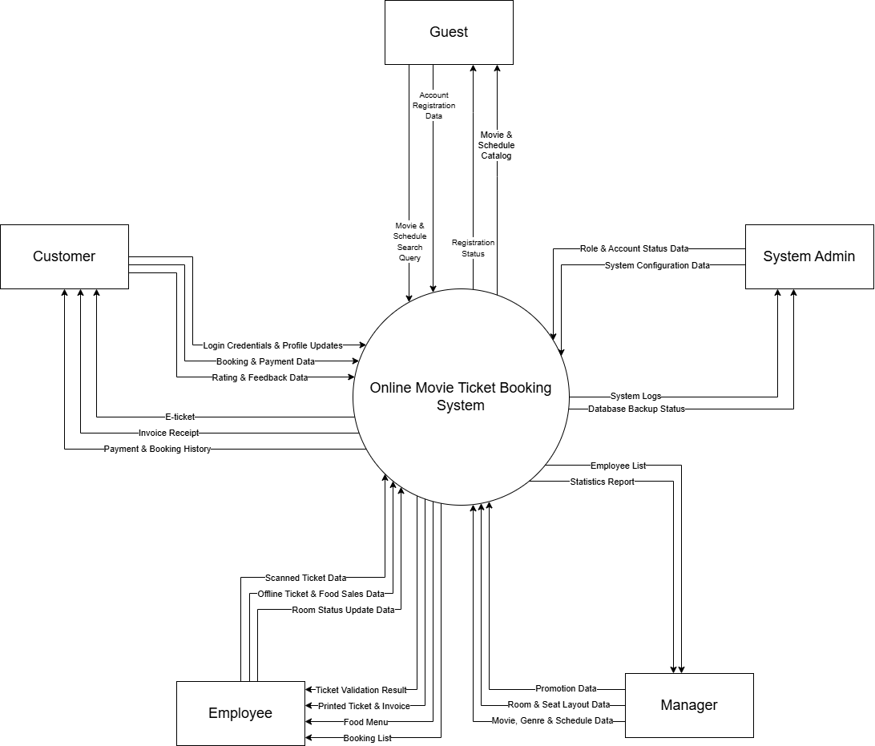

1.2 Main Business Processes

1.2.1 Đặt vé & Thanh toán trực tuyến (Ticket Booking & Payment)
Lanes: Guest/Customer, System, Payment Gateway. Customer selects a movie and showtime, selects seats, optionally adds food and applies a promotion code, then pays; the System creates the invoice and tickets and shows the confirmation. (Maps to UC22-UC30)
[Paste your swim-lane diagram image here]

1.2.2 Bán vé tại quầy & Soát vé (Counter Sale & Ticket Check-in)
Lanes: Walk-in Customer, Employee, System. A walk-in customer buys at the counter; the Employee selects the showtime/seats and collects payment, and the System creates the ticket and invoice. On the day of the show, the Employee looks up the ticket by code, email, or name and checks the customer in. (Maps to UC46-UC48)
[Paste your swim-lane diagram image here]

1.2.3 Quản lý Phim → Lịch chiếu → Mở bán (Movie → Schedule → Go-Live)
Lanes: Manager, System, Guest/Customer. The Manager adds a movie (optionally auto-filled from the TMDB API) and creates a showtime for it in a room; once the showtime is active the System publishes it, and the Guest/Customer can view and book it. (Maps to UC14, UC17, UC35, UC22)
[Paste your swim-lane diagram image here]

1.2.4 Vòng đời Khuyến mãi (Promotion Lifecycle)
Lanes: Manager, System, Customer. The Manager creates a promotion code; the System activates it on its start date; the Customer applies the code at checkout; the System tracks the usage count; and the Manager deactivates, reactivates, extends, or deletes the promotion as it approaches or passes its end date. (Maps to UC42-UC43)
[Paste your swim-lane diagram image here]

1.2.5 Xếp ca & Đổi ca làm việc (Shift Scheduling & Exchange)
Lanes: Manager, Employee (requester), Employee (colleague), System/Notification. The Manager assigns an Employee to a shift; the Employee requests to exchange an upcoming shift with a colleague; the System notifies the colleague, who accepts or rejects; the System updates the shift assignment and notifies both parties. (Maps to UC53-UC55)
[Paste your swim-lane diagram image here]

1.2.6 Đăng ký/Đăng nhập & Quên mật khẩu (Registration, Login & Password Recovery)
Lanes: Guest, System. The Guest registers an account (or signs in via Google OAuth), logs in, and if the password is forgotten, requests a reset link and sets a new password. (Maps to UC01-UC04)
[Paste your swim-lane diagram image here]

1.3 User Requirements

1.3.1 Actors
# | Actor | Description
1 | Manager | Actors who have the highest rights in the system. The manager can manage all core modules including movies, genres, cinema rooms, schedules, food items, promotions, and employee accounts.
2 | Employee | Staff members who operate directly in the system. They can manage offline ticket selling, validate bookings (check-in via QR codes), and process food and beverage orders at the counter.
3 | Customer | Registered members of the system. In addition to guest features, customers can book tickets online, rate and review movies, manage their booking history, and update their personal profiles.
4 | Guest | Unregistered users who can operate the basic public functions of the system: view movie lists, view movie details, view promotions, check ticket prices and showtimes, and register for a new account.
5 | System Admin | Actors responsible for high-level system administration and security. They manage all user accounts (including viewing the account list, blocking/unblocking, and assigning roles), configure system settings (such as banners, policies) and view System Logs to ensure integrity and compliance.

1.3.2 Use Cases (UC)
The Online Movie Ticket Booking System defines 55 use cases organized into 5 functional groups, aligned with the actor inheritance hierarchy described in Section 1.3.1. The following table summarizes all use cases with their associated feature area and description.

ID | Use Case | Feature | Use Case Description
UC01 | Register | Authentication & User Management | Allows a guest to create a new customer account by providing name, email, phone, and password.
UC02 | Login | Authentication & User Management | Allows a registered user to authenticate using email/password or Google OAuth and access the system based on their assigned role.
UC03 | Logout | Authentication & User Management | Allows an authenticated user to terminate their session and return to the public home page.
UC04 | Forgot Password | Authentication & User Management | Allows a guest to request a password reset link sent to their registered email address.
UC05 | Change Password | Authentication & User Management | Allows a logged-in user to change their current password by verifying the old one and providing a new one.
UC06 | View Profile | Authentication & User Management | Allows a logged-in user to view their personal profile information including name, email, phone, and role.
UC07 | Edit Profile | Authentication & User Management | Allows a logged-in user to update their personal information such as name, phone, date of birth, and avatar.
UC08 | Block / Unblock Account | Authentication & User Management | Allows System Admin to block or unblock a user account with a recorded reason, immediately terminating active sessions if blocked.
UC09 | Assign Role | Authentication & User Management | Allows System Admin to assign or change the role (Customer, Employee, Manager) of a user account.
UC10 | View User Account List | Authentication & User Management | Allows System Admin to view, search, and filter the list of all registered accounts in the system.
UC11 | View Movie List | Movie, Genre & Rating | Allows any visitor to browse the list of currently showing and upcoming movies displayed as poster cards with basic info.
UC12 | View Movie Detail | Movie, Genre & Rating | Allows any visitor to view full details of a movie including description, cast, trailer, showtimes, and ratings (extends UC11).
UC 13 | Search Movie | Movie, Genre & Rating | Allows any visitor to search for movies by title keyword, genre filter, or showing date.
UC 14 | Add Movie | Movie, Genre & Rating | Allows Manager to add a new movie to the system with title, poster, genres, duration, director, cast, and age rating.
UC15 | Edit Movie | Movie, Genre & Rating | Allows Manager to modify the information of an existing movie.
UC16 | Delete / Hide Movie | Movie, Genre & Rating | Allows Manager to soft-delete or hide a movie from public view while preserving existing booking data.
UC17 | Manage Genre | Movie, Genre & Rating | Allows Manager to add, edit, or delete movie genres and assign genres to movies.
UC18 | View Rating List | Movie, Genre & Rating | Allows any visitor to view the list of customer ratings and reviews for a specific movie (extends UC12).
UC19 | Rate Movie | Movie, Genre & Rating | Allows a customer to submit a star rating (1–5) and optional review comment for a movie they have checked in to watch.
UC20 | Edit / Delete Own Rating | Movie, Genre & Rating | Allows a customer to modify or remove their own previously submitted rating within 7 days after the movie's last showtime ends.
UC21 | View Rating Statistics | Movie, Genre & Rating | Allows any visitor to view the average rating score and star-distribution chart for a movie.
UC22 | View Showtime Schedule | Ticket Booking & Payment | Allows any visitor to view available showtimes for a movie filtered by date, showing time, room, and seat availability.
UC23 | Book Ticket | Ticket Booking & Payment | Allows a customer to initiate the ticket booking flow for a selected showtime, proceeding through seat selection, optional food/promotion, and payment.
UC24 | Select Seat | Ticket Booking & Payment | Allows a customer to select available seats from a real-time color-coded seat map of the cinema room (<<include>> from UC23).
UC25 | Select Food | Ticket Booking & Payment | Allows a customer to optionally add food and drink items to their booking before checkout (<<extend>> from UC23).
UC 26 | Apply Promotion | Ticket Booking & Payment | Allows a customer to enter and apply a promotion/voucher code to receive a discount during checkout (<<extend>> from UC23).
UC27 | Pay | Ticket Booking & Payment | Allows a customer to complete payment via VNPay, MoMo, or bank transfer, generating confirmed e-tickets with QR codes (<<include>> from UC23).
UC28 | View Booked Tickets | Ticket Booking & Payment | Allows a customer to view all their purchased tickets grouped by status: Upcoming, Checked-in, and Expired.
UC29 | View Ticket Detail | Ticket Booking & Payment | Allows a customer to view full ticket details including seat info, food items, payment breakdown, and downloadable QR code (extends UC28).
UC30 | View Invoice History | Ticket Booking & Payment | Allows a customer to view their complete payment and invoice history with itemized breakdowns.
UC31 | Add Cinema Room | Cinema Room, Schedule & Food | Allows Manager to create a new cinema room specifying name, type (2D/3D/IMAX), row count, and seats per row.
UC32 | Edit Cinema Room | Cinema Room, Schedule & Food | Allows Manager to update cinema room information such as name, type, and status.
UC33 | Delete Cinema Room | Cinema Room, Schedule & Food | Allows Manager to deactivate (soft-delete) a cinema room that has no future scheduled showtimes.
UC34 | Manage Seat Layout | Cinema Room, Schedule & Food | Allows Manager to visually arrange seat positions, designate VIP seats, and disable seat slots for aisles (extends UC33).
UC35 | Add Schedule | Cinema Room, Schedule & Food | Allows Manager to create a new showtime for a movie by selecting movie, room, date, time, and ticket prices with automatic conflict detection.
UC36 | Edit Schedule | Cinema Room, Schedule & Food | Allows Manager to modify an existing showtime's details; time and room changes are restricted if bookings exist.
UC37 | Delete Schedule | Cinema Room, Schedule & Food | Allows Manager to cancel a showtime, triggering refund processing and customer notification if bookings exist.
UC38 | View Food List | Cinema Room, Schedule & Food | Allows Employee to view all food and drink items on the menu with name, category, price, and availability status.
UC39 | Add Food Item | Cinema Room, Schedule & Food | Allows Employee to add a new food or drink item to the cinema menu with name, category, price, and image.
UC40 | Edit Food Item | Cinema Room, Schedule & Food | Allows Employee to update the information and pricing of an existing food item.
UC41 | Remove Food Item | Cinema Room, Schedule & Food | Allows Employee to hide or soft-delete a food item so it no longer appears in the customer's food selection.
UC42 | Manage Promotion | Promotion, Staff, Statistics & System | Allows Manager to create, edit, or delete promotion codes with discount type, value, validity period, and usage limits.
UC43 | View Promotion List | Promotion, Staff, Statistics & System | Allows Manager to view all promotions with their status (Active/Expired/Disabled) and usage statistics.
UC44 | Manage Employee | Promotion, Staff, Statistics & System | Allows Manager to add new employee accounts, edit their information, and activate or deactivate them.
UC45 | View Employee List | Promotion, Staff, Statistics & System | Allows Manager to view the list of all employees with their name, contact, status, and join date.
UC46 | Ticket Check-in | Promotion, Staff, Statistics & System | Allows Employee to look up a ticket by code, email, or name at the counter and confirm check-in. No QR/barcode scanner is used.
UC47 | View Booking Ticket List | Promotion, Staff, Statistics & System | Allows Employee to view the list of all booked tickets for a specific showtime with booking and payment status.
UC48 | Create Manual Ticket | Promotion, Staff, Statistics & System | Allows Employee to create a ticket manually at the counter for walk-in customers, immediately marked as checked-in.
UC49 | View Ticket Revenue Statistics | Promotion, Staff, Statistics & System | Allows Manager to view revenue dashboards including ticket sales, food sales, top movies, and room occupancy rates.
UC50 | Manage System Configuration | Promotion, Staff, Statistics & System | Allows System Admin to configure system-wide settings including banners, site policies, and email templates.
UC51 | View System Logs | Promotion, Staff, Statistics & System | Allows System Admin to view the immutable audit log of all system operations filtered by user, action type, and date range.
UC52 | Employee First-Login Setup | Promotion, Staff, Statistics & System | Requires a newly created Employee to complete their profile and set a permanent password before accessing any other function.
UC53 | Manage Work Shift | Promotion, Staff, Statistics & System | Allows Manager to assign Employees to fixed shift types on a calendar, either one day at a time or in bulk for a whole month.
UC54 | Shift Exchange | Promotion, Staff, Statistics & System | Allows an Employee to request transferring an assigned future shift to a colleague, who may accept, reject, or have the request cancelled.
UC55 | View Notifications | Promotion, Staff, Statistics & System | Allows an Employee to view and mark as read in-app notifications generated by shift-exchange activity.

1.3.2 Use Case Diagrams
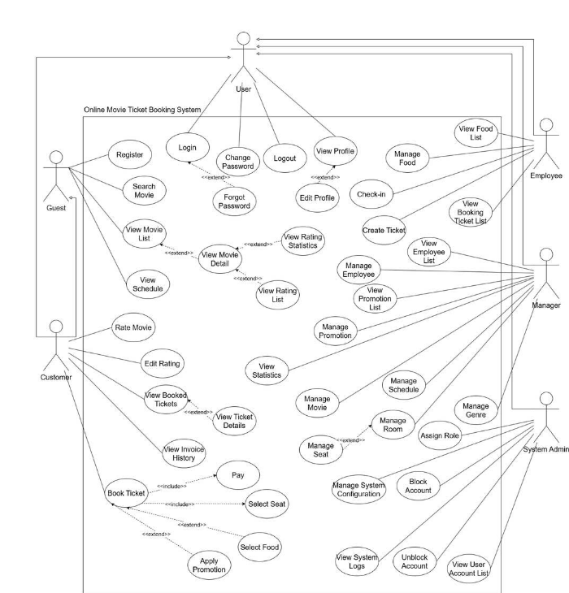

1.3.2.1 UCs for Guest
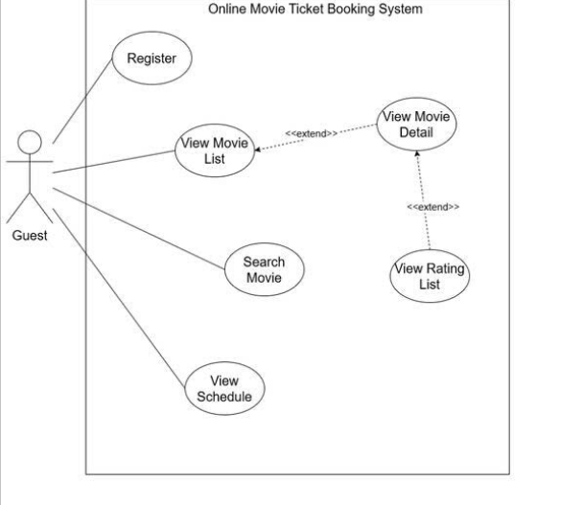
1.3.2.2 UCs for Customer
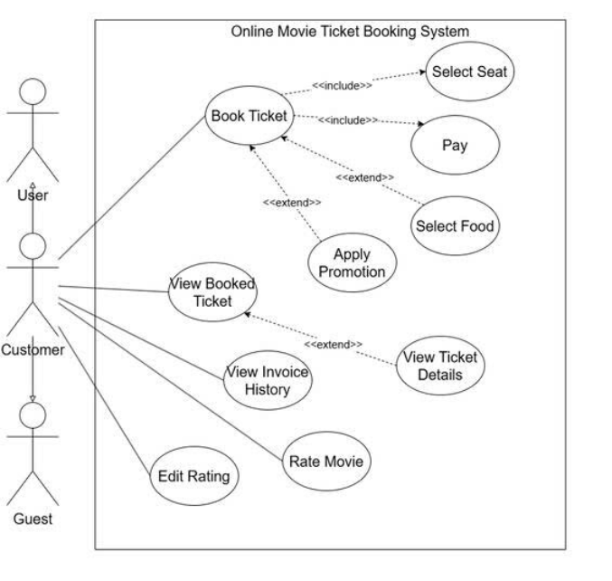

1.3.2.3 UCs for Employee
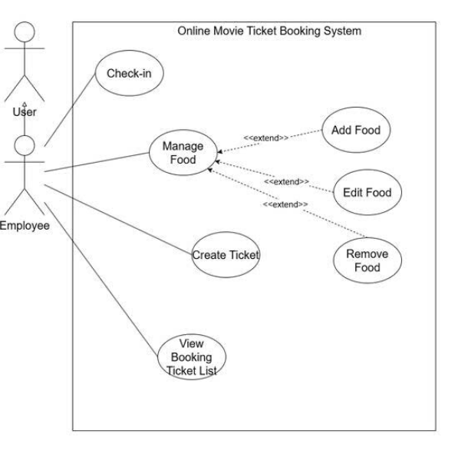
1.3.2.4 UCs for Manager
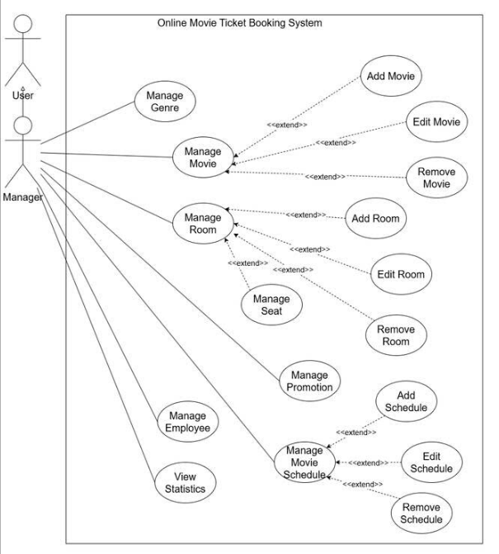

1.3.2.5 UCs for System Admin
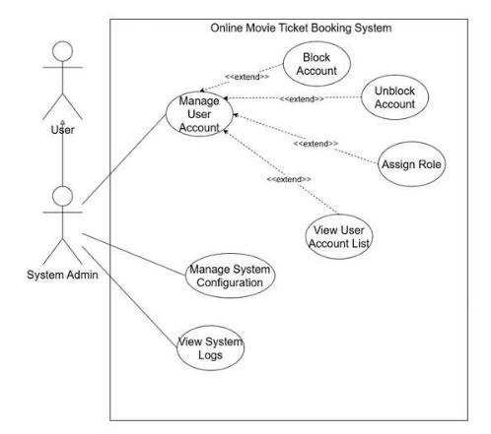

1.3.2.6 UCs for User
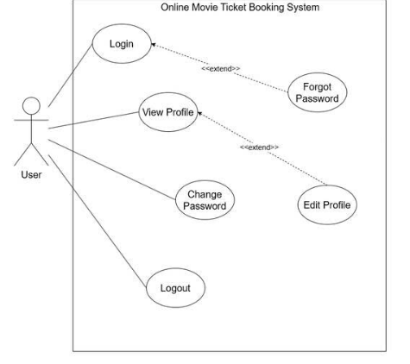

1.4 System Functionalities

1.4.1 Screens Flow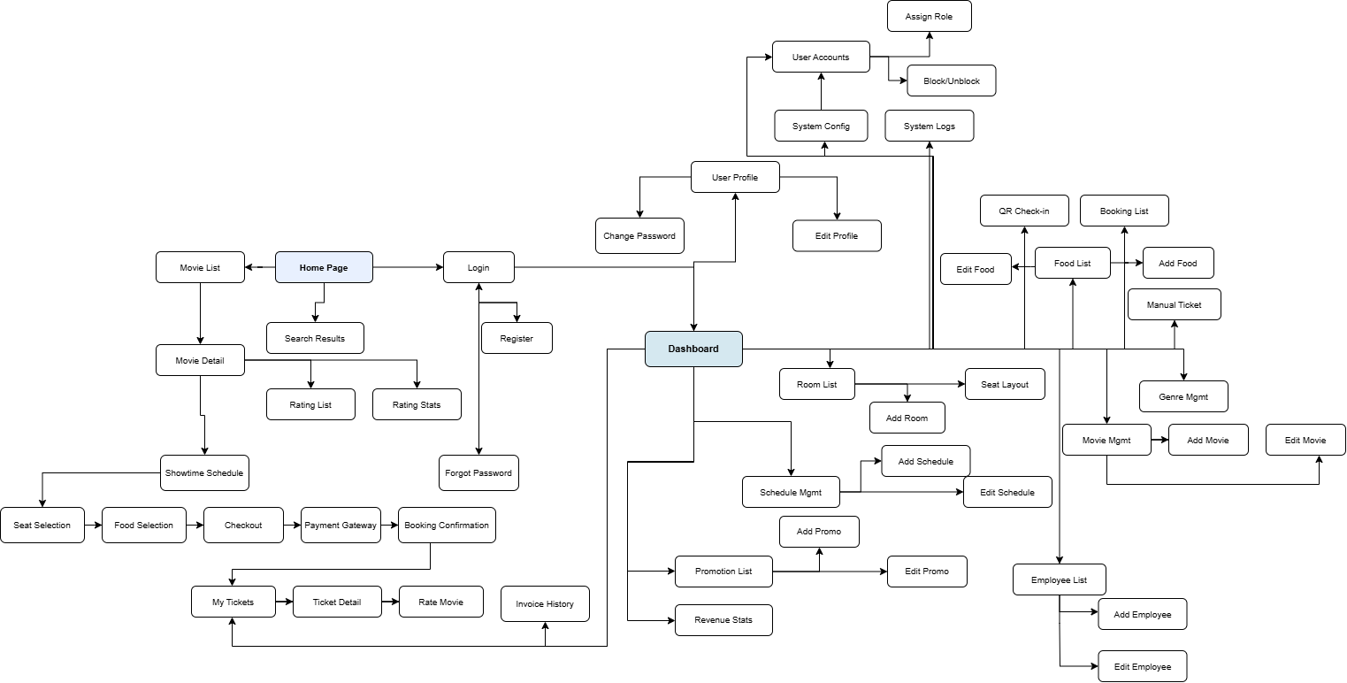

1.4.2 Screen Authorization

No | Screen | Guest | Customer | Employee | Manager | System Admin
1 | Home Page | X | X | X | X | X
2 | Movie List | X | X | X | X | X
3 | Movie Detail | X | X | X | X | X
4 | Showtime Schedule | X | X | X | X | X
5 | Search Results | X | X | X | X | X
6 | Rating List | X | X | X | X | X
7 | Rating Statistics | X | X | X | X | X
8 | User Login | X
9 | User Register | X
10 | Forgot Password | X
11 | Seat Selection |  | X
12 | Food Selection |  | X
13 | Checkout / Promo |  | X
14 | Payment Gateway |  | X
15 | Booking Confirmation |  | X
16 | My Tickets |  | X
17 | Ticket Detail |  | X
18 | Invoice History |  | X
19 | Rate Movie |  | X
20 | User Profile |  | X | X | X | X
21 | Edit Profile |  | X | X | X | X
22 | Change Password |  | X | X | X | X
23 | Dashboard |  | X | X | X | X
24 | QR Check-in Scanner |  |  | X
25 | Booking Ticket List |  |  | X
26 | Create Manual Ticket |  |  | X
27 | Food List |  |  | X
28 | Add Food |  |  | X
29 | Edit Food |  |  | X
30 | Movie Management |  |  |  | X
31 | Add Movie |  |  |  | X
32 | Edit Movie |  |  |  | X
33 | Genre Management |  |  |  | X
34 | Schedule Management |  |  |  | X
35 | Add Schedule |  |  |  | X
36 | Edit Schedule |  |  |  | X
37 | Room List |  |  |  | X
38 | Add Room |  |  |  | X
39 | Seat Layout Editor |  |  |  | X
40 | Employee List |  |  |  | X
41 | Add Employee |  |  |  | X
42 | Edit Employee |  |  |  | X
43 | Promotion List |  |  |  | X
44 | Add Promotion |  |  |  | X
45 | Edit Promotion |  |  |  | X
46 | Revenue Statistics |  |  |  | X
47 | User Account List |  |  |  |  | X
48 | Assign Role |  |  |  |  | X
49 | Block / Unblock Account |  |  |  |  | X
50 | System Configuration |  |  |  |  | X
51 | System Logs |  |  |  |  | X

1.4.3 Non-UI Functions
No. | Feature | System Function | Description
1 | Authentication | Session Expiration Service | Automatically invalidates user sessions after 24 hours of inactivity. Runs as a scheduled job every 15 minutes.
2 | Authentication | Login Lockout Timer | Temporarily locks a user account for 15 minutes after 5 consecutive failed login attempts. Automatically unlocks when the timer expires.
3 | Registration | Email Verification Service | Sends an email with a verification link upon new account registration. Verification tokens expire after 24 hours.
4 | Password Reset | Password Reset Token Service | Generates a unique reset token (valid for 15 minutes) and sends a reset link to the user's registered email when Forgot Password is triggered. Invalidates all previous tokens for that email.
5 | Ticket Booking | Seat Reservation Timer | Holds selected seats for 10 minutes during the booking process. Automatically releases unreserved seats back to "Available" when the timer expires.
6 | Ticket Booking | QR Code Generation Service | Generates a unique QR code for each confirmed ticket containing encoded booking ID and seat information. Triggered immediately after successful payment.
7 | Payment | VNPay/MoMo Payment Callback API | Receives asynchronous payment status callbacks (IPN/webhook) from external payment gateways. Verifies payment signature, updates booking status to "Confirmed" on success or "Failed" on failure.
8 | Payment | Payment Timeout Handler | Monitors pending payment transactions. If a payment is not completed within 5 minutes of gateway redirect, the system automatically cancels the booking attempt and releases the reserved seats.
9 | Notification | Booking Confirmation Email Service | Sends a confirmation email with e-ticket QR codes, booking details, and invoice to the customer within 1 minute of successful payment.
10 | Notification | Schedule Cancellation Notification | When a Manager deletes a showtime that has existing bookings, this service sends notification emails to all affected customers informing them of the cancellation and refund process.
11 | Promotion | Promotion Expiration Checker | A scheduled job (runs daily at midnight) that automatically updates promotion status from "Active" to "Expired" when the end date has passed.
12 | Rating | Average Rating Calculator | Recalculates the average star rating and rating distribution for a movie whenever a new rating is submitted, edited, or deleted. Updates are near real-time.
13 | Statistics | Revenue Data Aggregation Job | A scheduled job (runs every 5 minutes) that aggregates ticket sales, food sales, and occupancy data for the revenue statistics dashboard.
14 | System | Audit Logging Service | Automatically logs all significant system actions (Login, Logout, Create, Update, Delete, Block, Unblock, Role Change, Payment) with timestamp, user ID, IP address, and action details. Logs are immutable.
15 | System | Database Backup Job | A scheduled job (runs daily at 2:00 AM) that creates a full backup of the SQL Server database. Backup status is reported to the System Admin dashboard.
16 | Ticket | Ticket Status Auto-Update Service | A scheduled job (runs every 30 minutes) that automatically updates ticket status from "Confirmed" to "Expired" when the showtime has passed and the ticket was not checked in.

1.5 Entity Relationship Diagram
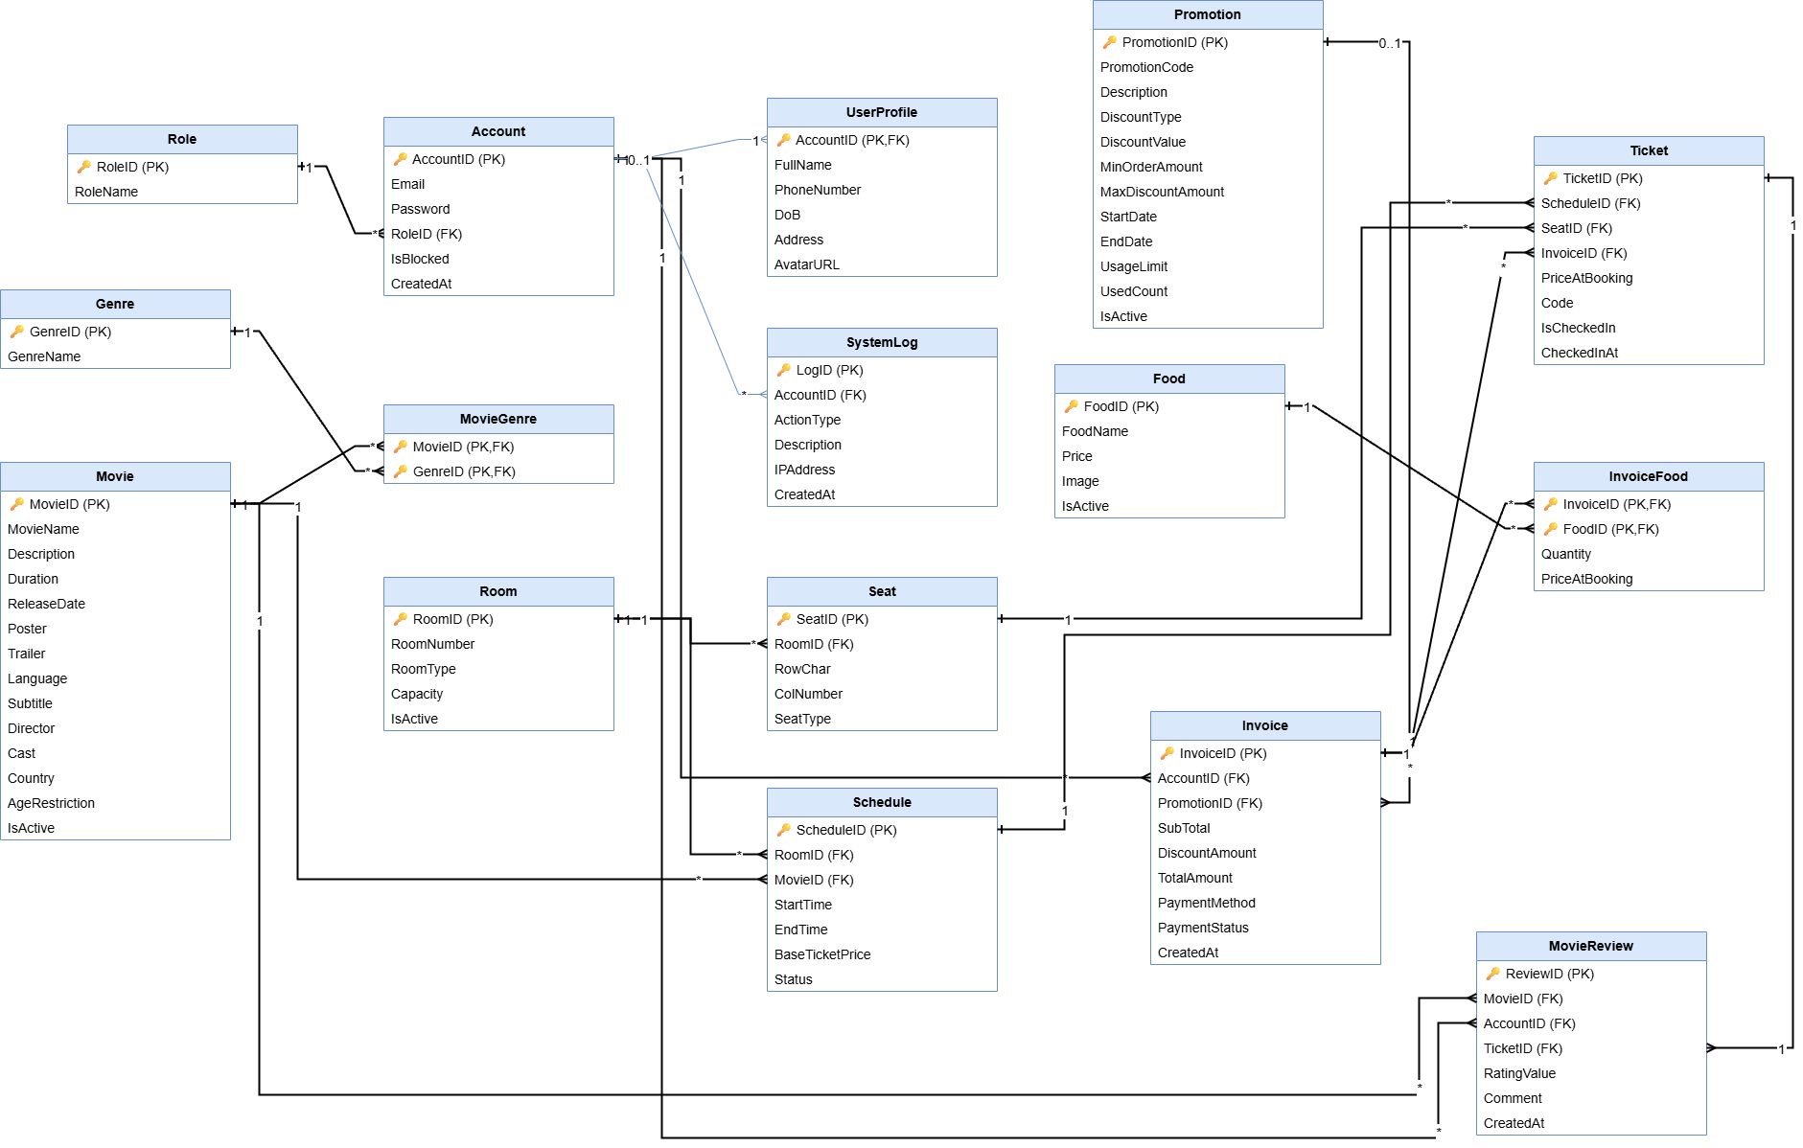

Entities Description
# | Entity | Description
1 | Role | Stores user roles in the system (Guest, Customer, Employee, Manager, SystemAdmin) for authorization.
2 | Account | User login account, including email, password, role, and account lock status.
3 | UserProfile | Detailed personal information (full name, phone number, date of birth, address, avatar) of the user, a 1-1 extension of Account.
4 | Movie | Information about movies shown at the cinema: name, description, duration, director, cast, language, age rating, and active status.
5 | Genre | Category of movie genres (Action, Comedy, Horror, Romance, Animation, etc.).
6 | MovieGenre | Intermediate table linking Movie and Genre in a many-to-many relationship (one movie can have multiple genres and vice-versa).
7 | Room | Cinema room information: room number, room type (2D/3D/IMAX/4DX), and capacity.
8 | Seat | Seats in each cinema room, including row position, seat number, and seat type (Normal/VIP).
9 | Schedule | Specific showtime schedule: room, movie, start/end time, basic ticket price, and showtime status.
10 | Food | Food and beverage items sold at the cinema: name, price, image, and active status.
11 | Promotion | Promotion/discount code applied to the invoice: discount type (%/amount), value, minimum order condition, validity period, and usage limits.
12 | Invoice | Customer payment invoice, storing total amount, discounted amount, payment method, and payment status.
13 | Ticket | Booked movie ticket, linked to a specific showtime and seat, with a QR code and check-in status.
14 | InvoiceFood | Intermediate table linking Invoice and Food in a many-to-many relationship, also storing quantity and price at the time of booking.
15 | MovieReview | Customer rating and comment about the movie after watching (each ticket is only allowed one rating).
16 | SystemLog | System activity log: acting account, action type, description, IP address, and time.

2. Use Case Specifications

2.1 Authentication & User Management

2.1.1 UC-01: Register
a. Functionalities
UC ID and Name: | UC-01: Register
Created By: | Huy | Date Created: | 28/05/2026
Primary Actor: | Guest | Secondary Actors: | Database System
Trigger: | User clicks "Register" on the homepage or login page.
Description: | This use case allows users to create an account by providing email, password, full name, and phone number.
Preconditions: | PRE-1. The system is operating normally.  PRE-2. User is not logged in.
Postconditions: | POST-1. A new account is created in the database.  POST-2. User is automatically logged in and redirected to the homepage.
Normal Flow: | - User navigates to the Login page .  - System displays the login form (email, password, Remember Me checkbox).  - User enters email and password, then submits  - System validates that email and password are not empty.  - System calls AccountDAO.login(email, password) which retrieves the stored hash and verifies it via PasswordHash.verify().  - System creates an HTTP session and stores the Account object as session.setAttribute("account", account).  - System checks for a stored redirectAfterLogin session attribute:  - If present → redirect to that original URL.  - If absent → redirect to the homepage.  .
Alternative Flows: | AF-1.Invalid credentials: If email doesn't exist or password doesn't match the stored hash → System redisplays the form with error "Incorrect email or password".  AF-2. Empty fields: If email or password is blank → System shows validation alert via JavaScript (client-side) and prevents submission.
Exceptions: | E1. Database connection fails: System displays a friendly error page.
Priority: | High - Must Have
Frequency of Use: | Continuously
Business Rules: | BR-01.1, BR-01.2, BR-01.3, BR01.4, BR01.5, BR01.6
Other Information: | - Registration form uses responsive design matching the login page style.  - Password fields include a show/hide toggle button for usability.  - Client-side JavaScript validation runs before form submission as a convenience layer.
Assumptions: | - The user has a stable internet connection and a compatible browser.  - The user has a valid email address that they have access to.  - The user's password is stored securely using SHA-256 with a unique random salt per user, not in plain text.
b. Business Rules
ID | Business Rule | Business Rule Description
BR-01.1 | Password Length | Password must be at least 6 characters long.
BR-01.2 | Email Uniqueness | Email must be unique in the system (enforced by a UNIQUE constraint on Account.Email and checked in DAO).
BR-01.3 | Default Role | New accounts default to RoleID = 2 (Customer).
BR-01.4 | Default Status | New accounts are created with IsBlocked = 0 (active).
BR-01.5 | Password Encryption | Password is encrypted with SHA-256 + 16-byte random salt before being stored in the database.

2.1.2 UC-02: Login
a. Functionalities
UC ID and Name: | UC-02: Login
Created By: | Huy | Date Created: | 28/05/2026
Primary Actor: | Customer, Manager, Admin, Employee | Secondary Actors: | Database System
Trigger: | User clicks "Login" on the homepage.
Description: | This use case authenticates a registered user by verifying email and password, then creates a session.
Preconditions: | PRE-1. The system is operating normally.  PRE-2. User is not logged in.  PRE-3. User already has a registered account.
Postconditions: | POST-1. User is authenticated and a session is created.  POST-2. User is redirected to the originally requested page or the homepage
Normal Flow: | - User navigates to the Login page  - System displays the login form (email, password, Remember Me checkbox).  - User enters email and password, then submits  - System validates that email and password are not empty.  - System calls AccountDAO.login(email, password) which retrieves the stored hash and verifies it via PasswordHash.verify().  - System creates an HTTP session and stores the Account object as session.setAttribute("account", account).  - System checks for a stored redirectAfterLogin session attribute:  - If present → redirect to that original URL.  - If absent → redirect to the homepage.  .
Alternative Flows: | AF-1. Invalid credentials: If email doesn't exist or password doesn't match the stored hash → System redisplays the form with error "Incorrect email or password".  AF-2. Empty fields: If email or password is blank → System shows validation alert via JavaScript and prevents submission.  AF-3. Login via Google OAuth: User clicks "Đăng nhập bằng Google" → System redirects to Google's OAuth consent screen → on approval, System exchanges the authorization code for an access token and retrieves the Google profile → System logs into the matching account, or auto-registers a new Customer account (RoleID = 2, blank local password) if the email is not yet registered → System creates the session as in the normal flow.
Exceptions: | E1.Database connection fails: System displays a friendly error page.
Priority: | High - Must Have
Frequency of Use: | Continuously
Business Rules: | BR-02.1, BR-02.2, BR-02.3, BR-02.4, BR-02.5
Other Information: | - Login page includes a Remember Me checkbox.  - Password field includes a show/hide toggle button.  - Login form includes links to Register and Forgot Password  - After successful login, users are redirected to the page they originally tried to access, or to the homepage if no redirect was pending.
Assumptions: | - The user has a stable internet connection and a compatible browser.  - The user has already completed the Registration use case (UC-01).  - Session cookies are enabled in the user's browser.
b. Business Rules
ID | Business Rule | Business Rule Description
BR-02.1 | Password Verification | Password is verified against the stored SHA-256 + salt hash using PasswordHash.verify().
BR-02.2 | Session Timeout | Session maximum inactive interval is 30 minutes.
BR-02.3 | Session Key | Authenticated user object is stored in session under the attribute name "account".
BR-02.4 | Redirect After Login | If a redirectAfterLogin attribute exists in the session, the user is redirected there after successful authentication; otherwise redirected to the homepage.
BR-02.5 | Google OAuth Login | A user may authenticate via Google OAuth2 instead of a local password. If the returned email does not match an existing account, a new Customer account (RoleID = 2) is created automatically with no local password set.

2.1.3 UC-03: Logout
a. Functionalities
UC ID and Name: | UC-03: Logout
Created By: | Huy | Date Created: | 28/05/2026
Primary Actor: | Customer, Manager, Admin, Employee | Secondary Actors: | Database System
Trigger: | User clicks "LogOut" in the header
Description: | This use case terminates the user's authenticated session and clears all session data.
Preconditions: | PRE-1. User is logged in with an active session.
Postconditions: | POST-1. User session is destroyed.  POST-2. User is redirected to the Login page.
Normal Flow: | - User clicks the "LogOut" link.  - System receives GET /Logout request.  - System calls session.invalidate() to destroy the current session.  - System redirects the user to GET /Login.  .
Alternative Flows: | AF-1.No active session: If the user accesses /Logout without a session → System simply redirects to /Login without error.
Exceptions: | None
Priority: | High - Must Have
Frequency of Use: | Occasionally
Business Rules: | BR-03.1
Other Information: | - The Logout button is only visible in the header when a user is logged in.  - No confirmation dialog is shown; logout is immediate.  - After logout, all session-scoped data is cleared.
Assumptions: | - The user's browser supports session cookie invalidation.  - The user expects to be logged out immediately without a confirmation prompt.
b. Business Rules
ID | Business Rule | Business Rule Description
BR-03.1 | Session Destruction | The HttpSession.invalidate() method is called to completely destroy the session and all its attributes.

2.1.4 UC-04: Forgot Password
a. Functionalities
UC ID and Name: | UC-04: Forgot Password
Created By: | Huy | Date Created: | 28/05/2026
Primary Actor: | Guest | Secondary Actors: | Database System
Trigger: | User clicks "Forgot Password ?" on the Login page.
Description: | This use case allows a user who has forgotten their password to request a password reset link.
Preconditions: | PRE-1. The system is operating normally.  PRE-2. User is not logged in.
Postconditions: | POST-1. A reset token is generated and stored in the database. POST-2. User is shown a reset link to set a new password.
Normal Flow: | - User clicks "Forgot Password ?" on the Login page.  - System displays the forgot password form asking for email.  - User enters their registered email and submits  - System validates the email format.  - System checks if the email exists via AccountDAO.isEmailExist().  - System generates a UUID token and stores it with a 1-hour expiry in the ResetToken and ResetTokenExpiry columns.  - System displays the reset link to the user.  .
Alternative Flows: | AF-1. Invalid email format: System redisplays the form with error "  Invalid email ".  AF-2. Email not found: System redisplays the form with error "  The email address does not exist in the system. ".
Exceptions: | E1. Database connection fails: System displays a friendly error page.
Priority: | Medium – Should Have
Frequency of Use: | Rarely
Business Rules: | BR-04.1, BR-04.2, BR-04.3, BR-04.4
Other Information: | - The forgot password page reuses the same responsive card layout and CSS as the login page.  - For development/demo purposes, the reset link is displayed directly on the screen instead of being sent via email.  - The reset link contains a unique UUID token as a query parameter
Assumptions: | - The user has a stable internet connection and a compatible browser.  - The user remembers the email address they registered with.  - The ResetToken column and ResetTokenExpiry column have been added to the Account table via ALTER TABLE SQL.
b. Business Rules
ID | Business Rule | Business Rule Description
BR-04.1 | Token Generation | Reset token is a randomly generated UUID v4 string.
BR-04.2 | Token Expiry | Reset token expires 1 hour after creation. The ResetTokenExpiry column stores the deadline; expired tokens are rejected by the query.
BR-04.3 | Token Cleanup | After a successful password reset, the ResetToken and ResetTokenExpiry columns are set to NULL via clearResetToken().
BR-04.4 | Single-Use Token | Each reset request invalidates any previous token by overwriting it.

2.1.5 UC - 05: Change Password
a. Functionalities
UC ID and Name: | UC-05: Change Password
Created By: | Huy | Date Created: | 28/05/2026
Primary Actor: | Customer, Manager, Admin, Employee | Secondary Actors: | Database System
Trigger: | User clicks "Change Password" in the header while logged in.
Description: | This use case allows an authenticated user to change their password by verifying their current password.
Preconditions: | PRE-1. User is logged in with an active session.  PRE-2. The system is operating normally.
Postconditions: | POST-1. User's password is updated in the database.  POST-2. User is notified of success.
Normal Flow: | - User clicks "Change Password" in the site header.  - System displays the change password form with fields: current password, new password, confirm new password.  - User fills in all fields and submits.  - System verifies the current password by calling AccountDAO.getAccountById() and PasswordHash.verify().  - System validates new password (≥ 6 characters) and confirms new passwords match.  - System calls AccountDAO.updatePassword() to hash and store the new password.  - System displays success message "Password changed successfully.".  .
Alternative Flows: | AF-1. Wrong current password: System redisplays form with error "The current password is incorrect.".  AF-2. New password too short: System redisplays form with error "The new password must have at least 6 characters.".  AF-3. Confirm password mismatch: System redisplays form with error "The verification password does not match. ".
Exceptions: | E1. Session expired: AuthFilter intercepts the request and redirects to Login page.  E2. Database connection fails: System displays a friendly error page.
Priority: | Medium – Should Have
Frequency of Use: | Rarely
Business Rules: | BR-05.1, BR-05.2, BR-05.3, BR-05.4
Other Information: | - The Change Password page reuses the same responsive card layout as the login/register forms.  - All password fields include a show/hide toggle button.  - The "Change Password" link is only visible in the header when the user is logged in.  - The session is NOT invalidated after a password change; the user remains logged in.
Assumptions: | - The user has a stable internet connection and a compatible browser.  - The user is already authenticated (session exists) when accessing this feature.  - The user knows their current password.
b. Business Rules
ID | Business Rule | Business Rule Description
BR-05.1 | Password Length | New password must be at least 6 characters long.
BR-05.2 | Current Password Verification | The current password must be verified against the stored hash before the change is allowed.
BR-05.3 | Password Encryption | The new password is encrypted with SHA-256 + random salt before storage.
BR-05.4 | Password Confirmation | The new password must be entered twice; the two entries must match.

2.1.6 UC - 06: View Profile
a. Functionalities
UC ID and Name: | UC - 06: View Profile
Created By: | Huy | Date Created: | 18/06/2026
Primary Actor: | Employee | Secondary Actors: | System
Trigger: | Employee clicks their name/avatar in the site header and opens /employee/profile.
Description: | Allows an Employee to view their personal profile information (full name, email, phone, address, date of birth, avatar) on a read-only page.
Preconditions: | PRE-1. Employee is logged in with an active session.  PRE-2. The system is operating normally.
Postconditions: | POST-1. Profile information is displayed to the Employee.  POST-2. The session remains unchanged.
Normal Flow: | 1. Employee opens /employee/profile.  2. System loads the logged-in Account from the session and joins it with the UserProfile table.  3. System displays the profile card: avatar, full name, email, phone, address, date of birth, role, status, and join date.
Alternative Flows: | AF-1. Session expired or not logged in: AuthFilter redirects to the Login page.
Exceptions: | E1. Database connection fails: System displays a friendly error page.
Priority: | Medium – Should Have
Frequency of Use: | Occasionally
Business Rules: | BR-06.1
Other Information: | - ⚠ Current build: this screen exists only for Employee (/employee/profile, EmployeeDashboardServlet.showProfile). There is no equivalent profile-view page for Customer, Manager, or System Admin.
Assumptions: | - The Employee is already authenticated when accessing this feature.
b. Business Rules
ID | Business Rule | Business Rule Description
BR-06.1 | Profile View (Employee-only) | Profile data is read from the Account + UserProfile join for the logged-in Employee only; the view is read-only. Customer, Manager, and System Admin do not have an equivalent page in the current build.

2.1.7 UC - 07: Edit Profile
a. Functionalities
UC ID and Name: | UC-07: Edit Profile
Created By: | Huy | Date Created: | 18/06/2026
Primary Actor: | Employee | Secondary Actors: | System
Trigger: | Employee logs in for the first time with the temporary password issued by a Manager (see UC-52).
Description: | ⚠ There is no general-purpose "edit profile anytime" feature in the current codebase (no ProfileController exists). The only profile-writing flow actually implemented is the one-time Employee First-Login Setup (UC-52), which lets a new Employee fill in full name, phone, address, date of birth, and a new password before using any other function.
Preconditions: | PRE-1. Employee account has NeedsSetup = true (has not completed first-login setup yet).
Postconditions: | POST-1. See UC-52 postconditions.
Normal Flow: | See UC-52: Employee First-Login Setup for the actual implemented flow. This UC is retained as a placeholder for a possible future "edit profile anytime" feature.
Alternative Flows: | None currently implemented beyond what is covered in UC-52.
Exceptions: | See UC-52.
Priority: | Medium – Should Have
Frequency of Use: | Rarely
Business Rules: | BR-07.1
Other Information: | - ⚠ Not implemented as a repeatable feature for any role. No ProfileController, no updateProfile action, and no avatar-upload servlet exist in the current codebase.
Assumptions: | - N/A
b. Business Rules
ID | Business Rule | Business Rule Description
BR-07.1 | One-Time Profile Entry | Profile fields (full name, phone, address, date of birth) can currently only be set once, during Employee First-Login Setup (UC-52). There is no update path afterward, and no equivalent exists for Customer, Manager, or System Admin.

2.1.8 UC - 08: Block / Unblock Account
a. Functionalities
UC ID and Name: | UC - 08: Block / Unblock Account
Created By: | Huy | Date Created: | 18/06/2026
Primary Actor: | Manager | Secondary Actors: | System
Trigger: | “Khóa”/“Mở khóa” button next to an Employee row in the Employee list (/manager/employees).
Description: | Allows a Manager to block or unblock an Employee account (RoleID = 3), preventing or restoring their ability to log in. ⚠ Current build: this only applies to Employee accounts; there is no System-Admin-level feature to block/unblock Customer, Manager, or Admin accounts.
Preconditions: | PRE-1. Manager is logged in with an active session.  PRE-2. The target account exists and has RoleID = 3 (Employee).
Postconditions: | POST-1. The Account.IsBlocked field is toggled for the target Employee.
Normal Flow: | 1. Manager opens the Employee list (/manager/employees).  2. Manager clicks the lock/unlock action for a target Employee.  3. System calls EmployeeServlet.doPost() with action=toggle and the accountId.  4. System updates Account.IsBlocked via EmployeeDAO.  5. System redisplays the list with the updated status.
Alternative Flows: | AF-1. Operation failure: System redisplays the list unchanged.
Exceptions: | E1. Session expired: AuthFilter redirects to the Login page.
Priority: | High – Must Have
Frequency of Use: | Rarely
Business Rules: | BR-08.1
Other Information: | - ⚠ No AccountAdminDAO, no /admin/users or /admin/staff route, and no SystemLog/Notification entries are created by this action in the current codebase — only the Employee-scoped toggle in EmployeeServlet exists.
Assumptions: | - The Manager has the authority to block/unblock Employee accounts.
b. Business Rules
ID | Business Rule | Business Rule Description
BR-08.1 | Employee-Only Blocking | Only Employee accounts (RoleID = 3) can be blocked/unblocked, and only by a Manager. Blocked accounts cannot log in (checked in LoginController). There is no equivalent feature for other roles.

2.1.9 UC-09: Assign Role
a. Functionalities
UC ID and Name: | UC-09: Assign Role
Created By: | Huy | Date Created: | 18/06/2026
Primary Actor: | System Admin | Secondary Actors: | System
Trigger: | ⚠ N/A — no trigger exists in the UI; this feature is not implemented.
Description: | ⚠ NOT IMPLEMENTED. There is no feature anywhere in the codebase to change an account's role after creation. A role is fixed at creation time: Customer via Register or Google login (RoleID 2), or Employee/Manager created directly with their role by a Manager (EmployeeServlet), or seeded directly in the database.
Preconditions: | N/A
Postconditions: | N/A
Normal Flow: | Not applicable — no UI, servlet action, or DAO method exists for this use case.
Alternative Flows: | N/A
Exceptions: | N/A
Priority: | High – Must Have
Frequency of Use: | Rarely
Business Rules: | BR-09.1
Other Information: | - This was originally specified as a System Admin feature. No AccountAdminDAO class, no /admin route, and no role-change action exist anywhere in the current codebase (AdminServlet only implements the dashboard, System Logs, and System Configuration).
Assumptions: | - N/A
b. Business Rules
ID | Business Rule | Business Rule Description
BR-09.1 | Planned, Not Implemented | Role assignment is a planned requirement only; no code path currently allows changing an account's RoleID after creation.

2.1.10 UC-10: View User Account List
a. Functionalities
UC ID and Name: | UC-010: View User Account List
Created By: | Huy | Date Created: | 18/06/2026
Primary Actor: | System Admin | Secondary Actors: | System
Trigger: | ⚠ N/A — no such page exists in the current build.
Description: | ⚠ NOT IMPLEMENTED. AdminServlet only exposes /admin (dashboard with aggregate KPI counts), /admin/logs (UC-51), and /admin/config (UC-50). There is no paginated/searchable account list, no /admin/users route, and no AccountAdminDAO class in the current codebase.
Preconditions: | N/A
Postconditions: | N/A
Normal Flow: | Not applicable — no UI, servlet action, or DAO method exists for this use case.
Alternative Flows: | N/A
Exceptions: | N/A
Priority: | High – Must Have
Frequency of Use: | Frequently
Business Rules: | BR-10.1
Other Information: | - The Admin Dashboard (under /admin) shows only aggregate counts (total customers, total staff), not a browsable list of individual accounts.
Assumptions: | - N/A
b. Business Rules
ID | Business Rule | Business Rule Description
BR-10.1 | Planned, Not Implemented | A full account list/search/sort feature for System Admin is a planned requirement only; not present in the current codebase.

2.2 Movie, Genre & Rating

2.2.1 UC-11: View Movie List
a. Functionalities
UC ID and Name: | UC-11: View Movie List
Created By: | Cường | Date Created: | 28/05/2026
Primary Actor: | Guest, Customer | Secondary Actors: | Database System
Trigger: | User accesses the Homepage or navigates to the "Movies" tab.
Description: | This use case allows users to view the catalog of movies currently showing and upcoming movies in the cinema.
Preconditions: | PRE-1. The system is operating normally.
Postconditions: | POST-1. A list of movies is displayed successfully to the user.
Normal Flow: | 1. User opens the "Movies" page on the web application.  2. System retrieves the list of movies from the database.  3. System categorizes movies into "Now Showing" and "Coming Soon" based on their release dates and their schedule availability.  4. System displays the movie list (including poster, title, duration, and age restriction badge) in a responsive grid layout.
Alternative Flows: | AF-1. User clicks on a specific Genre filter (e.g., Action, Sci-Fi).  - System filters and displays only movies matching the selected genre.
Exceptions: | E1. No movies match the criteria or the database is empty. (System displays: "Currently, no movies are available").  E2. Database connection fails. (System displays a friendly error page).
Priority: | High - Must Have
Frequency of Use: | Continuously
Business Rules: | BR-11.1, BR-11.2
Other Information: | Movies should be displayed in a responsive grid layout with pagination support.
Assumptions: | The user has a stable internet connection and a compatible browser.
b. Business Rules
ID | Business Rule | Business Rule Description
BR-11.1 | Visibility Status | Only movies with the status isActive = true (not soft-deleted by Manager) will be fetched and displayed on this page.
BR-11.2 | Categorization Logic | Now showing: ReleaseDate <= CurrentDate and the movie has no schedule records or has at least one active schedule where EndTime >= CurrentTime.  Coming soon: ReleaseDate > CurrentDate.

2.2.2 UC-12: View Movie Detail
a. Functionalities
UC ID and Name: | UC-12: View Movie Detail
Created By: | Cường | Date Created: | 28/05/2026
Primary Actor: | Guest, Customer | Secondary Actors: | Database System
Trigger: | User clicks on a specific movie poster, title, or "Detail" button from the Homepage or Movie List.
Description: | This use case allows users to view comprehensive information about a specific movie, including its synopsis, cast, director, trailer, and audience sentiment/ratings.
Preconditions: | PRE-1. The system is operating normally.  PRE-2. The selected movie exists in the database and its status is active.
Postconditions: | POST-1. The movie detail page is displayed successfully with accurate data.
Normal Flow: | 1. User clicks on a movie from the UI.  2. System receives the request with the specific Movie ID.  3. System retrieves movie details (synopsis, duration, release date, cast, genres, embedded trailer link, average rating score) from the database.  4. System displays the detailed information on the Movie Detail page.
Alternative Flows: | AF-1. User clicks the "Book Tickets" button.  - System redirects the user to the Showtime Schedule page (UC-22) for that specific movie.  AF-2. User clicks the "Watch Trailer" button.  - System opens the trailer video link in a new browser tab.
Exceptions: | E1. The requested Movie ID does not exist, has been deleted, or is hidden by the Manager. (System redirects the user back to the Homepage).  E2. Database connection fails. (System displays a generic 500 error page).
Priority: | High - Must Have
Frequency of Use: | Continuously
Business Rules: | BR-12.1, BR-12.2
Other Information: | The UI should visually match the "Movie Detail & Reviews" Figma design, emphasizing the poster and rating metrics.
Assumptions: | The user's device/browser supports opening external video links (e.g., YouTube) for trailers.
b. Business Rules
ID | Business Rule | Business Rule Description
BR-12.1 | Booking Button Behavior | The "Book Tickets" action button is always visible and will redirect the user to the Showtime Schedule page. If there are no active schedules, the empty state will be handled on the Schedule page itself.
BR-12.2 | Rating Calculation | The displayed "Audience Sentiment" (Average Rating) and Star Distribution must be dynamically calculated based on all valid reviews for this specific Movie ID (Linked to UC-18 and UC-21).

2.2.3 UC-13: Search Movie
a. Functionalities
UC ID and Name: | UC-13: Search Movie
Created By: | Cường | Date Created: | 28/05/2026
Primary Actor: | Guest, Customer | Secondary Actors: | Database System
Trigger: | User enters a keyword into the search bar and submits the query.
Description: | This use case allows users to quickly find specific movies by searching for keywords matching the movie title.
Preconditions: | PRE-1. The system is operating normally.
Postconditions: | POST-1. A list of movies matching the search keyword is displayed across both "Now Showing" and "Coming Soon" sections.
Normal Flow: | 1. User clicks on the search input field.  2. User types a keyword (e.g., "Batman").  3. The system instantly fetches and displays filtered movies using AJAX (Live Search) as the user types without requiring a page reload.  4. System processes the query and searches the database for matching movie titles using partial match logic (LIKE %keyword%).  5. System displays the filtered list of movies and shows a "Clear filter / Xóa lọc" button.
Alternative Flows: | None.
Exceptions: | E1. No results found: The system cannot find any movie matching the keyword. (System displays an empty state message / "Không có kết quả nào").  E2. Empty search: User submits an empty search query. (System simply ignores the filter and fetches the complete list of all active movies).
Priority: | Medium - Should Have
Frequency of Use: | Frequently
Business Rules: | BR-13.1, BR-13.2
Other Information: | The search operation must be case-insensitive.
Assumptions: | The database text search indexing is properly configured for optimal performance.
b. Business Rules
ID | Business Rule | Business Rule Description
BR-13.1 | Search Scope | The search function must only return movies that have an active status (isActive = true). Hidden or deleted movies must not appear in search results.
BR-13.2 | Keyword Matching | The system searches for partial matches (e.g., searching "ven" will return "Avengers").

2.2.4 UC-14: Add Movie
a. Functionalities
UC ID and Name: | UC-14: Add Movie
Created By: | Cường | Date Created: | 29/05/2026
Primary Actor: | Manager | Secondary Actors: | Database System
Trigger: | Manager clicks the "Add New Movie" button in the Movie Management dashboard.
Description: | This use case allows the Manager to add a new movie to the cinema's database, including providing its poster URL, defining its genres, and inputting all relevant details.
Preconditions: | PRE-1. The Manager is logged into the system with appropriate privileges.  PRE-2. Movie genres must already exist in the database (UC-17).
Postconditions: | POST-1. The new movie is successfully saved in the database and becomes visible in the Manager's movie list.
Normal Flow: | 1. Manager navigates to the "Manage Movies" page.  2. Manager clicks the "Add New Movie" button.  3. System displays the Add Movie form.  4. Manager inputs movie information (Title, Synopsis, Release Date, Duration, Age Restriction, Director, Cast, Poster URL, Trailer URL).  5. Manager checks the "Early Release" (Suất chiếu đột xuất) checkbox if applicable.  6. Manager selects one or more categories from the Genre list.  7. Manager clicks the "Save" button.  8. System validates the inputted data, specifically the release date constraint.  9. System saves the new movie record to the database with a default status of isActive = true.  10. System displays a success notification and redirects to the Movie List page.
Alternative Flows: | AF-1. Manager cancels the operation.  1. Manager clicks the "Cancel" button before saving.  2. System discards any inputted data and redirects back to the Movie List page.
Exceptions: | E1. Missing mandatory fields: Manager leaves required fields empty. (System prevents submission and highlights the empty fields).  E2. Release Date Violation: Release date does not meet the minimum required days (7 days for early release, 30 days for normal release). (System prevents submission and displays an error alert).
Priority: | High - Must Have
Frequency of Use: | Occasionally (Whenever new movies are acquired by the cinema)
Business Rules: | BR-14.1, BR-14.2, BR-14.3
Other Information: | The poster image and trailer are provided as external URLs rather than physical file uploads to optimize server storage.  Manager can click the "Dữ liệu TMDB" button to auto-fill the production budget and global box office fields by querying the external TMDB API for the entered movie title (see screen mapping in 3.4.2.1). This is a convenience lookup only; the Manager still reviews and submits the form manually.
Assumptions: | Manager has the correct and finalized promotional assets (URL links) provided by the movie distributor.
b. Business Rules
ID | Business Rule | Business Rule Description
BR-14.1 | Mandatory Fields | Movie Title, Release Date, Duration, Age Restriction, Synopsis (Description), and Poster URL are strictly required fields.
BR-14.2 | Data Constraints | Movie Duration must be an integer within the range of 40 to 300 minutes, representing a realistic movie length.
BR-14.3 | Release Date Validation | If the "Early Release" option is checked, the release date must be at least 7 days from the current date. Otherwise, it must be at least 30 days from the current date.

2.2.5 UC-15: Edit Movie
a. Functionalities
UC ID and Name: | UC-15: Edit Movie
Created By: | Cường | Date Created: | 29/05/2026
Primary Actor: | Manager | Secondary Actors: | Database System
Trigger: | Manager clicks the "Edit" button next to a specific movie in the Movie Management dashboard.
Description: | This use case allows the Manager to modify secondary details of an existing movie, such as its synopsis, assigned genres, trailer URL, cast, and age restriction.
Preconditions: | PRE-1. The Manager is logged into the system with appropriate privileges.  PRE-2. The selected movie must exist in the database.
Postconditions: | POST-1. The movie's details are successfully updated in the database and reflected across the system.
Normal Flow: | 1. Manager navigates to the "Manage Movies" page.  2. Manager clicks the "Edit" button for a target movie.  3. System retrieves the current movie data and displays it in an editable form. Core identity fields are rendered as Read-Only and visually indicated with a Lock icon alongside explanatory tooltips to enhance the Manager's UX and prevent confusion.  4. Manager modifies the allowed editable fields (e.g., updates the synopsis, trailer URL, or changes the genres).  5. Manager clicks the "Save Changes" button.  6. System validates the updated data.  7. System updates the movie record in the database, ignoring any tampered data for locked fields.  8. System displays a success notification and redirects back to the Movie List page.
Alternative Flows: | AF-1. Cancel Edit:  1. Manager clicks the "Cancel" button before saving.  2. System discards any changes and redirects back to the Movie List page.
Exceptions: | E1. Validation Error: Manager leaves mandatory fields empty. (System highlights errors and prevents saving).
Priority: | High - Must Have
Frequency of Use: | Occasionally
Business Rules: | BR-15.1, BR-15.2
Other Information: | If the Manager makes a critical mistake in a locked field (like Title or Duration) during creation, they must hide the current movie (set isActive = false) and add a completely new movie record.
Assumptions: | The Manager knows the accurate updated information for the movie.
b. Business Rules
ID | Business Rule | Business Rule Description
BR-15.1 | Validation Parity | The validation rules for editing a movie (mandatory fields, data formats) must be exactly the same as adding a new movie.
BR-15.2 | Core Data Lock Constraint | The Movie Title, Release Date, Duration, and Poster URL fields are strictly locked (Read-Only) and cannot be edited. This ensures 100% data integrity and prevents schedule overlaps in cinema rooms or discrepancies on previously sold tickets.

2.2.6 UC-16: Delete / Hide Movie
a. Functionalities
UC ID and Name: | UC-16: Delete / Hide Movie
Created By: | Cường | Date Created: | 29/05/2026
Primary Actor: | Manager | Secondary Actors: | Database System
Trigger: | Manager clicks the "Hiện phim" or "Ẩn phim" toggle button for a specific movie.
Description: | This use case allows the Manager to toggle a movie's public visibility. Instead of physically deleting the record (which would break past invoices and tickets), the system uses a "soft delete" to hide it or a toggle to restore it.
Preconditions: | PRE-1. The Manager is logged into the system.  PRE-2. The selected movie exists in the database.
Postconditions: | POST-1. The movie's active status (isActive) is successfully toggled and the public catalog is updated accordingly.
Normal Flow: | 1. Manager navigates to the "Manage Movies" page.  2. Manager clicks the visibility toggle for a movie.  3. System calls MovieController.doPost() with action=toggleStatus and the movieId.  4. System flips Movie.isActive via movieDAO.toggleMovieStatus() — no confirmation dialog or code is required.  5. System redisplays the updated list with a flash success message.
Alternative Flows: | ⚠ None. There is no separate "Emergency Hide" flow, confirmation dialog, or typed confirmation code (e.g. "ANPHIMKHANCAP") in the current codebase — the toggle is a single, immediate action regardless of whether the movie has active schedules.
Exceptions: | E1. Database error while toggling: System shows a flash error and the list is unchanged.
Priority: | High - Must Have
Frequency of Use: | Rarely (Usually when a movie's screening period ends, or during a sudden operational crisis)
Business Rules: | BR-16.1, BR-16.2
Other Information: | ⚠ This is a simple isActive flip with no guard against hiding a movie that has active/future schedules, and no distinct "Hidden" filter tab confirmed in code beyond the default status filter (filter=upcoming/etc.) on the movie list.
Assumptions: | N/A
b. Business Rules
ID | Business Rule | Business Rule Description
BR-16.1 | Soft Delete Policy | Movies are never hard-deleted; MovieController only toggles Movie.isActive via a soft-delete flag to preserve historical tickets/invoices.
BR-16.2 | No Emergency-Hide Confirmation | ⚠ Corrected: there is no special "emergency hide" mechanism or confirmation code in the codebase. Any Manager can toggle isActive at any time with a single click, including for movies with active schedules.

2.2.7 UC-17: Manage Genre
a. Functionalities
UC ID and Name: | UC-17: Manage Genre
Created By: | Cường | Date Created: | 30/05/2026
Primary Actor: | Manager | Secondary Actors: | Database System
Trigger: | Manager clicks on the "Manage Genres" tab from the Manager dashboard.
Description: | This use case allows the Manager to add new movie genres (e.g., Action, Sci-Fi), edit existing genre names, or delete genres to categorize movies effectively.
Preconditions: | PRE-1. The Manager is logged into the system with appropriate privileges.
Postconditions: | POST-1. The genre list is successfully updated in the database.
Normal Flow: | 1. Manager accesses the "Manage Genres" page.  2. System displays the current list of genres in a data table.  3. Manager selects an action: Add New, Edit, or Delete.  4. System prompts for input (genre name) or confirmation (for deletion).  5. Manager submits the form or confirms the action.  6. System validates the input data and database constraints.  7. System updates the genre records in the database.  8. System displays a success notification (e.g., "Thể loại đã được thêm/cập nhật/xoá thành công!") and reloads the updated list.
Alternative Flows: | AF-1. Cancel Action:  1. Manager clicks "Cancel" during the Add, Edit, or Delete process.  2. System aborts the action and returns to the main genre list.
Exceptions: | E1. Duplicate Genre: Manager attempts to add or edit a genre to a name that already exists. (System prevents saving and shows an error: "Genre existed!" or "Tên thể loại này đã tồn tại!").  E2. Delete Linked Genre: Manager attempts to delete a genre that is currently linked to existing movies. (System blocks the deletion and displays: "Cannot delete, this genre is being used by a movie").
Priority: | Medium - Should Have
Frequency of Use: | Rarely
Business Rules: | BR-17.1, BR-17.2
Other Information: | The UI for this use case is a highly optimized single-page interface leveraging AJAX Inline Edit. This allows the Manager to Add, Edit, or Delete genres directly within the data table rows in real-time, without requiring any page reloads or external modals.
Assumptions: | None.
b. Business Rules
ID | Business Rule | Business Rule Description
BR-17.1 | Unique Name | Genre names must be unique in the database. The system utilizes a SQL Server UNIQUE constraint to prevent duplicate entries.
BR-17.2 | Referential Integrity | A genre cannot be hard-deleted if its GenreID is currently referenced by any record in the MovieGenre bridging table (to prevent orphaned records).

2.2.8 UC-18: View Rating List
a. Functionalities
UC ID and Name: | UC-18: View Rating List
Created By: | Cường | Date Created: | 31/05/2026
Primary Actor: | Guest, Customer, Manager | Secondary Actors: | Database System
Trigger: | User scrolls down to the "Reviews" section on the Movie Detail page.
Description: | This use case allows users to view the list of ratings and text reviews submitted by customers for a specific movie. It helps guests/customers make booking decisions based on public feedback.
Preconditions: | PRE-1. The system is operating normally.  PRE-2. The selected movie exists and its status is active.
Postconditions: | POST-1. The average score, rating distribution, and a list of reviews are displayed successfully.
Normal Flow: | 1. User navigates to the review section of a movie detail page.  2. System retrieves the list of ratings from the database for that specific Movie ID.  3. System calculates the overall average rating score and the statistical distribution of reviews for each star level (1 to 5 stars).  4. System displays the average score, a visual rating distribution bar-chart, and individual reviews (showing Customer Username, Star Rating, Comment Text, Avatar, and Date Submitted).
Alternative Flows: | None
Exceptions: | E1. No Ratings Yet: There are no reviews submitted for the movie. (System displays a placeholder message: "Chưa có đánh giá nào cho phim này").
Priority: | Medium - Should Have
Frequency of Use: | Frequently
Business Rules: | BR-18.1
Other Information: | Manager moderation controls (e.g., "Delete" review button) are intentionally omitted from this public-facing page to prevent accidental deletions.
Assumptions: | The database handles sorting by default (usually chronological or by database ID).
b. Business Rules
ID | Business Rule | Business Rule Description
BR-18.1 | Visibility and Privacy | The system must only display the Customer's chosen Username next to the review. If the reviewer's name is empty or anonymous, the system defaults to displaying "Khách Hàng". Personal emails, passwords, or phone numbers must never be exposed in the public rating list.

2.2.9 UC-19: Rate Movie
a. Functionalities
UC ID and Name: | UC-19: Rate Movie
Created By: | Cường | Date Created: | 31/05/2026
Primary Actor: | Customer | Secondary Actors: | Database System
Trigger: | Customer clicks the "Rate this Movie" button from their "Booked Tickets" history or the Movie Detail page.
Description: | This use case allows authenticated customers who have actually watched a movie to submit a star rating (1-5) and a written review about their experience.
Preconditions: | PRE-1. The Customer is logged into the system.  PRE-2. The Customer must have purchased a ticket for the target movie, and the showtime must have already passed (status "Watched").
Postconditions: | POST-1. The rating is saved in the database, and the movie's average score is recalculated.
Normal Flow: | 1. Customer clicks the "Rate" button for an eligible movie.  2. System verifies the Customer's ticket status.  3. System displays the Rating Form (Star selector and Comment text area).  4. Customer selects a star rating (1 to 5) and optionally types a review.  5. Customer clicks "Submit Rating".  6. System validates the input data.  7. System saves the rating record to the database.  8. System recalculates and updates the movie's overall average rating.  9. System displays a success message and returns the user to the Movie Detail page.
Alternative Flows: | AF-1. Cancel Rating:  1. Customer clicks "Cancel" on the rating form.  2. System aborts the action and discards any input.
Exceptions: | E1. Not Eligible to Rate: Customer attempts to rate a movie they haven't booked or the showtime hasn't finished yet. (System blocks access and displays: "You can only rate movies you have watched").  E2. Already Rated: Customer tries to rate a movie they have already reviewed. (System redirects the user to the Edit Rating form - UC-20).
Priority: | Medium - Should Have
Frequency of Use: | Occasionally
Business Rules: | BR-19.1, BR-19.2
Other Information: | The system implements a Javascript-based profanity filter to block inappropriate words (e.g., ngu, rac, ...) before submission.
Assumptions: | None.
b. Business Rules
ID | Business Rule | Business Rule Description
BR-19.1 | Rating Eligibility | A Customer can only rate a movie if there is a corresponding record in the Ticket/Invoice table with the Customer's ID, the specific Movie ID, and the schedule's End Time is in the past.
BR-19.2 | One Rating Per Movie | A Customer is strictly limited to one active rating per movie. Attempting to submit another rating will result in an update to the existing one (UC-20).

2.2.10 UC-20: Edit / Delete Own Rating
a. Functionalities
UC ID and Name: | UC-20: Edit / Delete Own Rating
Created By: | Cường | Date Created: | 31/05/2026
Primary Actor: | Customer | Secondary Actors: | Database System
Trigger: | Customer clicks the "Edit" or "Delete" icon on their previously submitted review.
Description: | This use case allows customers to modify the star score and text of their own past reviews or remove them entirely from the system.
Preconditions: | PRE-1. The Customer is logged into the system.  PRE-2. The Customer must be the original author of the rating they are trying to modify.  PRE-3. The request occurs within 7 days after the movie's last scheduled showtime has ended.
Postconditions: | POST-1. The rating is updated or removed, and the movie's average score is adjusted accordingly.
Normal Flow: | (Edit Rating Flow)  1. Customer navigates to their existing review.  2. Customer clicks "Edit".  3. System loads the previous rating data into the form.  4. Customer modifies the stars or text and clicks "Update".  5. System validates and saves the changes to the database.  6. System recalculates the movie's average rating score.  7. System displays a success message.
Alternative Flows: | AF-1. Delete Rating:  1. Customer clicks "Delete" on their review.  2. System shows a confirmation prompt.  3. Customer confirms.  4. System hard-deletes or soft-deletes the rating record.  5. System recalculates the movie's average rating score.  6. System displays a success message.
Exceptions: | E1. Unauthorized Action: A user tries to edit/delete a rating that belongs to a different Customer ID via API manipulation. (System denies the request with a 403 Forbidden error).  E2. Edit/delete window expired: more than 7 days have passed since the movie's last scheduled showtime ended; System rejects the request with a flash error ("Hết hạn sửa/xóa đánh giá.").
Priority: | Low - Could Have
Frequency of Use: | Rarely
Business Rules: | BR-20.1, BR-20.2
Other Information: | None.
Assumptions: | None.
b. Business Rules
ID | Business Rule | Business Rule Description
BR-20.1 | Ownership Verification | The system must strictly verify that the CustomerID of the logged-in session matches the CustomerID attached to the rating record before processing an update or delete command.
BR-20.2 | Score Recalculation Trigger | Any modification or deletion of a rating must instantly trigger a background recalculation of the parent Movie's average score.
BR-20.3 | Edit/Delete Time Window (corrected) | ⚠ Corrected from an earlier "30 days" draft: a Customer may only edit or delete their own rating within 7 days after the movie's last scheduled showtime has ended (enforced in MovieReviewDAO via GETDATE() <= DATEADD(day, 7, MAX(Schedule.EndTime))). After this window the rating is permanently locked.

2.2.11 UC-21: View Rating Statistics
a. Functionalities
UC ID and Name: | UC-21: View Rating Statistics
Created By: | Cường | Date Created: | 31/05/2026
Primary Actor: | Guest, Customer, Manager | Secondary Actors: | Database System
Trigger: | User views the Rating section on the public Movie Detail page.
Description: | This use case provides an aggregated, analytical view of how a specific movie is performing based on customer sentiment, displaying average scores, total review counts, and a visual 5-star distribution chart.
Preconditions: | PRE-1. The system is operating normally.  PRE-2. The selected movie exists and is active.
Postconditions: | POST-1. The statistical rating dashboard for the movie is successfully generated and displayed.
Normal Flow: | 1. User navigates to the Rating section of a specific movie detail page.  2. System queries the database for all approved ratings tied to this movie.  3. System calculates the overall average score (rounded to one decimal place) and counts the number of reviews for each individual star level (1 to 5).  4. System formats the data into a visual distribution bar-chart and applies a CSS Transition Animation to grow the bars smoothly from 0% to the target percentage on page load.  5. System displays the analytical statistics prominently to the user.
Alternative Flows: | None.
Exceptions: | E1. No Data Available: There are no ratings in the database yet. (System hides the analytical charts and displays an empty state message: "Chưa có đánh giá nào cho phim này").
Priority: | Low - Could Have
Frequency of Use: | Frequently (Loaded alongside the movie detail view)
Business Rules: | BR-21.1
Other Information: | The UI utilizes pure HTML/CSS to render the visual distribution bars dynamically, eliminating the need to load heavy third-party charting libraries like Chart.js.
Assumptions: | The database queries for statistics are lightweight and execute quickly to prevent slow page loads.
b. Business Rules
ID | Business Rule | Business Rule Description
BR-21.1 | Real-time Aggregation | The statistics displayed (Average Score and Bar Chart) must reflect the current state of the database in real-time, calculating dynamically upon page load based only on valid, non-deleted reviews.

2.3 Ticket Booking & Payment

2.3.1 UC-22: View Showtime Schedule
a. Functionalities
UC ID and Name: | UC-22: View Showtime Schedule
Created By: | Bình | Date Created: | 29/05/2026
Primary Actor: | Guest/Customer | Secondary Actors: | System
Trigger: | Guest/Customer selects a movie and clicks "View Showtimes".
Description: | Guest views available showtimes for movies filtered by date and/or movie. Each showtime displays the movie name, room, start time, available seats, and ticket price.
Preconditions: | PRE-1. At least one schedule with status ‘Scheduled’ exists in the system.
Postconditions: | POST-1. Showtime list is displayed successfully.  POST-2. No data is modified during the viewing process.
Normal Flow: | 1. Guest/Customer choose one movie.  2. System displays a list of dates with available showtimes (defaulting to today).  3. Guest selects a date.  4. System retrieves all schedules for the selected date with status ‘Scheduled’.  5. System displays each showtime with movie name, poster, room, room type, start time, and base price.  6. Guest can click a showtime to proceed to booking (redirects to UC-23 if logged in, or login page if Guest).
Alternative Flows: | AF-1. Guest filters showtimes by a specific movie.  AF-2. Guest filters by room type (2D / 3D / IMAX / 4DX).  AF-3. Guest is not logged in and is redirected to the login page before booking.
Exceptions: | E1. No showtimes are available for the selected date.  E2. System fails to load schedule data.
Priority: | High – Must Have
Frequency of Use: | Very Frequently
Business Rules: | BR-05, BR-20
Other Information: | Only schedules with status ‘Scheduled’ and movies with IsActive = 1 are shown.
Assumptions: | Schedule data is kept up-to-date by Manager.
b. Business Rules
ID | Business Rule | Business Rule Description
BR-05 | Movie Visibility | Movies with IsActive = 0 are hidden from Guest and Customer views.
BR-20 | Showtime Status Constraint | Only schedules with status ‘Scheduled’ or ‘Ongoing’ are visible for booking.

2.3.2 UC-23: Book Ticket
a. Functionalities
UC ID and Name: | UC-23: Book Ticket
Created By: | Bình | Date Created: | 29/05/2026
Primary Actor: | Customer | Secondary Actors: | System
Trigger: | Customer selects a showtime from the schedule (UC-22) and clicks "Book Now".
Description: | Customer walks through the online booking flow: select seats (⊇ UC-24), optionally select food (≫ UC-25) and apply a promotion (≫ UC-26), then reach a checkout summary. ⚠ Corrected: the flow does NOT currently include a working Pay step for customers — see UC-27. It results in a checkout summary page only, not an Invoice/Ticket.
Preconditions: | PRE-1. Customer is logged into the system.  PRE-2. The selected showtime has status ‘Scheduled’ and has available seats.  PRE-3. Customer’s account is not blocked.
Postconditions: | POST-1. ⚠ Not reached today: BookingController has no handler for the checkout page's confirmPayment submission, so no Invoice or Ticket is created when a Customer books online.  POST-2. (Planned, once UC-27 is implemented) Invoice created with PaymentStatus = 'Paid'; one ticket per selected seat.
Normal Flow: | 1. Customer selects a showtime and clicks "Book Now" (/booking?action=seat).  2. System displays the seat map (⊇ UC-24 Select Seat); Customer selects up to 8 seats.  3. System stores the selection in a session BookingCart and redirects to ?action=food.  4. System displays the food menu (≫ UC-25, optional); Customer proceeds to ?action=checkout.  5. System displays the order summary: seats, food, promotion field, and total.  6. Customer enters a promotion code if desired (≫ UC-26) and clicks "Xác nhận thanh toán".  7. ⚠ The checkout page submits action=confirmPayment to /booking, but BookingController's POST switch only implements selectSeat and selectFood — there is no confirmPayment handler, so the request falls through and the Customer is redirected to the homepage without any Invoice/Ticket being created.
Alternative Flows: | AF-1. Customer navigates back to change seat or food selection before reaching checkout.  AF-2. Customer skips food selection and/or promotion entirely.
Exceptions: | E1. Selected seat is already booked by another invoice/ticket at submit time (checked against existing Ticket rows for the schedule).  E2. ⚠ Confirm-payment step: no handler exists, so this always "fails" silently by redirecting home (see Normal Flow step 7).
Priority: | High – Must Have
Frequency of Use: | Very Frequently
Business Rules: | BR-19, BR-27.1, BR-28
Other Information: | ⚠ This is the single biggest implementation gap in the codebase: the customer self-service online purchase never actually produces a Ticket/Invoice. Today, the only place a Ticket + Invoice is genuinely created is the Employee counter/walk-in sale (UC-48, EmployeeDashboardServlet.handleBook).
Assumptions: | Customer has a valid payment method available. Stable internet connection is required throughout the booking flow.
b. Business Rules
ID | Business Rule | Business Rule Description
BR-19 | Seat Availability | A seat can only be booked for a showtime if it is not already assigned to another ticket of the same schedule.
BR-27.1 | No Server-Side Seat Hold (corrected) | ⚠ Corrected: there is no 10-minute (or any) seat-hold/expiry timer in the codebase. Selected seats live only in the customer's session BookingCart; nothing reserves them server-side until a Ticket row is actually inserted, which currently never happens for this flow.
BR-28 | Invoice Total Calculation (planned) | SubTotal = sum of ticket prices + food prices. TotalAmount = SubTotal − DiscountAmount. This calculation exists in the checkout summary display but is not persisted, since no Invoice is created.

2.3.3 UC-24: Select Seat
a. Functionalities
UC ID and Name: | UC-24: Select Seat
Created By: | Bình | Date Created: | 29/05/2026
Primary Actor: | Customer | Secondary Actors: | System
Trigger: | System displays the seat map as part of the Book Ticket flow (included by UC-23).
Description: | Customer views the seat map of the selected room and selects up to 8 available seats. VIP seats are visually distinguished and priced with a flat +10,000 VND surcharge over the base price (not a 1.5× multiplier — that formula is only used in the Employee counter-sale flow, UC-48).
Preconditions: | PRE-1. Customer is in an active booking session (UC-23).  PRE-2. The seat map data for the selected showtime is loaded.
Postconditions: | POST-1. Selected seats are stored in the customer's session BookingCart. ⚠ Corrected: they are not reserved server-side — another customer could select the same seat concurrently since nothing locks it until a real Ticket row exists.  POST-2. Seat prices are calculated based on seat type (Normal / VIP).
Normal Flow: | 1. System loads the seat layout for the room and marks seats already booked for this schedule as occupied.  2. System displays the seat map with color coding: Available, Occupied, Selected, VIP.  3. Customer clicks on up to 8 available seats to select them.  4. System highlights selected seats and updates the subtotal in real-time (VIP = base price + 10,000 VND).  5. Customer confirms seat selection and proceeds to Select Food.
Alternative Flows: | AF-1. Customer deselects a previously selected seat by clicking it again.  AF-2. Customer selects a mix of Normal and VIP seats.
Exceptions: | E1. A seat becomes unavailable (booked by another customer) between page load and submission; System rejects the specific seat(s) and asks the Customer to re-select.  E2. Customer attempts to select more than 8 seats in one transaction; System rejects the extra selection.
Priority: | High – Must Have
Frequency of Use: | Very Frequently
Business Rules: | BR-19, BR-26.1, BR-27.1
Other Information: | ⚠ Corrected: the seat map does not auto-refresh on a timer in the code found; availability is only re-checked at submission time.
Assumptions: | Customer understands the seat map layout and color coding legend.
b. Business Rules
ID | Business Rule | Business Rule Description
BR-19 | Seat Availability | A seat can only be booked if not already assigned to another ticket for the same schedule.
BR-26.1 | VIP Seat Pricing (corrected) | ⚠ Corrected: the customer online-booking flow (BookingController) adds a flat +10,000 VND surcharge for VIP seats. The 1.5× base-price multiplier only applies to the separate Employee counter-sale flow (UC-48).
BR-27.1 | Max Seats Per Transaction | A customer may select at most 8 seats in a single booking transaction (enforced in BookingController.selectSeat).

2.3.4 UC-25: Select Food
a. Functionalities

UC ID and Name: | UC-25: Select Food
Created By: | Bình | Date Created: | 29/05/2026
Primary Actor: | Customer | Secondary Actors: | System
Trigger: | System displays the food selection menu during the Book Ticket flow (extends UC-23). This step is optional.
Description: | Customer optionally selects food and beverage items to add to their booking order. Only active food items are displayed.
Preconditions: | PRE-1. Customer is in an active booking session (UC-23).  PRE-2. Customer has selected at least one seat (UC-24 completed).
Postconditions: | POST-1. Selected food items with quantities are added to the booking order.  POST-2. Order subtotal is updated to include food prices.
Normal Flow: | 1. System displays the list of active food items with name, image, and price.  2. Customer selects food items and sets quantity for each.  3. System updates the order subtotal in real-time.  4. Customer confirms food selection and proceeds to the next step.
Alternative Flows: | AF-1. Customer skips food selection entirely.  AF-2. Customer adjusts food item quantity (increase / decrease / remove).
Exceptions: | E1. A food item becomes unavailable (deactivated) during the session; system removes it and notifies.
Priority: | Medium – Should Have
Frequency of Use: | Frequently
Business Rules: | BR-30, BR-37
Other Information: | Food prices at the time of booking are locked into InvoiceFood.PriceAtBooking regardless of future price changes.
Assumptions: | Customer browses the food menu within the seat hold time window (10 minutes).
b. Business Rules
ID | Business Rule | Business Rule Description
BR-30 | Food Item Deactivation | Only food items with IsActive = 1 are displayed in the selection menu.
BR-37 | Food Price Positive | All food item prices must be greater than 0.

2.3.5 UC-26: Apply Promotion
a. Functionalities

UC ID and Name: | UC-26: Apply Promotion
Created By: | Bình | Date Created: | 29/05/2026
Primary Actor: | Customer | Secondary Actors: | System
Trigger: | Customer enters a promotion code during the Book Ticket flow (extends UC-23). This step is optional.
Description: | Customer applies a promotion/voucher code to receive a discount on the booking total. The system validates the code and calculates the discount amount.
Preconditions: | PRE-1. Customer is in an active booking session (UC-23).  PRE-2. Customer has selected at least one seat.
Postconditions: | POST-1. Discount amount is calculated and applied to the order.  POST-2. Order total is updated: TotalAmount = SubTotal − DiscountAmount.
Normal Flow: | 1. Customer enters a promotion code in the promo input field.  2. Customer clicks "Apply".  3. System validates the promotion code: exists, active, within date range, usage limit not reached, minimum order met.  4. System calculates the discount based on DiscountType (Percentage or FlatAmount) and MaxDiscountAmount cap.  5. System displays the discount amount and updated total.  6. Customer proceeds to payment.
Alternative Flows: | AF-1. Customer removes the applied promotion code before payment.  AF-2. Customer replaces the code with a different promotion code.  AF-3. Customer skips promotion entirely.
Exceptions: | E1. Promotion code does not exist.  E2. Promotion code is expired (outside StartDate–EndDate range).  E3. Promotion has reached its usage limit (UsedCount ≥ UsageLimit).  E4. Order subtotal does not meet MinOrderAmount requirement.
Priority: | Medium – Should Have
Frequency of Use: | Occasionally
Business Rules: | BR-11, BR-12, BR-13
Other Information: | Only one promotion code can be applied per invoice. Promotion UsedCount is incremented only after successful payment.
Assumptions: | Customer has obtained the promotion code through marketing channels or loyalty programs.
b. Business Rules
ID | Business Rule | Business Rule Description
BR-11 | Unique Promotion Code | Each promotion code must be unique in the system.
BR-12 | Promotion Validity Period | Promotion is only usable within its StartDate–EndDate range.
BR-13 | Discount Value Limits | Percentage: 1–100%. Flat amount: > 0. Actual discount capped by MaxDiscountAmount if set.

2.3.6 UC-27: Pay
a. Functionalities

UC ID and Name: | UC-27: Pay
Created By: | Bình | Date Created: | 29/05/2026
Primary Actor: | Customer | Secondary Actors: | System, Payment Gateway
Trigger: | Customer confirms the order summary and clicks "Proceed to Payment" (included by UC-23).
Description: | ⚠ NOT IMPLEMENTED for customer self-service. There is no payment-method selection screen, no VNPay/MoMo/ZaloPay gateway integration, no IPN/webhook handling, and no ticket code/QR generation triggered by a customer payment anywhere in the codebase.
Preconditions: | N/A — the precondition (an active booking session ready to pay) is reached, but there is no next step to act on it.
Postconditions: | N/A — none of the postconditions below are currently reachable for a customer's own purchase:  (Planned) Invoice created with PaymentStatus = 'Paid'; tickets generated with a ticket code; seats permanently booked.
Normal Flow: | ⚠ Not implemented. The checkout.jsp page submits a hidden action=confirmPayment field to /booking, but BookingController has no case for it — the only real payment-method selector, invoice creation, and ticket-code generation logic that exists in the codebase today lives in the Employee counter-sale flow (EmployeeDashboardServlet.handleBook, UC-48), which supports Cash / Card / VNPay as a payment-method *label* only (there is no real gateway API call, IPN, or callback verification for any method).
Alternative Flows: | AF-1. (Planned) Customer cancels payment; invoice marked 'Failed', seats released. Not reachable today since there is no invoice-creation step to cancel.
Exceptions: | E1. ⚠ Not applicable today — there is no gateway call that could fail, time out, or be unreachable, because no gateway integration exists.
Priority: | High – Must Have
Frequency of Use: | Very Frequently
Business Rules: | BR-27.1, BR-28
Other Information: | ⚠ VNPay/MoMo/ZaloPay, IPN callbacks, and automatic email confirmation are all planned requirements only. No email/SMTP library is used anywhere in this codebase (confirmed absent from the whole source tree).
Assumptions: | N/A until this use case is actually implemented.
b. Business Rules
ID | Business Rule | Business Rule Description
BR-27.1 | No Server-Side Seat Hold (corrected) | ⚠ Corrected: there is no seat-hold/expiry timer of any duration in the codebase; this business rule is aspirational only.
BR-28 | Invoice Total Calculation (planned) | SubTotal = ticket prices + food prices. TotalAmount = SubTotal − DiscountAmount. Used today only in the Employee counter-sale flow's on-screen total, and in the (non-persisting) customer checkout summary.

2.3.7 UC-28: View Booked Tickets
a. Functionalities

UC ID and Name: | UC-28: View Booked Tickets
Created By: | Bình | Date Created: | 29/05/2026
Primary Actor: | Customer | Secondary Actors: | System
Trigger: | ⚠ N/A — no such page exists in the current build.
Description: | ⚠ NOT IMPLEMENTED. ⚠ NOT IMPLEMENTED. There is no controller or servlet mapping anywhere in web.xml/the controller package for a customer-facing "My Tickets"/"Booking History" page. Combined with UC-27 not being implemented, a Customer who books online today has nothing to view here anyway — Tickets only exist for the Employee counter-sale flow, and there is no screen for a Customer to browse tickets purchased on their behalf.
Preconditions: | N/A
Postconditions: | N/A
Normal Flow: | Not applicable — no UI, servlet action, or controller exists for this use case in the current codebase.
Alternative Flows: | N/A
Exceptions: | N/A
Priority: | High – Must Have
Frequency of Use: | Frequently
Business Rules: | BR-16
Other Information: | ⚠ NOT IMPLEMENTED. There is no controller or servlet mapping anywhere in web.xml/the controller package for a customer-facing "My Tickets"/"Booking History" page. Combined with UC-27 not being implemented, a Customer who books online today has nothing to view here anyway — Tickets only exist for the Employee counter-sale flow, and there is no screen for a Customer to browse tickets purchased on their behalf.
Assumptions: | N/A until this use case is actually implemented.
b. Business Rules
ID | Business Rule | Business Rule Description
BR-28.1 | Planned, Not Implemented | This remains a planned requirement only; no code path currently supports it.

2.3.8 UC-29: View Ticket Detail
a. Functionalities

UC ID and Name: | UC-29: View Ticket Detail
Created By: | Bình | Date Created: | 29/05/2026
Primary Actor: | Customer | Secondary Actors: | System
Trigger: | ⚠ N/A — no such page exists in the current build.
Description: | ⚠ NOT IMPLEMENTED. ⚠ NOT IMPLEMENTED. No controller exists for this screen. There is no ticket code/QR *image* generated anywhere — tickets only carry a text code (format TK-<scheduleId>-<seatId>-<random>) used for the Employee's manual check-in lookup (UC-46), not a scannable image.
Preconditions: | N/A
Postconditions: | N/A
Normal Flow: | Not applicable — no UI, servlet action, or controller exists for this use case in the current codebase.
Alternative Flows: | N/A
Exceptions: | N/A
Priority: | High – Must Have
Frequency of Use: | Frequently
Business Rules: | BR-16, BR-08
Other Information: | ⚠ NOT IMPLEMENTED. No controller exists for this screen. There is no ticket code/QR *image* generated anywhere — tickets only carry a text code (format TK-<scheduleId>-<seatId>-<random>) used for the Employee's manual check-in lookup (UC-46), not a scannable image.
Assumptions: | N/A until this use case is actually implemented.
b. Business Rules
ID | Business Rule | Business Rule Description
BR-29.1 | Planned, Not Implemented | This remains a planned requirement only; no code path currently supports it.

2.3.9 UC-30: View Invoice History
a. Functionalities

UC ID and Name: | UC-30: View Invoice History
Created By: | Bình | Date Created: | 29/05/2026
Primary Actor: | Customer | Secondary Actors: | System
Trigger: | ⚠ N/A — no such page exists in the current build.
Description: | ⚠ NOT IMPLEMENTED. ⚠ NOT IMPLEMENTED. No controller exists for this screen. Invoices are currently only created via the Employee counter-sale flow (UC-48); there is no customer-facing page to browse them.
Preconditions: | N/A
Postconditions: | N/A
Normal Flow: | Not applicable — no UI, servlet action, or controller exists for this use case in the current codebase.
Alternative Flows: | N/A
Exceptions: | N/A
Priority: | Medium – Should Have
Frequency of Use: | Occasionally
Business Rules: | BR-28, BR-40
Other Information: | ⚠ NOT IMPLEMENTED. No controller exists for this screen. Invoices are currently only created via the Employee counter-sale flow (UC-48); there is no customer-facing page to browse them.
Assumptions: | N/A until this use case is actually implemented.
b. Business Rules
ID | Business Rule | Business Rule Description
BR-30.1 | Planned, Not Implemented | This remains a planned requirement only; no code path currently supports it.

2.4 Cinema Room, Schedule & Food

2.4.1 UC-31: Add Cinema Room
- Functionalities
UC ID and Name: | UC-31: Add Cinema Room
Created By: | Phong | Date Created: | 29/05/2026
Primary Actor: | Manager | Secondary Actors: | System
Trigger: | Manager opens Cinema Room Management page and clicks "Add Room".
Description: | Manager creates a new cinema room by specifying room number, room type (2D/3D/IMAX/4DX), and maximum seating capacity.
Preconditions: | PRE-1. Manager is logged into the system.  PRE-2. Manager has permission to manage cinema rooms.
Postconditions: | POST-1. New cinema room is created and visible in the room list.  POST-2. Default seat layout can be configured via UC-35.
Normal Flow: | 1. Manager opens Cinema Room Management page.  2. System displays room creation form.  3. Manager enters room number, selects room type, and sets capacity.  4. Manager submits the form.  5. System validates input data (unique room number, valid type, capacity > 0).  6. System creates the room record in the database.  7. System displays a success message and refreshes the room list.
Alternative Flows: | AF-1. Manager cancels the creation process before submission.
Exceptions: | E1. Room number already exists in the system.  E2. Capacity value is invalid (zero or negative).  E3. Room type is not in the allowed list.
Priority: | High – Must Have
Frequency of Use: | Rarely
Business Rules: | BR-31, BR-32
Other Information: | After creating a room, Manager should proceed to UC-35 to configure the seat layout.
Assumptions: | Manager understands room type specifications and cinema layout requirements.

- Business Rules
ID | Business Rule | Business Rule Description
BR-31 | Unique Room Number | Each cinema room must have a unique room number in the system (enforced by UNIQUE constraint on Room.RoomNumber).
BR-32 | Valid Room Type | Room type must be one of the predefined values: 2D, 3D, IMAX, or 4DX (enforced by CHECK constraint on Room.RoomType).

2.4.2 UC-32: Edit Cinema Room
- Functionalities
UC ID and Name: | UC-32: Edit Cinema Room
Created By: | Phong | Date Created: | 29/05/2026
Primary Actor: | Manager | Secondary Actors: | System
Trigger: | Manager selects an existing cinema room and clicks "Edit".
Description: | Manager updates the information of a cinema room such as room number, room type, capacity, or active status.
Preconditions: | PRE-1. Manager is logged into the system.  PRE-2. The cinema room exists in the system.
Postconditions: | POST-1. Cinema room information is updated successfully.
Normal Flow: | 1. Manager opens Cinema Room Management page.  2. Manager selects a room from the list.  3. Manager clicks "Edit".  4. System displays current room information in an editable form.  5. Manager updates the desired fields.  6. Manager saves changes.  7. System validates input data.  8. System updates the room record.  9. System displays a success message.
Alternative Flows: | AF-1. Manager cancels editing without saving.  AF-2. Manager navigates to Manage Seat Layout (UC-35) from the edit page.
Exceptions: | E1. Updated room number conflicts with another existing room.  E2. Room has future scheduled showtimes; type change may affect pricing.
Priority: | High – Must Have
Frequency of Use: | Occasionally
Business Rules: | BR-31, BR-32
Other Information: | Editing room type does not retroactively change ticket prices for existing schedules.
Assumptions: | Manager is aware that changing room type may affect future scheduling.
- Business Rules
ID | Business Rule | Business Rule Description
BR-31 | Unique Room Number | Each cinema room must have a unique room number in the system.
BR-32 | Valid Room Type | Room type must be one of: 2D, 3D, IMAX, or 4DX.

2.4.3 UC-33: Delete Cinema Room
- Functionalities

UC ID and Name: | UC-33: Delete Cinema Room
Created By: | Phong | Date Created: | 29/05/2026
Primary Actor: | Manager | Secondary Actors: | System
Trigger: | Manager selects a cinema room and clicks "Delete" or "Deactivate".
Description: | Manager deactivates a cinema room to prevent it from being used in future schedules. The room record is retained for historical data.
Preconditions: | PRE-1. Manager is logged into the system.  PRE-2. The cinema room exists and is currently active.
Postconditions: | POST-1. Room is marked as inactive (IsActive = 0).  POST-2. Room no longer appears in schedule creation options.
Normal Flow: | 1. Manager opens Cinema Room Management page.  2. Manager selects an active room.  3. Manager clicks "Delete" or "Deactivate".  4. System checks for future schedules in this room.  5. System displays a confirmation prompt.  6. Manager confirms the deactivation.  7. System sets room IsActive = 0.  8. System displays a success message.
Alternative Flows: | AF-1. Manager cancels the deactivation at confirmation step.
Exceptions: | E1. Room has future schedules with status 'Scheduled'; system rejects deactivation.  E2. Room is already inactive.
Priority: | Medium – Should Have
Frequency of Use: | Rarely
Business Rules: | BR-29
Other Information: | System performs soft-delete only. Room data is preserved for revenue reports and ticket history.
Assumptions: | Manager resolves or cancels all future schedules before deactivating a room.

- Business Rules

ID | Business Rule | Business Rule Description
BR-29 | Room Deactivation Constraint | A room can only be deactivated if it has no future schedules with status 'Scheduled'. Active schedules must be cancelled or completed first.

2.4.4 UC-34: Manage Seat Layout
- Functionalities
UC ID and Name: | UC-34: Manage Seat Layout
Created By: | Phong | Date Created: | 29/05/2026
Primary Actor: | Manager | Secondary Actors: | System
Trigger: | Manager opens a room's seat layout (/SeatController) from the room list.
Description: | Manager bulk-edits the seat type (Standard / VIP / Couple) of an entire row at a time. ⚠ Corrected: the current codebase does not support adding/removing individual seats, rearranging rows/columns, or disabling seats for aisles — SeatController only offers a row-level seat-type change (action=updateRow). Seat *generation* (creating the grid itself) happens automatically in RoomServlet/SeatDAO.generateSeats when a room is added or resized (UC-31/UC-32), not in this screen.
Preconditions: | PRE-1. Manager is logged into the system.  PRE-2. The cinema room exists in the system.
Postconditions: | POST-1. Seat layout is saved for the room.  POST-2. VIP seats are priced at 1.5× base ticket price for future schedules.
Normal Flow: | 1. Manager opens /SeatController?roomId=... (default action=view).  2. System displays the seat grid grouped by row, flagging whether the room already has schedules (hasSchedulesForRoom).  3. Manager selects a row and a seat type (Standard/VIP/Couple) to apply to every seat in that row.  4. Manager submits action=updateRow.  5. System validates the room has no existing schedules — if it does, the layout is locked and the update is rejected.  6. System updates the seat type for every seat in the selected row.
Alternative Flows: | ⚠ None beyond the row-level bulk edit. There is no per-seat toggle, no drag-and-drop rearrangement, and no aisle/disabled-seat concept in the current implementation.
Exceptions: | E1. Room already has schedules: layout is locked, update rejected.  E2. Invalid seat type submitted: request rejected.
Priority: | High – Must Have
Frequency of Use: | Rarely
Business Rules: | BR-26, BR-33.1
Other Information: | Seat generation itself (row × seatsPerRow grid) happens automatically in RoomServlet when a room is created or its capacity is changed, not through this screen.
Assumptions: | Manager plans seat types before the room's first schedule is created, since the layout locks once schedules exist.

- Business Rules
ID | Business Rule | Business Rule Description
BR-26 | VIP Seat Pricing | VIP seats are priced at 1.5× the base ticket price for the Employee counter-sale flow; the customer online-booking flow instead adds a flat +10,000 VND surcharge for VIP seats (see UC-24).
BR-33.1 | Layout Lock | Once a room has at least one schedule (past or future), its seat layout (row seat-types) can no longer be changed via updateRow; the room's capacity/layout must stay stable to keep historical ticket data consistent.

2.4.5 UC-35: Add Schedule
- Functionalities
UC ID and Name: | UC-35: Add Schedule
Created By: | Phong | Date Created: | 29/05/2026
Primary Actor: | Manager | Secondary Actors: | System
Trigger: | Manager opens Schedule Management page and clicks "Add Schedule".
Description: | Manager creates a new showtime by selecting a movie, a room, setting the start time, and defining the base ticket price. The system auto-calculates the end time based on movie duration.
Preconditions: | PRE-1. Manager is logged into the system.  PRE-2. At least one active movie and one active room exist in the system.
Postconditions: | POST-1. New schedule is created with status 'Scheduled'.  POST-2. Customers can now view and book tickets for this showtime.
Normal Flow: | 1. Manager opens Schedule Management page.  2. Manager clicks "Add Schedule".  3. System displays the schedule creation form with movie and room dropdowns.  4. Manager selects a movie.  5. Manager selects a room.  6. Manager sets the start time (date and time).  7. System auto-calculates EndTime = StartTime + Movie.Duration.  8. Manager enters the base ticket price.  9. Manager submits the form.  10. System validates: no time overlap in the same room, movie is active, room is active.  11. System creates the schedule record.  12. System displays a success message.
Alternative Flows: | AF-1. Manager cancels the creation before submission.  AF-2. System detects time overlap and suggests the next available time slot.
Exceptions: | E1. Selected time overlaps with an existing schedule in the same room.  E2. Selected movie is inactive.  E3. Selected room is inactive.  E4. Start time is in the past.
Priority: | High – Must Have
Frequency of Use: | Frequently
Business Rules: | BR-25, BR-34
Other Information: | Manager should allow a buffer of at least 15 minutes between consecutive schedules in the same room for cleaning.
Assumptions: | Manager is familiar with the cinema’s programming policies and peak-hour pricing strategy.

- Business Rules
ID | Business Rule | Business Rule Description
BR-25 | Schedule Time Overlap | Two schedules in the same room cannot have overlapping time ranges (StartTime to EndTime). The system must validate against all existing non-cancelled schedules.
BR-34 | Auto End Time Calculation | Schedule EndTime is automatically computed as StartTime + Movie.Duration (in minutes). Manager cannot manually set EndTime.

2.4.6 UC-36: Edit Schedule
- Functionalities
UC ID and Name: | UC-36: Edit Schedule
Created By: | Phong | Date Created: | 29/05/2026
Primary Actor: | Manager | Secondary Actors: | System
Trigger: | Manager selects an existing schedule and clicks "Edit".
Description: | Manager modifies the showtime details such as start time, room, or base ticket price of an existing schedule.
Preconditions: | PRE-1. Manager is logged into the system.  PRE-2. The schedule exists with status 'Scheduled'.
Postconditions: | POST-1. Schedule information is updated successfully.  POST-2. If tickets were already sold, affected customers are notified.
Normal Flow: | 1. Manager opens Schedule Management page.  2. Manager selects a schedule.  3. Manager clicks "Edit".  4. System displays current schedule information.  5. Manager updates the desired fields (time, room, price).  6. Manager saves changes.  7. System validates: no time overlap, room is active, EndTime is recalculated if time changed.  8. System checks if any tickets have been sold for this schedule.  9. If tickets exist, system displays a warning and asks for confirmation.  10. System updates the schedule record.  11. System displays a success message.
Alternative Flows: | AF-1. Manager cancels editing without saving.  AF-2. Manager proceeds despite ticket-sold warning after confirmation.
Exceptions: | E1. Updated time overlaps with another schedule in the same room.  E2. Schedule status is not 'Scheduled' (cannot edit Ongoing, Finished, or Cancelled).  E3. Room change fails because the new room has a time conflict.
Priority: | High – Must Have
Frequency of Use: | Occasionally
Business Rules: | BR-25, BR-35
Other Information: | Changing the base ticket price does not affect already-sold tickets (PriceAtBooking is stored per ticket).
Assumptions: | Manager understands that editing a schedule with existing tickets may require customer notification.

- Business Rules
ID | Business Rule | Business Rule Description
BR-25 | Schedule Time Overlap | Two schedules in the same room cannot have overlapping time ranges.
BR-35 | Schedule Edit with Sold Tickets | If tickets have already been sold for a schedule, the system must warn the Manager before allowing changes to time or room. Price changes do not affect already-sold tickets.

2.4.7 UC-37: Delete Schedule
- Functionalities
UC ID and Name: | UC-37: Delete Schedule
Created By: | Phong | Date Created: | 29/05/2026
Primary Actor: | Manager | Secondary Actors: | System
Trigger: | Manager selects a schedule and clicks "Cancel" or "Delete".
Description: | Manager cancels or deletes a scheduled showtime. ⚠ Corrected: there is no refund workflow, invoice flagging, or customer email notification anywhere in the codebase for this action.
Preconditions: | PRE-1. Manager is logged into the system.  PRE-2. The schedule exists in the system.
Postconditions: | POST-1. If the schedule has no tickets, it is hard-deleted.  POST-2. If the schedule has tickets, it is soft-cancelled (status set to 'Cancelled') instead of deleted; existing tickets/invoices are left untouched — no refund or notification is triggered.
Normal Flow: | 1. Manager opens Schedule Management page.  2. Manager selects a schedule and clicks "Delete".  3. System checks isDeletable (schedule must not be currently 'Ongoing').  4. System attempts a hard delete.  5. If the delete fails because tickets already reference this schedule, System falls back to a soft cancel (status = 'Cancelled') instead.  6. System displays a success message and refreshes the list.
Alternative Flows: | AF-1. Delete is blocked entirely if the schedule is currently 'Ongoing'.
Exceptions: | E1. Schedule status is already 'Finished' or 'Cancelled'.  E2. Schedule is currently 'Ongoing' (cannot cancel a running show).
Priority: | High – Must Have
Frequency of Use: | Rarely
Business Rules: | BR-36
Other Information: | ⚠ Refund processing and customer notification are NOT implemented anywhere in the codebase (no email/SMTP integration exists at all). This remains a planned requirement, not a current capability.
Assumptions: | Manager understands that cancelling a schedule with sold tickets currently has no automated refund or customer-facing consequence beyond the status change.

- Business Rules
ID | Business Rule | Business Rule Description
BR-36.1 | Delete vs. Soft-Cancel | A schedule is hard-deleted only if it has no associated tickets; otherwise the delete is automatically converted into a soft cancel (status = 'Cancelled').
BR-36.2 | No Refund Automation | ⚠ Corrected: no refund, invoice-flagging, or notification logic exists for cancelled schedules in the current codebase.

2.4.8 UC-38: View Food List
- Functionalities
UC ID and Name: | UC-38: View Food List
Created By: | Phong | Date Created: | 29/05/2026
Primary Actor: | Employee | Secondary Actors: | System
Trigger: | Employee opens the Food Management page.
Description: | Employee views the complete list of food and beverage items with name, price, image, and active status.
Preconditions: | PRE-1. Employee is logged into the system.  PRE-2. Employee has permission to access Food Management.
Postconditions: | POST-1. Food list is displayed successfully.  POST-2. No data is modified during the viewing process.
Normal Flow: | 1. Employee opens Food Management page.  2. System retrieves all food items from the database.  3. System displays the list with name, price, image, and status (Active/Inactive).  4. Employee can search by name or filter by status.
Alternative Flows: | AF-1. Employee filters by status (Active / Inactive).  AF-2. Employee searches by food name.
Exceptions: | E1. No food items exist in the system.  E2. System fails to load the food list.
Priority: | Medium – Should Have
Frequency of Use: | Frequently
Business Rules: | BR-30
Other Information: | Inactive food items are displayed with a distinct visual indicator (e.g., greyed out).
Assumptions: | Food data is maintained by Employee role.

- Business Rules
ID | Business Rule | Business Rule Description
BR-30 | Food Item Deactivation | Food items marked as inactive (IsActive = 0) are hidden from the customer’s food selection menu but remain visible in historical invoices and the Employee’s management view.

2.4.9 UC-39: Add Food Item
- Functionalities
UC ID and Name: | UC-39: Add Food Item
Created By: | Phong | Date Created: | 29/05/2026
Primary Actor: | Employee | Secondary Actors: | System
Trigger: | Employee opens Food Management page and clicks "Add Food".
Description: | Employee adds a new food or beverage item to the cinema menu by specifying name, price, and optionally uploading an image.
Preconditions: | PRE-1. Employee is logged into the system.  PRE-2. Employee has permission to manage food items.
Postconditions: | POST-1. New food item is created and visible in the food list and customer menu.
Normal Flow: | 1. Employee opens Food Management page.  2. Employee clicks "Add Food".  3. System displays the food creation form.  4. Employee enters food name, price, and optionally uploads an image.  5. Employee submits the form.  6. System validates input (name not empty, price > 0, image format).  7. System creates the food record with IsActive = 1.  8. System displays a success message and refreshes the list.
Alternative Flows: | AF-1. Employee cancels the creation before submission.  AF-2. Employee skips image upload; system uses a default placeholder.
Exceptions: | E1. Price is zero or negative.  E2. Uploaded image has invalid format or exceeds size limit.
Priority: | High – Must Have
Frequency of Use: | Occasionally
Business Rules: | BR-37, BR-38
Other Information: | Food items are immediately available for customer selection after creation.
Assumptions: | Employee knows the correct pricing set by management.

- Business Rules
ID | Business Rule | Business Rule Description
BR-37 | Food Price Positive | Food item price must be greater than 0 (enforced by application-level validation).
BR-38 | Food Image Format | Uploaded food images must be in JPG or PNG format and must not exceed 2 MB in file size.

2.4.10 UC-40: Edit Food Item
- Functionalities
UC ID and Name: | UC-40: Edit Food Item
Created By: | Phong | Date Created: | 29/05/2026
Primary Actor: | Employee | Secondary Actors: | System
Trigger: | Employee selects a food item and clicks "Edit".
Description: | Employee updates the name, price, image, or active status of an existing food item.
Preconditions: | PRE-1. Employee is logged into the system.  PRE-2. The food item exists in the system.
Postconditions: | POST-1. Food item information is updated successfully.
Normal Flow: | 1. Employee opens Food Management page.  2. Employee selects a food item.  3. Employee clicks "Edit".  4. System displays current food information in an editable form.  5. Employee updates the desired fields.  6. Employee saves changes.  7. System validates input data.  8. System updates the food record.  9. System displays a success message.
Alternative Flows: | AF-1. Employee cancels editing without saving.  AF-2. Employee replaces the food image with a new upload.
Exceptions: | E1. Updated price is zero or negative.  E2. Uploaded image has invalid format or exceeds size limit.
Priority: | High – Must Have
Frequency of Use: | Occasionally
Business Rules: | BR-37, BR-38
Other Information: | Price changes do not affect already-created invoices (PriceAtBooking is stored per InvoiceFood record).
Assumptions: | Employee coordinates with management for pricing changes.

- Business Rules
ID | Business Rule | Business Rule Description
BR-37 | Food Price Positive | Food item price must be greater than 0.
BR-38 | Food Image Format | Uploaded food images must be in JPG or PNG format and must not exceed 2 MB.

2.4.11 UC-41: Remove Food Item
- Functionalities
UC ID and Name: | UC-41: Remove Food Item
Created By: | Phong | Date Created: | 29/05/2026
Primary Actor: | Employee | Secondary Actors: | System
Trigger: | Employee selects a food item and clicks "Remove" or "Deactivate".
Description: | Employee deactivates a food item to hide it from the customer menu. The item is retained in the database for historical invoice records.
Preconditions: | PRE-1. Employee is logged into the system.  PRE-2. The food item exists and is currently active.
Postconditions: | POST-1. Food item is marked as inactive (IsActive = 0).  POST-2. Item is hidden from customer food selection but visible in management view and past invoices.
Normal Flow: | 1. Employee opens Food Management page.  2. Employee selects an active food item.  3. Employee clicks "Remove" or "Deactivate".  4. System displays a confirmation prompt.  5. Employee confirms the deactivation.  6. System sets food IsActive = 0.  7. System displays a success message and refreshes the list.
Alternative Flows: | AF-1. Employee cancels the action at confirmation step.
Exceptions: | E1. Food item is already inactive.
Priority: | Medium – Should Have
Frequency of Use: | Rarely
Business Rules: | BR-30
Other Information: | System performs soft-delete only. Food data is preserved for invoice history and revenue reports.
Assumptions: | Employee understands that deactivation is reversible by editing the item and setting it active again.

- Business Rules

ID | Business Rule | Business Rule Description
BR-30 | Food Item Deactivation | Food items marked as inactive (IsActive = 0) are hidden from the customer’s food selection menu but remain visible in historical invoices and management views.

2.5 Promotion, Staff, Statistics & System

2.5.1 UC-42: Manage Promotion
a. Functionalities
UC ID and Name: | UC-42: Manage Promotion
Created By: | Tuấn | Date Created: | 29/05/2026
Primary Actor: | Manager | Secondary Actors: | System
Trigger: | Manager opens Promotion Management page and selects an action (Create / Edit / Delete) on a promotion code.
Description: | Manager manages the full lifecycle of a promotion code: create, edit, soft-delete, deactivate, reactivate, activate-early, extend, or permanently hard-delete — used to apply discounts on customer invoices.
Preconditions: | PRE-1. Manager is logged into the system.  PRE-2. Manager has permission to manage promotions.
Postconditions: | POST-1. Promotion is created, updated, or deleted successfully in the system.  POST-2. Updated promotion list is reflected on the website.
Normal Flow: | 1. Manager opens Promotion Management page.  2. Manager selects an action: Create, Edit, Deactivate, Reactivate, Activate Early, Extend, Delete (soft), or Hard Delete.  3. System displays the corresponding form or confirmation prompt.  4. Manager fills in or updates promotion data (code, discount type, value, start/end date, usage limit, minimum order).  5. Manager submits the form.  6. System runs the promotion decision table (decidePromotionAction) — e.g. Reactivate is blocked if the promotion is 'expired' (must use Extend instead); Hard Delete is blocked if the promotion is referenced by a paid invoice or has UsedCount > 0.  7. System saves changes to the database.  8. System displays a success message and refreshes the list.
Alternative Flows: | AF-1. Manager cancels the action before submission.  AF-2. Manager deactivates a promotion instead of deleting it (soft delete, blocked if referenced by a paid invoice).  AF-3. Manager reactivates an inactive (not expired) promotion.  AF-4. Manager extends an expired promotion's end date, which also reactivates it.  AF-5. Manager activates an upcoming promotion early.
Exceptions: | E1. Promotion code already exists (must match [A-Z0-9-_]+).  E2. End date is earlier than start date, or date range spans less than 24 hours.  E3. Discount value is invalid (≤ 0, or > 100% for percentage type).  E4. Reactivate attempted on an 'expired' promotion — rejected, must use Extend instead.  E5. Hard Delete attempted on a promotion referenced by a paid invoice or with UsedCount > 0 — rejected.
Priority: | High – Must Have
Frequency of Use: | Occasionally
Business Rules: | BR-11, BR-12, BR-13, BR-13.1
Other Information: | The business-rule decision logic is centralized in PromotionServlet.decidePromotionAction(), which is unit-tested (PromotionServletDecidePromotionActionTest).
Assumptions: | Manager understands promotion business policies.
b. Business Rules
ID | Business Rule | Business Rule Description
BR-11 | Unique Promotion Code | Each promotion code must be unique in the system and match the pattern [A-Z0-9-_]+.
BR-12 | Promotion Validity Period | Start date must be earlier than end date, with a minimum 24-hour span, and the promotion is only usable within this period.
BR-13 | Discount Value Limits | Percentage discount must be between 1% and 100%. Flat amount must be greater than 0 and not exceed the order subtotal.
BR-13.1 | Delete/Reactivate Guards | A promotion cannot be hard-deleted if it is referenced by a paid invoice or has UsedCount > 0. An 'expired' promotion cannot be reactivated directly — it must be extended (new end date) instead, which reactivates it.

2.5.2 UC-43: View Promotion List
a. Functionalities
UC ID and Name: | UC-43: View Promotion List
Created By: | Tuấn | Date Created: | 29/05/2026
Primary Actor: | Manager | Secondary Actors: | System
Trigger: | Manager opens the Promotion Management page.
Description: | Manager views promotions across 4 status tabs — Upcoming, Active, Expired, Inactive — each with code, discount type, validity period, usage count, and status.
Preconditions: | PRE-1. Manager is logged into the system.  PRE-2. Manager has permission to view promotions.
Postconditions: | POST-1. Promotion list is displayed successfully.  POST-2. No data is modified during the viewing process.
Normal Flow: | 1. Manager opens Promotion Management page.  2. System retrieves promotions for the selected status tab (Upcoming / Active / Expired / Inactive).  3. System displays the list with code, discount type, value, validity period, usage count, and status.  4. Manager can search by keyword, filter by discount type, sort, and paginate.
Alternative Flows: | AF-1. Manager switches between the 4 status tabs (Upcoming / Active / Expired / Inactive).  AF-2. Manager searches by promotion code or keyword.
Exceptions: | E1. No promotion record exists in the system.  E2. System fails to load the promotion list.
Priority: | Medium – Should Have
Frequency of Use: | Frequently
Business Rules: | BR-11
Other Information: | Expired promotions are displayed with distinct visual styling.
Assumptions: | Promotion data is consistently maintained by Manager.
b. Business Rules
ID | Business Rule | Business Rule Description
BR-11 | Unique Promotion Code | Each promotion code must be unique in the system.

2.5.3 UC-44: Manage Employee
a. Functionalities
UC ID and Name: | UC-44: Manage Employee
Created By: | Tuấn | Date Created: | 29/05/2026
Primary Actor: | Manager | Secondary Actors: | System
Trigger: | Manager opens Employee Management page and selects an action (Add / Edit / Activate / Deactivate).
Description: | Manager adds new employees, edits employee information, or activates/deactivates an employee account to control system access.
Preconditions: | PRE-1. Manager is logged into the system.  PRE-2. Manager has permission to manage employees.
Postconditions: | POST-1. Employee record is created, updated, activated, or deactivated successfully.  POST-2. Affected employee can or cannot log in according to the new account status.
Normal Flow: | 1. Manager opens Employee Management page.  2. Manager selects an action (Add / Edit / Activate / Deactivate).  3. System displays the corresponding form or confirmation prompt.  4. Manager fills in or updates employee data (full name, email, phone number, role, status).  5. Manager submits the form.  6. System validates the input data.  7. System saves changes to the database.  8. System displays a success message.
Alternative Flows: | AF-1. Manager cancels the action before submission.  AF-2. Manager resets an employee password instead of editing other fields.
Exceptions: | E1. Email already exists in the system.  E2. Invalid input format (email, phone number).  E3. Manager attempts to assign a role higher than Employee.
Priority: | High – Must Have
Frequency of Use: | Occasionally
Business Rules: | BR-14, BR-15
Other Information: | System maintains an audit log for every employee account change.
Assumptions: | Manager has full authorization to manage Employee role only, not Admin or Manager roles.
b. Business Rules
ID | Business Rule | Business Rule Description
BR-14 | Employee Role Restriction | Manager can only assign or modify accounts with the Employee role. Manager cannot create or edit Admin or other Manager accounts.
BR-15 | Unique Employee Email | Each employee account must have a unique email address in the system.

2.5.4 UC-45: View Employee List
a. Functionalities
UC ID and Name: | UC-45: View Employee List
Created By: | Tuấn | Date Created: | 29/05/2026
Primary Actor: | Manager | Secondary Actors: | System
Trigger: | Manager opens the Employee Management page.
Description: | Manager views the list of all employees with information such as full name, email, phone, role, and account status.
Preconditions: | PRE-1. Manager is logged into the system.  PRE-2. Manager has permission to view employees.
Postconditions: | POST-1. Employee list is displayed successfully.  POST-2. No data is modified during the viewing process.
Normal Flow: | 1. Manager opens Employee Management page.  2. System retrieves all employee records from the database.  3. System displays the list with name, email, phone number, role, and status.  4. Manager can search, filter, or sort the list.
Alternative Flows: | AF-1. Manager applies filter by status (Active / Inactive).  AF-2. Manager searches by name or email.
Exceptions: | E1. No employee record exists in the system.  E2. System fails to load the employee list.
Priority: | Medium – Should Have
Frequency of Use: | Frequently
Business Rules: | BR-14
Other Information: | Sensitive information (password) must never be displayed in the list.
Assumptions: | Employee data is kept up-to-date by Manager.
b. Business Rules
ID | Business Rule | Business Rule Description
BR-14 | Employee Role Restriction | Manager can only view and manage accounts with the Employee role.

2.5.5 UC-46: Ticket Check-in
a. Functionalities
UC ID and Name: | UC-46: Ticket Check-in
Created By: | Tuấn | Date Created: | 29/05/2026
Primary Actor: | Employee | Secondary Actors: | System
Trigger: | Employee opens the Check-in screen at the counter and searches for a customer's ticket.
Description: | ⚠ Corrected: there is no QR/barcode scanner or camera in the current codebase. Employee looks up a ticket by its text ticket code, the customer's email, or name, then manually confirms check-in.
Preconditions: | PRE-1. Employee is logged into the system.  PRE-2. The ticket exists and its invoice is paid.
Postconditions: | POST-1. Ticket.IsCheckedIn is set to 1 and CheckedInAt is recorded.  POST-2. Customer is allowed to enter the theater.
Normal Flow: | 1. Employee opens /employee/checkin.  2. Employee filters by Today / Pending / Checked, or searches by ticket code, email, or name.  3. System queries tickets matching the filter/search.  4. System displays matching ticket(s) with movie, showtime, room, seat, and payment status.  5. Employee selects the matching ticket and confirms check-in.  6. System runs UPDATE Ticket SET IsCheckedIn = 1 WHERE TicketID = ?.  7. System displays a success message and refreshes the list.
Alternative Flows: | AF-1. Employee looks up a single ticket directly by exact code for a quick single-code verification.
Exceptions: | E1. No ticket matches the search.  E2. Ticket has already been checked in.  E3. Ticket's invoice has not been paid.
Priority: | High – Must Have
Frequency of Use: | Very Frequently
Business Rules: | BR-46.1
Other Information: | ⚠ Corrected: check-in is a manual search-and-confirm action performed by the Employee, not an automated scan. There is no hardware scanner dependency.
Assumptions: | Employee has access to the ticket code, email, or name provided by the customer at the counter.
b. Business Rules
ID | Business Rule | Business Rule Description
BR-46.1 | Manual Check-in Only | ⚠ Corrected: check-in (EmployeeDashboardServlet.handleCheckin) is performed by an Employee manually searching for a ticket by code, email, or name and confirming it — there is no QR/barcode image, camera scan, or scanning hardware involved anywhere in the current codebase.

2.5.6 UC-47: View Booking Ticket List

UC ID and Name: | UC-47: View Booking Ticket List
Created By: | Tuấn | Date Created: | 29/05/2026
Primary Actor: | Employee | Secondary Actors: | System
Trigger: | Employee opens the Schedule list and selects a specific showtime.
Description: | Employee views all booked tickets of a selected showtime to monitor seat occupancy and customer check-in status.
Preconditions: | PRE-1. Employee is logged into the system.  PRE-2. The selected showtime exists in the system.
Postconditions: | POST-1. List of booked tickets for the showtime is displayed successfully.  POST-2. No data is modified during the viewing process.
Normal Flow: | 1. Employee opens the Schedule list.  2. Employee selects a showtime to view.  3. System retrieves all tickets associated with the selected showtime.  4. System displays ticket information including seat, customer name, payment status, and check-in status.  5. Employee can filter or search by seat or status.
Alternative Flows: | AF-1. Employee filters tickets by check-in status (Checked-in / Not checked-in).  AF-2. Employee searches by customer name or ticket code.
Exceptions: | E1. No tickets have been booked for the selected showtime.  E2. Selected showtime no longer exists.
Priority: | Medium – Should Have
Frequency of Use: | Frequently
Business Rules: | BR-16
Other Information: | Customer sensitive information (phone, email) is partially masked.
Assumptions: | Showtime and ticket data are correctly synchronized.
b. Business Rules
ID | Business Rule | Business Rule Description
BR-16 | Unique Ticket Code | Each ticket must have a unique QR code value, used as its primary identifier in the list view.

2.5.7 UC-48: Create Manual Ticket
a. Functionalities
UC ID and Name: | UC-48: Create Manual Ticket
Created By: | Tuấn | Date Created: | 29/05/2026
Primary Actor: | Employee | Secondary Actors: | System
Trigger: | Employee selects a showtime at the counter and clicks “Create Manual Ticket” for a walk-in customer.
Description: | Employee creates a ticket manually at the counter on behalf of a customer who buys directly without using the online booking system.
Preconditions: | PRE-1. Employee is logged into the system.  PRE-2. The selected showtime is still open for booking.  PRE-3. At least one seat is available in the selected showtime.
Postconditions: | POST-1. New ticket is created and linked to a new invoice.  POST-2. Selected seats are marked as occupied for the showtime.  POST-3. Invoice payment status is updated according to payment method.
Normal Flow: | 1. Employee selects a showtime.  2. System displays the seat map with seat status.  3. Employee selects available seat(s).  4. Employee optionally adds food/beverage items.  5. Employee optionally applies a promotion code.  6. System calculates the total amount.  7. Employee selects the payment method and collects payment.  8. System creates the invoice and ticket(s) with a generated QR code.  9. System prints the ticket(s) and displays a success message.
Alternative Flows: | AF-1. Employee cancels the booking before confirming payment.  AF-2. Employee removes a selected seat or food item before confirming.  AF-3. Customer pays in cash; system marks the invoice as Paid immediately.
Exceptions: | E1. Selected seat has just been booked by another transaction.  E2. Showtime status changes to Cancelled or Finished during booking.  E3. Applied promotion code is invalid or expired.  E4. Payment fails or times out.
Priority: | High – Must Have
Frequency of Use: | Frequently
Business Rules: | BR-19, BR-20
Other Information: | Manual tickets must be printed and handed to the customer with the QR code.
Assumptions: | Employee handles cash and POS transactions properly at the counter.
b. Business Rules
ID | Business Rule | Business Rule Description
BR-19 | Seat Availability | A seat can be booked for a showtime only if it is not already assigned to another ticket of the same showtime.
BR-20 | Showtime Status Constraint | Manual tickets can only be created for showtimes with status Scheduled or Ongoing, not Finished or Cancelled.

2.5.8 UC-49: View Ticket Revenue Statistics

UC ID and Name: | UC-49: View Ticket Revenue Statistics
Created By: | Tuấn | Date Created: | 29/05/2026
Primary Actor: | Manager | Secondary Actors: | System
Trigger: | Manager opens the Reports page and selects “Revenue Statistics”.
Description: | Manager views aggregated revenue reports including ticket sales and food/beverage revenue, filtered by date range, movie, or room.
Preconditions: | PRE-1. Manager is logged into the system.  PRE-2. Manager has permission to view revenue reports.
Postconditions: | POST-1. Revenue report is displayed with charts and detailed numbers.  POST-2. No transactional data is modified during reporting.
Normal Flow: | 1. Manager opens the Reports page.  2. Manager selects “Revenue Statistics”.  3. Manager selects filters (date range, movie, room).  4. System validates filter parameters.  5. System aggregates data from paid invoices and tickets within the selected scope.  6. System displays charts and detailed tables (ticket revenue, food revenue, total).  7. Manager may export the report to Excel or PDF.
Alternative Flows: | AF-1. Manager exports the report to Excel or PDF.  AF-2. Manager changes filters to view a different scope.
Exceptions: | E1. No paid invoices in the selected scope.  E2. Start date is later than end date.  E3. Selected date range exceeds the allowed limit (e.g., over 1 year).
Priority: | High – Must Have
Frequency of Use: | Frequently
Business Rules: | BR-21, BR-22
Other Information: | Reports must be consistent with invoice data and never include refunded transactions.
Assumptions: | Invoice and ticket data are fully synchronized.
b. Business Rules
ID | Business Rule | Business Rule Description
BR-21 | Revenue From Paid Invoices Only | Revenue statistics are computed only from invoices with status Paid; Pending, Failed, and Refunded invoices are excluded.
BR-22 | Valid Report Date Range | The start date of a report must be earlier than or equal to the end date, and the total range must not exceed 1 year.

2.5.9 UC-50: Manage System Configuration

a. Functionalities
UC ID and Name: | UC-50: Manage System Configuration
Created By: | Tuấn | Date Created: | 29/05/2026
Primary Actor: | System Admin | Secondary Actors: | System
Trigger: | System Admin opens the System Configuration page and modifies a configuration item.
Description: | System Admin updates global system configurations such as homepage banners, interface theme, and public web policies (Terms of Service, Privacy Policy).
Preconditions: | PRE-1. System Admin is logged into the system.  PRE-2. System Admin has permission to modify system configurations.
Postconditions: | POST-1. System configuration is updated successfully.  POST-2. Changes are reflected on the public website.  POST-3. An audit log entry is created for the change.
Normal Flow: | 1. System Admin opens System Configuration page.  2. System displays current configuration values.  3. System Admin selects a configuration item to modify (banner, theme, policy).  4. System Admin uploads files or updates content.  5. System Admin saves changes.  6. System validates input (file format, size, content length).  7. System updates configuration and writes an audit log entry.  8. System displays a success message.
Alternative Flows: | AF-1. System Admin reverts changes before saving.  AF-2. System Admin restores a previous configuration version from history.
Exceptions: | E1. Uploaded banner file has invalid format (not JPG/PNG).  E2. Uploaded file exceeds the maximum size limit.  E3. Policy content exceeds the maximum length.
Priority: | Medium – Should Have
Frequency of Use: | Rarely
Business Rules: | BR-23, BR-24
Other Information: | Configuration changes are versioned to support rollback.
Assumptions: | System Admin reviews changes carefully before applying, since they affect all users.
b. Business Rules
ID | Business Rule | Business Rule Description
BR-23 | Configuration Change Audit | Every change to system configuration must be recorded in the system log with admin ID, timestamp, and changed value.
BR-24 | Banner File Constraints | Uploaded banner images must be in JPG or PNG format and must not exceed 5 MB in size.

2.5.10 UC-51: View System logs
a. Functionalities
UC ID and Name: | UC-51: View System Logs
Created By: | Tuấn | Date Created: | 29/05/2026
Primary Actor: | System Admin | Secondary Actors: | System
Trigger: | System Admin opens the "System Logs" page from the admin dashboard.
Description: | System Admin views the activity logs recorded by the system, including user actions, timestamps, IP addresses, and action descriptions. Logs are used for auditing, troubleshooting, and monitoring system activities.
Preconditions: | PRE-1. System Admin is logged into the system.  PRE-2. System Admin has permission to view system logs.
Postconditions: | POST-1. System log entries are displayed successfully.  POST-2. No log data is modified during the viewing process.
Normal Flow: | 1. System Admin opens the System Logs page.  2. System retrieves log entries from the SystemLog table, sorted by date (newest first).  3. System displays each log entry with: Log ID, account (email/name), action type, description, IP address, and timestamp.  4. System Admin can filter logs by date range.  5. System Admin can filter logs by action type (e.g., BOOK_TICKET, LOGIN, EDIT_MOVIE).  6. System Admin can search logs by account email or description keyword.  7. System Admin can export filtered logs to Excel or CSV.
Alternative Flows: | AF-1. System Admin filters logs by a specific date range.  AF-2. System Admin filters by action type.  AF-3. System Admin searches by account email or keyword.  AF-4. System Admin exports the filtered log list to Excel/CSV.
Exceptions: | E1. No log entries match the applied filters.  E2. System fails to load log data due to large volume; system applies pagination.  E3. Export fails due to excessive data size.
Priority: | Medium – Should Have
Frequency of Use: | Occasionally
Business Rules: | BR-23, BR-41
Other Information: | Logs are read-only. System Admin cannot edit or delete log entries to ensure audit integrity. Pagination is applied with a default of 50 entries per page.
Assumptions: | All critical system actions are properly logged by the application before this use case is invoked.
b. Business Rules
ID | Business Rule | Business Rule Description
BR-23 | Configuration Change Audit | Every change to system configuration must be recorded in the SystemLog table with admin ID, action type, description, IP address, and timestamp.
BR-41 | Log Immutability | System log entries are immutable. No user, including System Admin, can edit or delete log records to ensure audit trail integrity.

2.5.11 UC-52: Employee First-Login Setup
a. Functionalities
UC ID and Name: | UC-52: Employee First-Login Setup
Created By: | Tuấn | Date Created: | 13/07/2026
Primary Actor: | Employee | Secondary Actors: | System
Trigger: | Employee logs in for the first time using the temporary password issued when their account was created by a Manager.
Description: | Forces a newly created Employee to complete their personal profile (full name, phone, address, date of birth) and set a permanent password before accessing any other Employee function.
Preconditions: | PRE-1. Employee account exists with NeedsSetup = true.  PRE-2. Employee has authenticated successfully with the temporary password.
Postconditions: | POST-1. UserProfile is created/updated with the submitted information.  POST-2. Account.NeedsSetup is cleared.  POST-3. Employee is redirected to the Employee Dashboard.
Normal Flow: | 1. Employee logs in with the temporary password.  2. System detects NeedsSetup = true and redirects to the Setup page, blocking all other Employee routes.  3. System displays a form for full name, phone number, address, date of birth, and a new password.  4. Employee fills in the required fields and submits.  5. System validates the input.  6. System saves the profile and new password, then clears the NeedsSetup flag.  7. System redirects the Employee to the Dashboard.
Alternative Flows: | AF-1. Employee tries to open another Employee page before finishing setup; System redirects back to the Setup page.
Exceptions: | E1. Validation error (missing field or password too short): System redisplays the form with an error message.  E2. Database connection fails: System displays a friendly error page.
Priority: | High – Must Have
Frequency of Use: | Rarely (once per employee)
Business Rules: | BR-42.1, BR-42.2
Other Information: | This step cannot be skipped or postponed; every Employee route except Setup is blocked until it is completed.
Assumptions: | The Manager has communicated the temporary password to the employee through a secure channel.
b. Business Rules
ID | Business Rule | Business Rule Description
BR-42.1 | Mandatory First Setup | An Employee account created by a Manager has NeedsSetup = true by default; all Employee routes except the Setup page are blocked until the profile and password are completed.
BR-42.2 | Password Replacement | The temporary password generated at account creation is replaced by the Employee's own password during setup and cannot be reused afterward.

2.5.12 UC-53: Manage Work Shift
a. Functionalities
UC ID and Name: | UC-53: Manage Work Shift
Created By: | Tuấn | Date Created: | 13/07/2026
Primary Actor: | Manager | Secondary Actors: | System
Trigger: | Manager opens the Work Shift Management page and selects a shift type and date to assign.
Description: | Manager schedules Employees into fixed shift types (Morning 6h, Afternoon 6h, Evening 6h, Morning 8h, Afternoon 8h) on a calendar, either one day at a time or in bulk for the remaining days of a month.
Preconditions: | PRE-1. Manager is logged in.  PRE-2. At least one active Employee account exists.
Postconditions: | POST-1. A WorkShift record is created, updated, or removed for the target Employee, date, and shift type.  POST-2. The Employee's shift calendar reflects the change.
Normal Flow: | 1. Manager opens the Work Shift Management page and selects a shift type and month/year.  2. System displays a calendar showing which Employee is assigned to that shift type on each day.  3. Manager selects a day and an Employee to assign.  4. System validates that the date is not in the past and the Employee is not already assigned to another shift that day.  5. System creates the WorkShift record.  6. System displays a success message and refreshes the calendar.
Alternative Flows: | AF-1. Bulk assign: Manager picks one Employee and one shift type and confirms "assign for the rest of the month"; System creates a WorkShift record for every remaining day of the month not already assigned, skipping conflicts.  AF-2. Manager edits an existing shift's status or notes.  AF-3. Manager deletes a shift that has not yet occurred.
Exceptions: | E1. Manager attempts to assign or delete a shift on a past date; System rejects the action.  E2. Selected Employee is already assigned to a shift that day; System rejects the assignment.
Priority: | High – Must Have
Frequency of Use: | Frequently
Business Rules: | BR-43.1, BR-43.2
Other Information: | The system only supports 5 predefined shift types; custom shift times are not configurable through this interface.
Assumptions: | Manager plans shifts based on the cinema's fixed operating hours.
b. Business Rules
ID | Business Rule | Business Rule Description
BR-43.1 | Fixed Shift Catalog | Shifts must be one of five predefined types (6H_SANG, 6H_CHIEU, 6H_TOI, 8H_SANG, 8H_CHIEU) with fixed start/end times.
BR-43.2 | No Past-Date Changes | Shifts dated in the past cannot be created, edited, or deleted.

2.5.13 UC-54: Shift Exchange
a. Functionalities
UC ID and Name: | UC-54: Shift Exchange
Created By: | Tuấn | Date Created: | 13/07/2026
Primary Actor: | Employee | Secondary Actors: | System, Notification Service
Trigger: | Employee selects one of their own upcoming shifts and requests to transfer it to a colleague.
Description: | Allows an Employee to hand off an assigned future shift to another Employee; the receiving colleague can accept or reject the request, and the requester can cancel it while still pending.
Preconditions: | PRE-1. Employee is logged in.  PRE-2. The shift being exchanged belongs to the requester and its date is in the future.
Postconditions: | POST-1. If accepted, the WorkShift's assigned Employee changes to the colleague.  POST-2. Both parties are notified of the outcome.  POST-3. If rejected or cancelled, the shift remains assigned to the original Employee.
Normal Flow: | 1. Employee opens "My Shifts" and selects an upcoming shift.  2. Employee selects a colleague and submits an exchange request.  3. System validates that the shift is in the future and belongs to the requester.  4. System creates a pending shift-exchange request and notifies the colleague.  5. Colleague opens "My Shifts" and reviews the incoming request.  6. Colleague accepts the request.  7. System reassigns the shift to the colleague and notifies the requester of the acceptance.
Alternative Flows: | AF-1. Colleague rejects the request; System notifies the requester and the shift stays with the original Employee.  AF-2. Requester cancels the request while still pending; System notifies the colleague if already seen.  AF-3. Requester attempts to transfer a shift to themselves; System rejects the request.  AF-4. Two colleagues attempt to respond to the same request at the same time (race condition); only the first response is applied, the second is rejected as already resolved.
Exceptions: | E1. Requested shift's date has already passed by the time the colleague responds; System rejects the response and marks the request expired.  E2. Requester selects a shift already exchanged or cancelled elsewhere; System shows an error and refreshes the list.
Priority: | Medium – Should Have
Frequency of Use: | Occasionally
Business Rules: | BR-44.1, BR-44.2, BR-44.3
Other Information: | Proposed by the team as the Use Case Testing candidate for its full basic/alternative-flow journey (see Test Plan §5.3).
Assumptions: | Employees coordinate the exchange informally before submitting the request in the system.
b. Business Rules
ID | Business Rule | Business Rule Description
BR-44.1 | Future Shifts Only | Only shifts with a date in the future can be requested for exchange.
BR-44.2 | Self-Exchange Prohibited | An Employee cannot submit an exchange request naming themselves as the receiving colleague.
BR-44.3 | Single Resolution | A shift-exchange request can be accepted, rejected, or cancelled only once; any action taken after it is already resolved is rejected.

2.5.14 UC-55: View Notifications
a. Functionalities
UC ID and Name: | UC-55: View Notifications
Created By: | Tuấn | Date Created: | 13/07/2026
Primary Actor: | Employee | Secondary Actors: | System
Trigger: | Employee clicks the notification bell icon in the header.
Description: | Allows an Employee to view in-app notifications generated by shift-exchange activity (requested, accepted, rejected, cancelled) and mark them as read.
Preconditions: | PRE-1. Employee is logged in.
Postconditions: | POST-1. Notifications are displayed with read/unread state.  POST-2. Selected notifications are marked as read.
Normal Flow: | 1. Employee clicks the bell icon.  2. System retrieves the Employee's recent notifications and unread count.  3. System displays the notification list, newest first, with an unread indicator.  4. Employee clicks a notification to mark it as read.
Alternative Flows: | AF-1. Employee clicks "Mark all as read"; System marks every unread notification as read.
Exceptions: | E1. No notifications exist: System displays an empty state.
Priority: | Low – Could Have
Frequency of Use: | Frequently
Business Rules: | BR-45.1
Other Information: | Notifications are currently generated only by the Shift Exchange use case (UC-54); there is no general-purpose customer-facing notification feature.
Assumptions: | Employees check notifications periodically rather than relying on push alerts.
b. Business Rules
ID | Business Rule | Business Rule Description
BR-45.1 | Notification Scope | Notifications are scoped to the owning Employee account and cannot be viewed or marked as read by any other user.

3. Functional Requirements
[Provide descriptions about the system’s functions/screens. The functions/screens are grouped by the system features, and even sub-features if needed. For the screens, you need to provide the screen layouts (mock-up screens) and relevant specifications if needed]

3.1 Feature Name1

3.1.1 SubFeature Name1.1

3.1.1.1 Screen/Function Name1
[Content #1: UI layout (Mockup screen prototype)]
[Content #2: brief descriptions of the screen/function, mapped to the relevant use cases]
[Content #3: provide further descriptions for the screen’s components/fields using table format below]
Field Name | Description
Field Name1 | Field description: data type min/max length or value, initial data, etc.
Field Name2 | …
Field Group-Name1
Field Name3 | …
Field Name4 | …
Field Group-Name2
… | …

3.1.1.2 Screen/Function Name2
…

3.1.2 SubFeature Name1.2
…

3.2 User Authentication

3.2.1 User Register
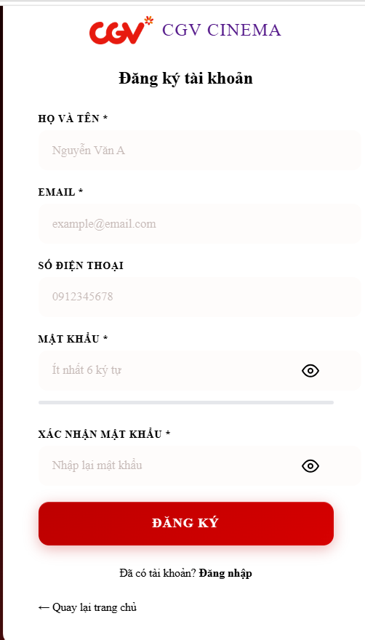

(Mapped to UC-01: Register)
This screen allows the Guest to:
● Create Account: sign up as a new Customer with full name, email, phone, and password.
● Password Strength Indicator: visualize password complexity in real time (Yếu → Rất mạnh).
● Inline Validation: validate each field on blur and input with per-field error messages.
Field Description
Field Name | Description
CGV Cinema | Navigate to the Home page
Họ và tên | Data type: string, required. The user's full name
Email | Data type: email string, required. Must be a valid email format and not already registered
Số điện thoại | Data type: tel string, optional. Pattern: (0|+84)\d{9} (Vietnamese phone number).
Mật khẩu | Data type: password string, required. Minimum 6 characters. Show/hide toggle button. Real-time strength bar (Yếu / Trung bình / Khá / Mạnh / Rất mạnh).
Xác nhận mật khẩu | Data type: password string, required. Must match the Mật khẩu field. Show/hide toggle button.
Đăng ký | Submit button. Validates all fields client-side before POST to /Register.
Đăng nhập | Navigate to the Login page if already have an account.
Quay lại trang chủ | Navigate to the Home page.

3.2.2 User Login
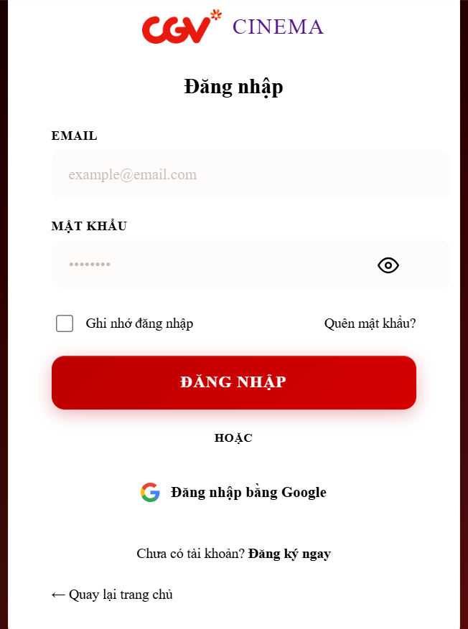

(Mapped to UC-02: Login)
This screen allows the Users to:
● Authenticate: log in using email and password to access role-specific dashboards
● Access Google SSO: sign in quickly via Google OAuth.
● Recover Password: navigate to the Forgot Password page to reset a forgotten password.
Field Description
Field Name | Description
CGV Cinema | Navigate to the Home page
Email | Data type: email string, required. The registered email address of the account.
Mật khẩu | Data type: password string, required. Masked input with a show/hide toggle button.
Ghi nhớ đăng nhập | Data type: checkbox. Extends session lifetime when checked
Quên mật khẩu | Navigate to the Forgot Password page to reset a forgotten password.
Đăng nhập bằng Google | Authenticate using a Google account via OAuth.
Đăng ký ngay | Navigate to the Register Page to sign up for an account.
Quay lại trang chủ | Navigate to the Home page

3.2.3 Forgot Password
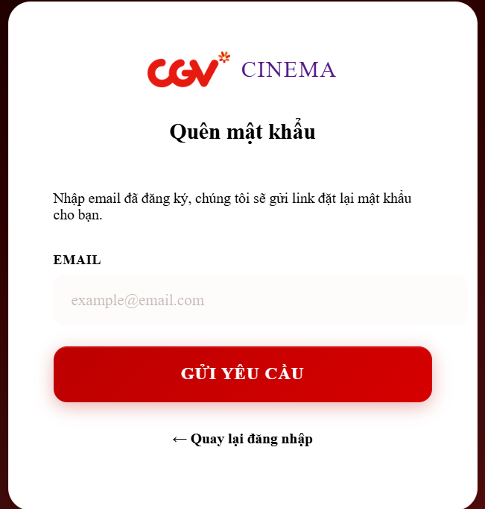

(Mapped to UC-03: Forgot Password)
This screen allows the User to:
● Request Reset Link: enter registered email to receive a password reset link.
● Prevent Enumeration: always displays a generic success message even if the email doesn't exist, preventing email enumeration attacks.
● Countdown Timer: shows a real-time countdown of the reset link expiry (1 hour).

Field Description
Field Name | Description
CGV Cinema | Navigate to the Home page.
Email | Data type: email string, required. The registered email address to send the reset link to.
Gửi yêu cầu | Submit button. Generates a UUID reset token with 1-hour expiry and stores it via AccountDAO.updateResetToken(). Displays the reset link on screen (for development) with a countdown timer.
Quay lại đăng nhập | Navigate back to the Login page.

3.2.4 Change Password
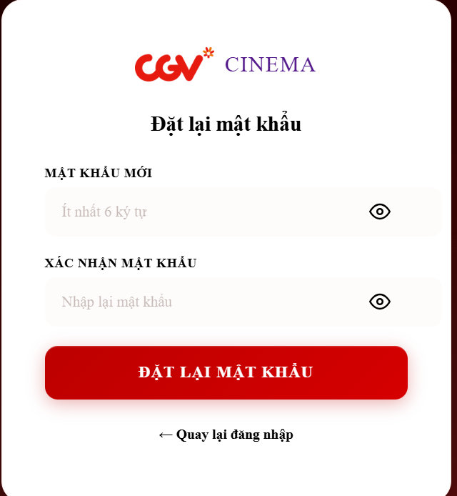

(Mapped to UC-05: Change Password)
This screen allows the User to:
●Change Password: update the account password by verifying the current password first. ● Password Validation: enforce minimum length (6 characters) and confirm match before

Field Description
Field Name | Description
CGV Cinema | Navigate to the Home page.
Mật khẩu hiện tại | Data type: password string, required. Current password for identity verification. Show/hide toggle button.
Mật khẩu mới | Data type: password string, required. Minimum 6 characters. Show/hide toggle button.
Xác nhận mật khẩu mới | Data type: password string, required. Must match Mật khẩu mới. Show/hide toggle button.
Đổi mật khẩu | Submit button. Verifies current password via PasswordHash.verify(), validates new password rules, then calls AccountDAO.updatePassword() to hash and store. On success, displays "Đổi mật khẩu thành công." The session is NOT invalidated; user remains logged in.
Quay lại trang chủ | Navigate to the Home page

3.2.5 View Profile
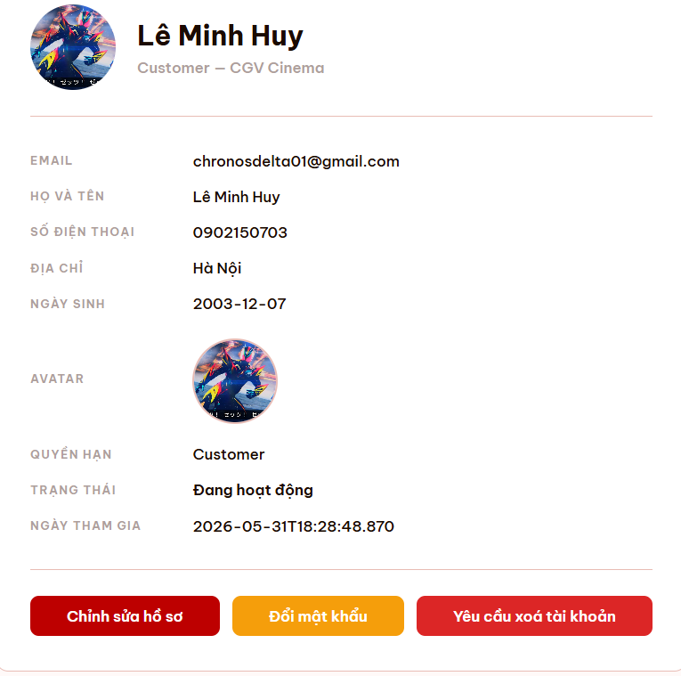
(Mapped to UC-06: View Profile)
This screen allows the User to:
●View Personal Information: display full name, email, phone number, address, date of birth, and avatar.
● View Account Status: see current role name, account status (active/blocked), and join date.
● Access Profile Actions: navigate to Edit Profile modal, Change Password, or Request Account Deletion.

Field Description
Field Name | Description
Chỉnh sửa hồ sơ | Open the edit profile modal
Đổi mật khẩu | Link. Navigate to the Change Password page
Yêu cầu xoá tài khoản | Link. Navigates to deletion request page.

3.2.6 Edit Profile
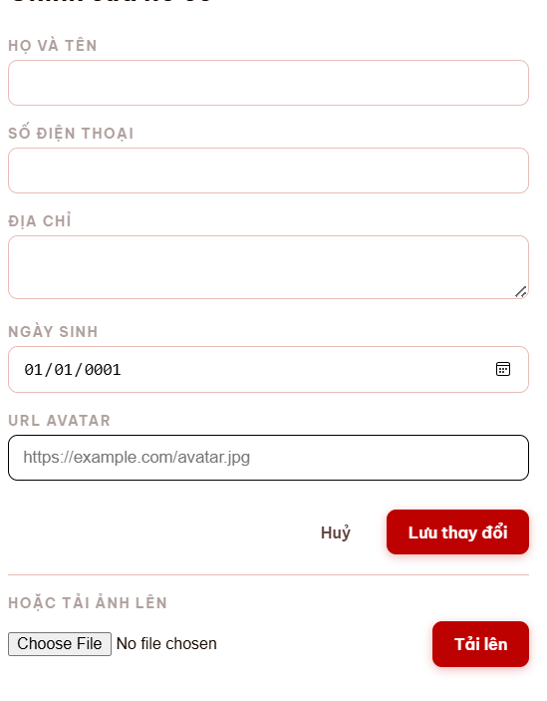

(Mapped to UC-07: Edit Profile)
This screen allows the User to:
● Update Personal Information: modify full name, phone number, address, and date of birth.
● Change Avatar: set a new avatar via URL or upload an image file.
● Real-time Validation: fields are validated on the client side before submission.

Field Description
Field Name | Description
Họ và tên | Data type: string, required. The user's full name.
Số điện thoại | Data type: string, optional. Phone number.
Địa chỉ | Data type: text (multi-line), optional. Residential address.
Ngày sinh | Data type: date, optional. Date of birth.
URL Avatar | Data type: URL, optional. Link to an external avatar image.
Tải ảnh lên | Data type: file (JPEG/PNG/GIF). Alternative upload method via AvatarUploadServlet.
Huỷ | Button. Closes the modal without saving.
Lưu thay đổi | Submit button. Calls ProfileController.doPost() with action=updateProfile. Updates the UserProfile table (INSERT if first-time, otherwise UPDATE). Refreshes the session account object and displays "Cập nhật hồ sơ thành công!" on success, or "Cập nhật hồ sơ thất bại!" on failure.

3.2.7 Deletion Request
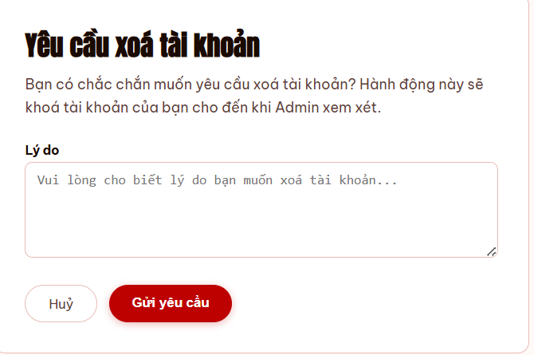

This screen allows the Customer to:
● Submit Deletion Request: send a request to permanently delete their account.
● Provide Reason: explain why they want their account removed.
● Track Pending Status: see if a previous request is still awaiting admin review.

Field Description
Field Name | Description
Lý do | Data type: text (multi-line), required. Reason for requesting account deletion.
Huỷ | Button. Navigates back to the Home page without submitting.
Gửi yêu cầu | Submit button. Calls DeletionRequestServlet.doPost() with action=create. Inserts a pending request and notifies Admin. On success: displays "Yêu cầu xoá tài khoản đã được gửi! Admin sẽ xem xét." On failure: "Gửi yêu cầu thất bại!

3.3 System Administration

3.3.1 Master Data

3.3.1.1 Manage Customers Account
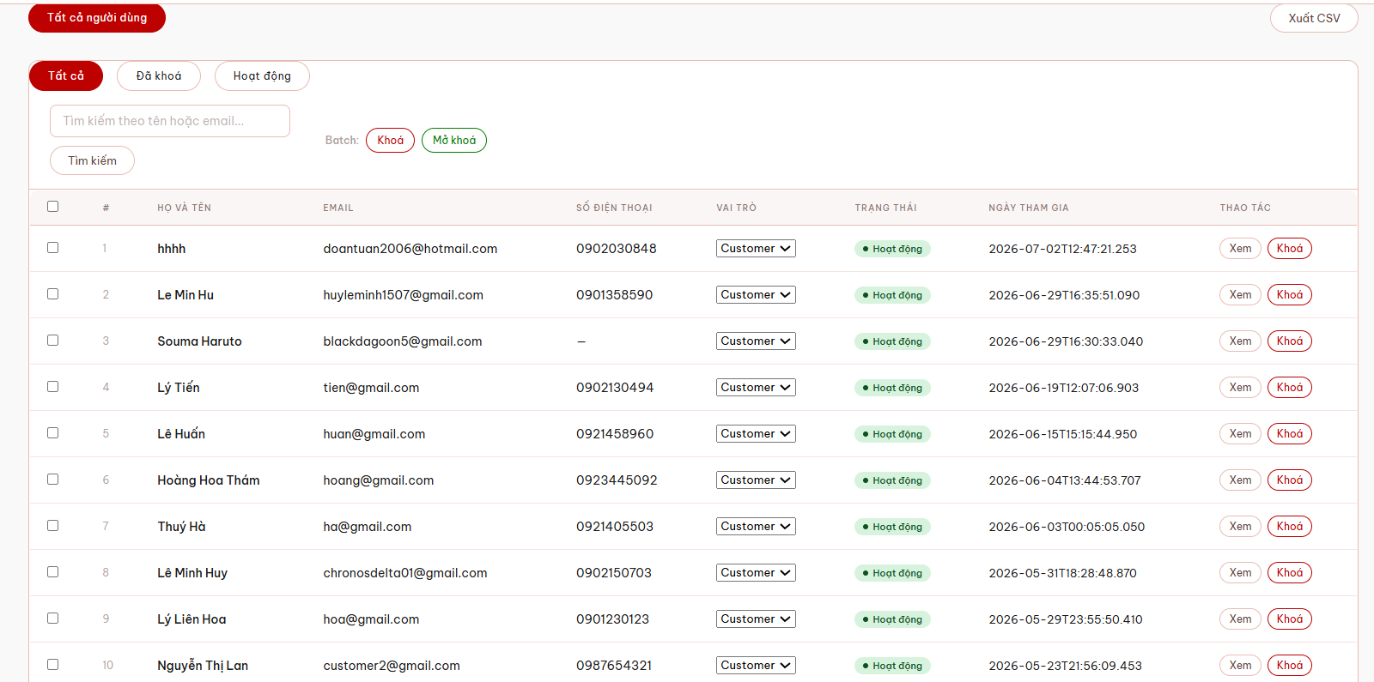

This screen allows the Admin to:

Field Description
Field Name | Description
Xuất CSV | Export the list of customer accounts
Tìm kiếm theo tên hoặc email
Tìm kiếm
Tìm theo Đã khoá
Tìm theo Hoạt động
Bash Khoá
Bash Mở Khoá
Check Box
Sắp xếp theo Họ và tên
Sắp xếp theo Email
Sắp xếp theo Số điện thoại
Thao tác xem
Thao tác khoá
Vai trò(Phân quyền )

3.3.1.2 Manage Staffs Account
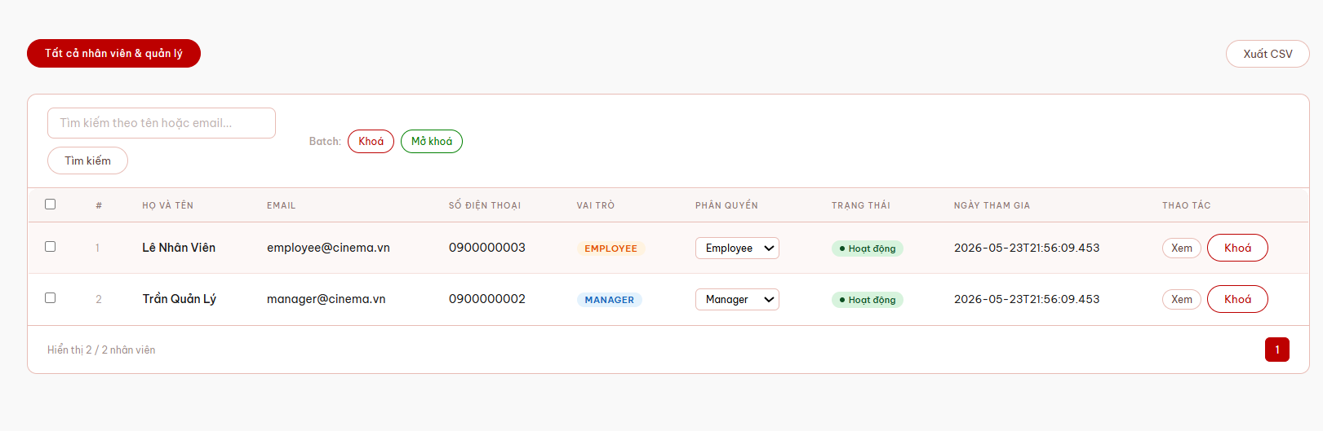

This screen allows the Admin to:

Field Name | Description
Xuất CSV | Export the list of customer accounts
Tìm kiếm theo tên hoặc email
Tìm kiếm
Tìm theo Đã khoá
Tìm theo Hoạt động
Bash Khoá
Bash Mở Khoá
Check Box
Sắp xếp theo Họ và tên
Sắp xếp theo Email
Sắp xếp theo Số điện thoại
Thao tác xem
Thao tác khoá
Vai trò(Phân quyền )

3.3.1.2 Setting Details
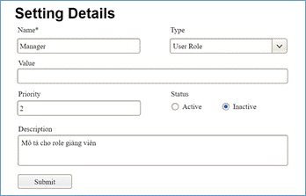

This screen allows the Administrator to:
● Add New Setting: add new master data.
● Update Setting Details: update details of a specific master data
Field Description
Field Name | Description
Name | Data type: non-digit string, max length of 20 characters
Type | Initial data values: all active setting names (with null or blank type)
Value | Data type: any string, max length of 100 characters
Priority | Data type: a positive integer
Description | Data type: any string, max length of 200 characters

3.3.2 User Management

3.3.2.1 User List
…

3.3.2.2 User Details
…

3.4 Movie Management

3.4.1 Movie Catalog (Public)

3.4.1.1 Home Page
(Mapped to UC-11: View Movie List, UC-13: Search Movie)
This screen allows the Guest and Customer to:
- Explore Movies: browse through the visually appealing Hero Banner and curated lists of "Now Showing" and "Upcoming" movies.
- Search and Filter: use the live search bar to quickly find a specific movie by its title, or use the dropdown filters to sort movies by genres (e.g., Action, Horror).
- Quick Booking: click the primary "Đặt vé ngay" button on the banner to instantly navigate to the showtime selection page for the hottest movie.
- Discover Cinema Features: read about the premium services and technologies offered by the cinema, such as IMAX, 4DX, and VIP Seating.
- Navigate the Platform: access other main sections of the website (Theaters, Members) or authenticate their accounts via the top navigation bar.
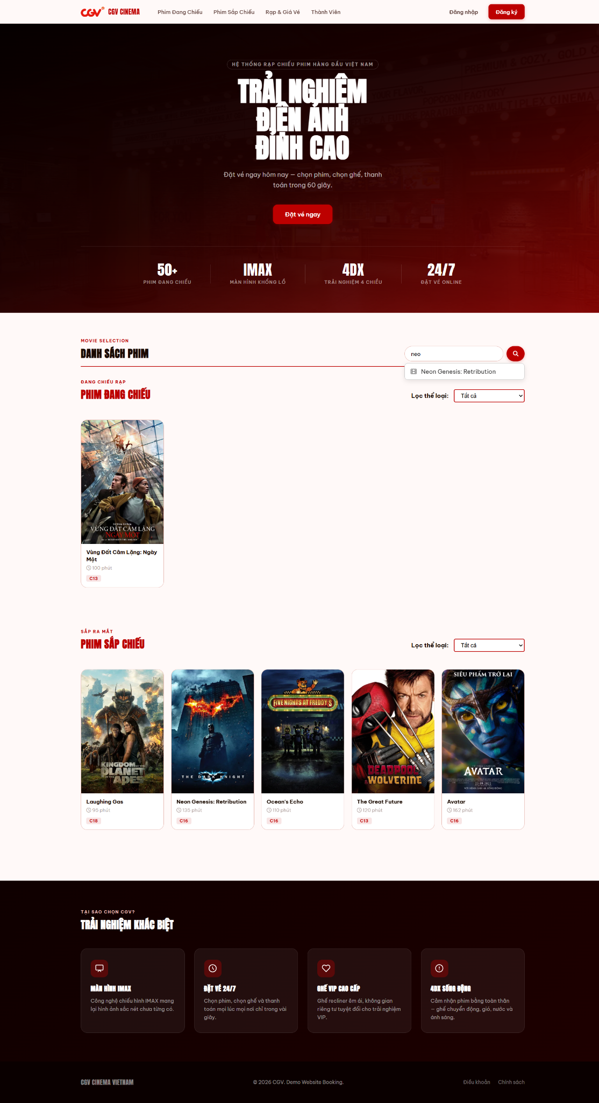
Field Description
Field Name | Description
Navigation Bar | Displays the brand logo and main navigation links (Now Showing, Upcoming, Theaters & Ticket Prices, Members). Includes Login and Register buttons for user authentication.
Hero Banner | A large promotional banner displaying the cinema's main marketing message ("Trải nghiệm điện ảnh đỉnh cao").
"Đặt vé ngay" Button | A call-to-action button that quickly redirects users to the booking page.
Features/Stats Bar | Highlights key cinema advantages and statistics (50+ Movies, IMAX, 4DX, 24/7 Online Booking) located at the bottom of the hero banner.
Search Input | A text box allowing users to search for a specific movie by its title. Includes a magnifying glass icon button.
Live Search Suggestions | A dropdown list that automatically appears when typing in the search box, showing matched movie titles as clickable links.
"Lọc thể loại" Dropdown (Now Showing) | A combobox filter that allows users to filter the "Now Showing" movies by specific genres (Action, Horror, Comedy, etc.).
Movie Card (Now Showing) | Displays information about a currently screening movie, including its Poster, Title, Duration, and Age Restriction label (e.g., C16, C18). Clickable to view movie details.
"Lọc thể loại" Dropdown (Upcoming) | A combobox filter that allows users to filter the "Upcoming" movies by specific genres.
Movie Card (Upcoming) | Displays information about a movie that will be released soon, including its Poster, Title, Duration, and Age Restriction label.
"Trải nghiệm khác biệt" Section | A promotional section detailing the cinema's premium experiences and facilities (IMAX, 24/7 Booking, VIP Seats, 4DX).
Footer | Located at the bottom of the page, containing copyright information and links to Terms of Service and Privacy Policies.

3.4.1.2 Movie Detail Screen
(Mapped to UC-12: View Movie Detail, UC-18: View Rating List, UC-19: Rate Movie, UC-20: Edit/Delete Rating, UC-21: View Rating Statistics)
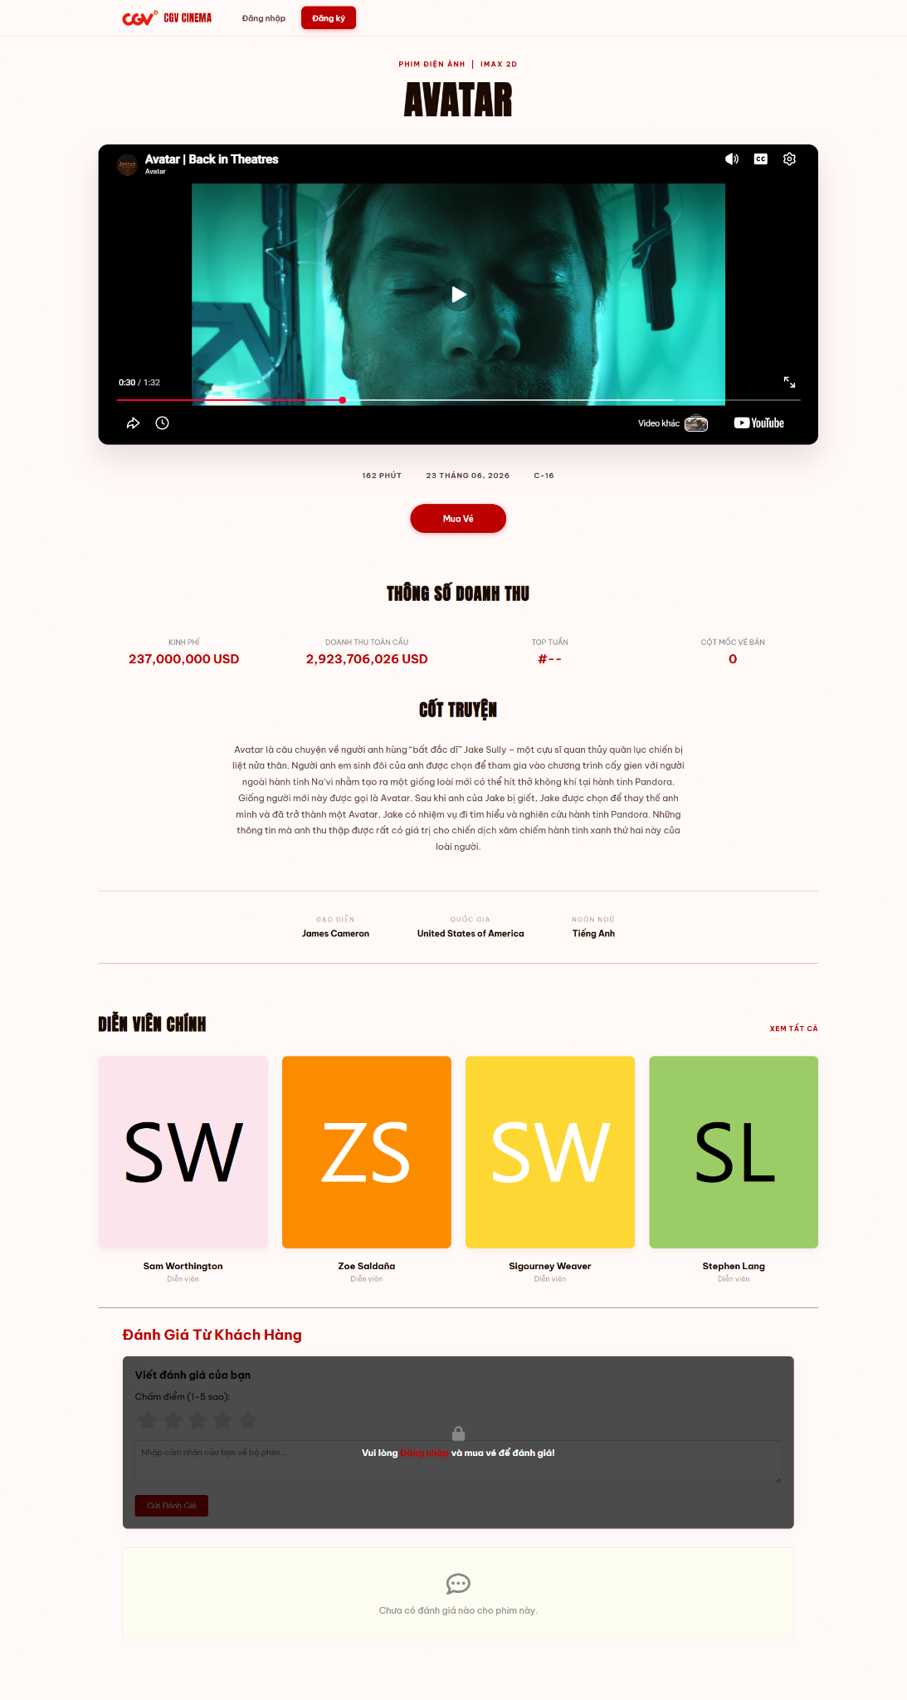
This screen allows the Guest and Customer to:
- View Movie Details: read comprehensive information about a specific movie, including its metadata (duration, age restriction), synopsis, director, and cast list.
- Watch Trailer: play the embedded promotional video directly within the page layout, allowing users to watch the official trailer without opening a popup or leaving the detail page.
- Book Tickets: click the prominent "Mua Vé" button to navigate directly to the showtime and seat selection process for this specific movie.
- View Box Office Stats: see the movie's financial success and milestones, such as production budget and global revenue.
- Interact with Audience Sentiment: browse through the review section to read individual user feedback. If logged in and possessing a valid ticket, customers can submit their own star rating and written review.
Field Description
Field Name | Description
Navigation Bar | Displays the brand logo, main navigation links, and Login/Register buttons.
Movie Tags / Genres | Displays the movie's format and genres (e.g., PHIM ĐIỆN ẢNH | IMAX 3D) above the title.
Movie Title | Displays the full, official name of the movie in large, bold typography.
Trailer Player | An embedded video player (YouTube) allowing users to watch the movie's official trailer directly on the page.
Movie Meta Info | Displays key movie details: Duration (e.g., 162 PHÚT), Release Date, and Age Restriction (e.g., C-16).
"Mua Vé" Button | A primary call-to-action button that redirects the user to select showtimes and book tickets for this specific movie.
Box Office Statistics | Displays financial and ranking data of the movie, including Budget (Kinh phí), Global Box Office (Doanh thu toàn cầu), Weekly Rank (Top tuần), and Tickets Sold Milestone (Cột mốc vé bán).
Synopsis (Cốt truyện) | A text block providing a detailed summary of the movie's plot and storyline.
Crew Information | Displays key production details including the Director (Đạo diễn), Country of origin (Quốc gia), and spoken Language (Ngôn ngữ).
Cast List (Diễn viên chính) | A horizontal list of character cards displaying the initials, full names, and roles of the main actors. Includes a "Xem tất cả" (See All) link.
Review Section Title | A header "Đánh Giá Từ Khách Hàng" indicating the user feedback area.
Star Rating Selector | A 5-star interactive rating system allowing users to score the movie from 1 to 5 stars.
Review Text Box | A text area for users to type their feedback. Displays a lock icon and prompts users to "Login and buy a ticket" if they are not eligible to review.
"Gửi Đánh Giá" Button | A button to submit the user's star rating and written review to the system.
Review Comments Area | Displays a list of submitted reviews from other customers. Shows a placeholder message (e.g., "Chưa có đánh giá nào...") if no reviews exist.

3.4.2 Movie Catalog Management (Manager)

3.4.2.1 Add Movie Screen
(Mapped to UC-14: Add Movie)

This screen allows the Manager / Admin to:
- Input Movie Details: fill in comprehensive information about a new movie, including its title, duration, genres, release format, cast, and synopsis.
- Fetch TMDB Data: click the "Dữ liệu TMDB" button to automatically retrieve and populate financial data (production budget and global box office) from the external TMDB API.
- Preview Media: enter a URL for the movie poster and view an instant visual preview to ensure the image link is valid and correct.
- Set Visibility: toggle the "Active" checkbox to determine whether the newly added movie should be immediately published and visible to customers on the Home Page.
- Save/Cancel Operations: submit the validated form data to store the new movie in the database, or discard the changes and return to the management list.
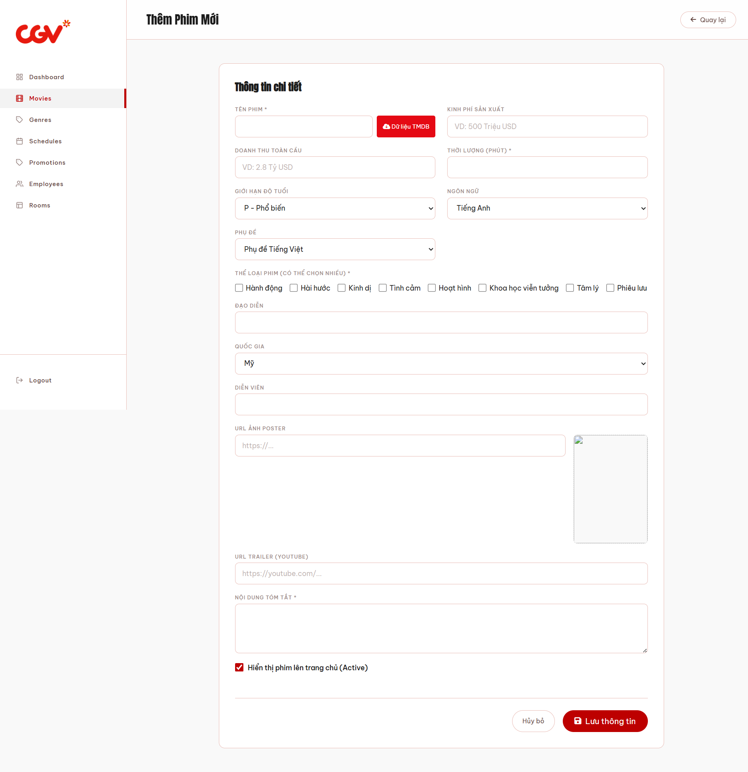
Field Description
Field Name | Description
Sidebar Menu | The left-hand navigation menu allowing the manager to switch between management modules (Movies, Genres, Schedules, etc.) and Logout.
"Quay lại" Button | A button located at the top right to cancel the current action and return to the Movie Management list page.
Tên phim * | A mandatory text input for entering the official title of the movie.
"Dữ liệu TMDB" Button | A function button next to the movie title that automatically fetches external financial data (Budget & Box Office) from the TMDB API based on the entered title.
Kinh phí sản xuất | A text input field to manually enter or auto-fill the movie's production budget (e.g., 500 Triệu USD).
Doanh thu toàn cầu | A text input field to manually enter or auto-fill the global box office revenue (e.g., 2.8 Tỷ USD).
Thời lượng (phút) * | A mandatory number input specifying the runtime of the movie in minutes.
Giới hạn độ tuổi | A dropdown list to select the appropriate age restriction for the movie (e.g., P, C13, C16, C18).
Ngôn ngữ | A dropdown list to select the primary spoken language of the movie (e.g., English, Vietnamese, Korean).
Phụ đề | A dropdown list to select the available subtitle format (e.g., Vietnamese Subtitles, English Subtitles, Dubbed).
Thể loại phim * | A group of mandatory checkboxes allowing the manager to assign one or multiple genres (Action, Comedy, Horror, etc.) to the movie.
Đạo diễn | A text input for entering the name of the movie's director(s).
Quốc gia | A dropdown list to select the movie's country of origin.
Diễn viên | A text input for listing the main cast members of the movie.
URL Ảnh Poster | A text input for the URL of the movie's promotional poster. Includes a live image preview panel on the right side.
URL Trailer (Youtube) | A text input for the YouTube URL of the movie's official trailer.
Nội dung tóm tắt * | A mandatory multi-line text area for entering a descriptive synopsis or plot summary of the movie.
Hiển thị phim lên trang chủ (Active) | A checkbox that, when ticked, immediately publishes the movie to the public-facing Home Page.
"Hủy bỏ" Button | A secondary button to discard all entered information and return to the previous page without saving.
"Lưu thông tin" Button | The primary submit button to validate the form inputs and save the new movie record into the database.

3.4.2.2 Movie Management List Screen
(Mapped to UC-16: Delete / Hide Movie)
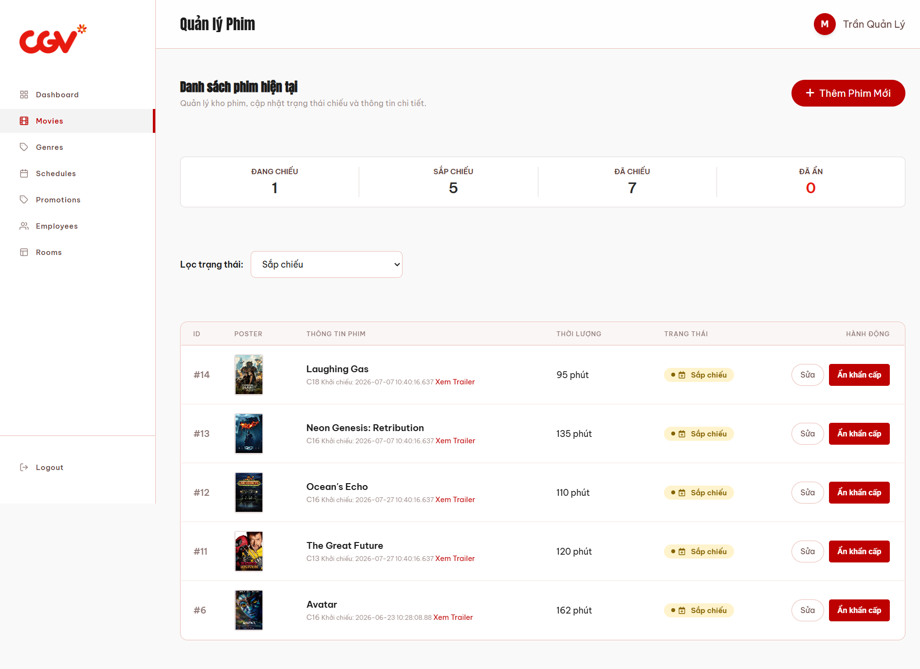
This screen allows the Manager to:
- View Movie Statistics: quickly see the total number of movies categorized by their current lifecycle status (Now Showing, Upcoming, Ended, Hidden).
- Filter Movies: use the status filter dropdown to easily sort and find specific groups of movies.
- Manage Movie Catalog: view a comprehensive list of all movies in the system, including their posters, basic metadata, durations, and current statuses.
- Edit Movies: click the "Sửa" (Edit) button to navigate to the edit screen and update a movie's details.
- Toggle Visibility (Emergency Hide): click the "Ẩn khẩn cấp" (Emergency Hide) or "Hiện" (Show) button to instantly remove or restore a movie's visibility from the public Home Page.
- Add New Movies: click the "+ Thêm Phim Mới" button to navigate to the movie creation screen.
Field Description
Field Name | Description
Sidebar Menu | The left-hand navigation menu allowing the manager to switch between management modules.
Top Header | Displays the current page title ("Quản lý Phim") and the logged-in manager's profile information.
"+ Thêm Phim Mới" Button | A primary call-to-action button that redirects the manager to the Add New Movie screen.
Statistics Cards | Four informational cards displaying the real-time count of movies in different states: Đang chiếu (Now Showing), Sắp chiếu (Upcoming), Đã chiếu (Ended), and Đã ẩn (Hidden).
"Lọc trạng thái" Dropdown | A combobox filter that allows the manager to filter the movie list table based on their current screening status.
Movie List Table | A data grid displaying the filtered list of movies with columns for ID, Poster, Movie Info, Duration, Status, and Actions.
Column: ID | Displays the unique database identifier (#ID) for each movie.
Column: POSTER | Displays a thumbnail image of the movie's promotional poster.
Column: THÔNG TIN PHIM | Displays the movie's Title, Age Restriction, Premiere Date, and a clickable "Xem Trailer" link to preview the video.
Column: THỜI LƯỢNG | Displays the runtime of the movie in minutes (e.g., 95 phút).
Column: TRẠNG THÁI | Displays a visual badge indicating the movie's current status (e.g., Sắp chiếu, Đang chiếu).
"Sửa" Button | An action button located in the "Hành động" column that navigates to the Edit Movie screen for the selected record.
"Ẩn khẩn cấp" / "Hiện" Button | A quick-action toggle button allowing the manager to immediately hide a movie from the public site or restore its visibility.

3.4.2.3 Edit Movie Screen
(Mapped to UC-15: Edit Movie)
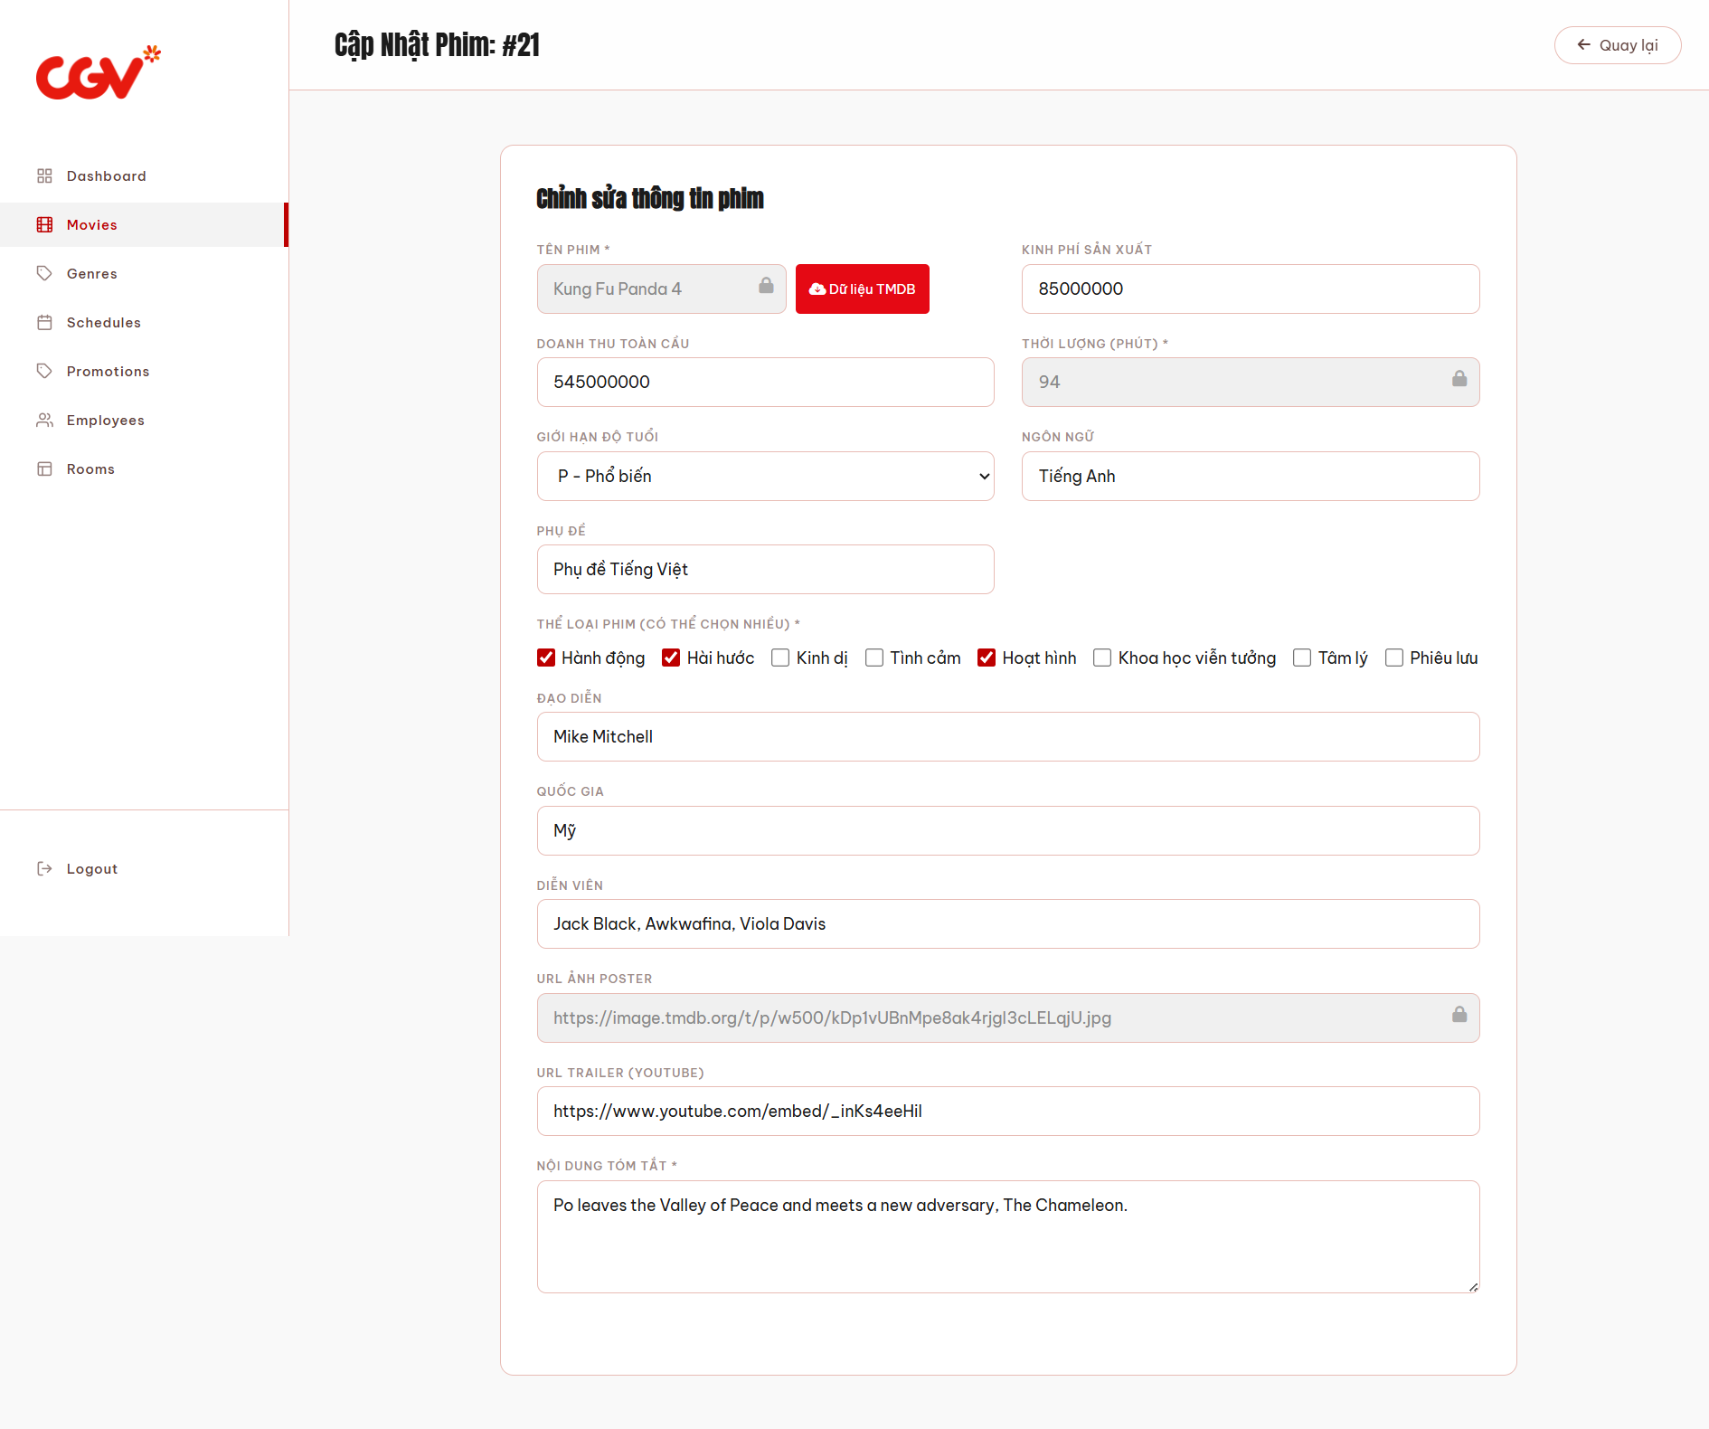
This screen allows the Manager / Admin to:

- Update Movie Details: modify non-critical information of an existing movie, such as its synopsis, cast, age restriction, trailer URL, and financial statistics (budget, box office).
- Sync TMDB Data: use the "Dữ liệu TMDB" button to automatically fetch and update the latest financial statistics from the external TMDB API.
- Review Locked Fields: view critical movie attributes (Title, Duration, and Poster URL) which are locked and read-only to prevent conflicts with existing showtimes and historical booking data.
- Update Genres: add or remove genre categories associated with the movie by checking/unchecking the respective boxes.
- Save/Cancel Operations: submit the validated form to permanently update the movie record in the database, or discard the changes and return to the movie list.
Field Description
Field Name | Description
Sidebar Menu | The left-hand navigation menu allowing the manager to switch between management modules.
"Quay lại" Button | A button located at the top right to cancel the editing process and return to the Movie Management list page.
Tên phim * (Locked) | Displays the official title of the movie. This field is locked (read-only) to prevent identity conflicts in the database.
"Dữ liệu TMDB" Button | A function button that automatically fetches and updates the movie's latest financial data (Budget & Box Office) from the TMDB API.
Kinh phí sản xuất | A text input field to update the movie's production budget.
Doanh thu toàn cầu | A text input field to update the global box office revenue.
Thời lượng (phút) * (Locked) | Displays the runtime of the movie in minutes. This field is locked to prevent overlapping or breaking existing generated schedules.
Giới hạn độ tuổi | A dropdown list to update the appropriate age restriction for the movie.
Ngôn ngữ | A text input field to update the primary spoken language of the movie.
Phụ đề | A text input field to update the subtitle or dubbing information.
Thể loại phim * | A group of checkboxes displaying the currently assigned genres. The manager can check or uncheck boxes to update the movie's categories.
Đạo diễn | A text input for updating the name of the movie's director(s).
Quốc gia | A text input for updating the movie's country of origin.
Diễn viên | A text input for updating the main cast members of the movie.
URL Ảnh Poster (Locked) | Displays the URL of the movie's promotional poster. This field is locked to maintain visual consistency across active showtimes.
URL Trailer (Youtube) | A text input for updating the YouTube URL of the movie's official trailer.
Nội dung tóm tắt * | A multi-line text area for updating the synopsis or plot summary of the movie.
Hiển thị phim lên trang chủ (Active) | A checkbox that dictates the movie's visibility. Unchecking this box will immediately hide the movie from the public site.
"Hủy bỏ" Button (Phần bị khuất dưới ảnh) | A secondary button to discard all changes and return to the previous page without saving.
"Cập nhật thông tin" Button (Phần bị khuất) | The primary submit button to validate the modifications and update the movie record in the database.

3.4.2.4 Manage Genre Screen
(Mapped to UC-17: Manage Genre)
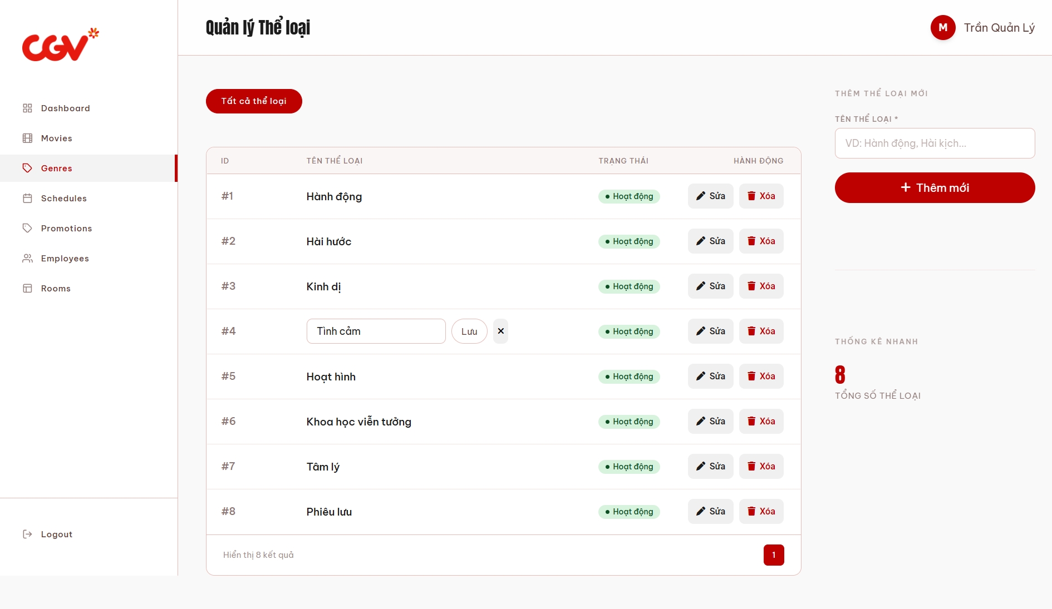
This screen allows the Manager to:
- View Genres: browse a complete list of all movie genres available in the system, along with their active statuses.
- Add New Genre: quickly create a new genre category by entering its name in the right-hand panel and submitting it.
- Inline Edit Genre: click the "Sửa" (Edit) button to rename a genre directly within the data table without navigating to a separate page.
- Delete Genre: click the "Xóa" (Delete) button to permanently remove an unused genre from the database.
- Monitor Quick Stats: view the total count of existing genres at a glance via the statistics widget on the right.
Field Description

Field Name | Description
Sidebar Menu | The left-hand navigation menu allowing the manager to switch between management modules.
Top Header | Displays the current page title ("Quản lý Thể loại") and the logged-in manager's profile information.
"Tất cả thể loại" Tab/Filter | A primary tab indicating the current view of the genre list.
Genre List Table | A data grid displaying all existing genres with columns for ID, Name, Status, and Actions.
Column: ID | Displays the unique database identifier (#ID) for each genre.
Column: TÊN THỂ LOẠI | Displays the descriptive name of the genre (e.g., Hành động, Hài hước). When in edit mode, this field transforms into a text input.
Column: TRẠNG THÁI | Displays a visual badge indicating whether the genre is currently active ("Hoạt động").
"Sửa" Button | An action button that activates the inline-editing mode for a specific genre, allowing the manager to rename it directly in the table.
"Xóa" Button | An action button that deletes the selected genre from the database. (Typically requires a confirmation prompt).
Inline "Lưu" Button | Appears only during inline-editing mode. Saves the updated genre name to the database.
Inline "x" (Cancel) Button | Appears only during inline-editing mode. Cancels the edit and restores the original genre name.
"TÊN THỂ LOẠI *" Input Box | A mandatory text input field located in the right panel for entering the name of a new genre to be created.
"+ Thêm mới" Button | The primary submit button to validate and save the newly typed genre into the system.
"Thống kê nhanh" Widget | A quick statistics panel displaying the total number of genres currently existing in the database (e.g., "8 TỔNG SỐ THỂ LOẠI").

3.5 Movie Rating

3.5.1 Rate Movie Screen (Customer)
(Mapped to UC-19: Rate Movie, UC-20: Edit / Delete Own Rating)
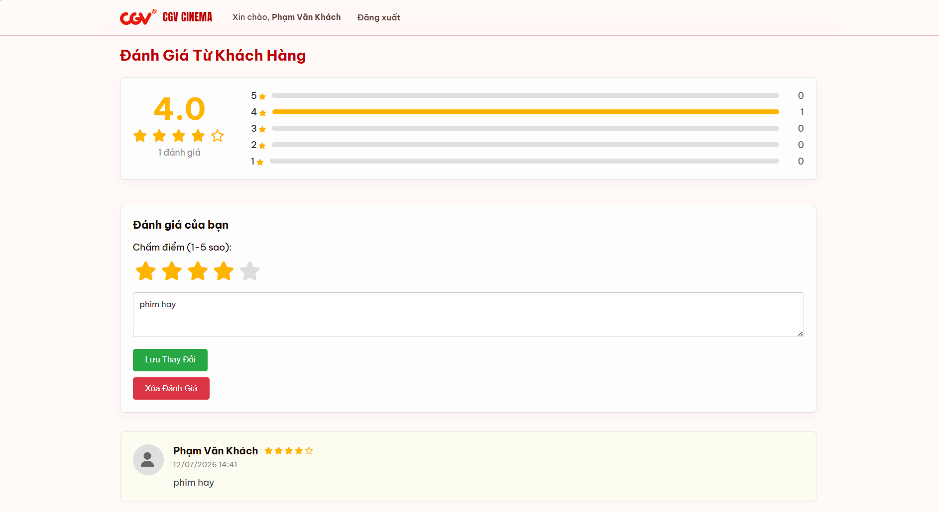
This section allows the authenticated Customer to:
- View Overall Rating: see the average rating score of the movie alongside a detailed breakdown of rating distributions (from 1 to 5 stars).
- Submit Review: write a new review and rate the movie if they have a valid ticket and haven't reviewed it yet.
- Edit Existing Review: modify their previously submitted star rating and written feedback, then save the changes.
- Delete Review: permanently remove their own review and rating from the movie's feedback section.
- Browse Audience Reviews: read individual reviews left by other verified customers, including their names, avatars, timestamps, and comments.

Field Description

Field Name | Description
Top Navigation Bar | Displays the brand logo and the authenticated user's greeting ("Xin chào, [Tên khách hàng]"), along with a "Đăng xuất" (Logout) link.
Section Title | Displays the header "Đánh Giá Từ Khách Hàng" (Customer Reviews).
Average Rating Score | Displays the aggregated average rating score (e.g., 4.0) calculated from all user reviews, along with the total count of reviews.
Rating Distribution Chart | A bar chart displaying the breakdown of how many users voted for each star tier (from 5 stars down to 1 star).
"Đánh giá của bạn" Panel | A dedicated form panel allowing the logged-in customer to input, edit, or delete their personal review for the movie.
Interactive Star Selector | A 5-star input mechanism allowing the customer to select their rating score (1 to 5 stars) by clicking on the stars.
Review Text Box | A multi-line text area where the customer can type their feedback or modify their previously written comment.
"Lưu Thay Đổi" / "Gửi Đánh Giá" Button | A primary action button (green) that submits the new review or saves modifications made to an existing review into the database.
"Xóa Đánh Giá" Button | A secondary action button (red) that deletes the customer's existing review. Only visible if the customer has previously submitted a review.
User Review Card | An individual component displaying a submitted review from a customer. It includes the user's avatar, name, star rating, submission date/time, and the review text.

4. Non-Functional Requirements

3.1 External Interfaces

3.1.1 User Interfaces

The web application shall provide a responsive user interface compatible with modern web browsers (Google Chrome, Mozilla Firefox, Microsoft Edge, Safari) on both desktop and mobile devices. The interface shall follow a consistent layout structure: a navigation bar on top, a main content area in the center, and a footer at the bottom. All pages must be rendered in Vietnamese as the default language. Admin/Manager/Employee dashboards use a sidebar navigation layout for management functions.

3.1.2 Hardware Interfaces

The system shall interface with the following hardware components:

QR code lookup form (search by ticket code, email, or name) for ticket check-in at the counter (UC-46). No physical scanner or camera is used.

Ticket printer at the counter for manual ticket creation (UC-48).

Standard input devices (keyboard, mouse, touchscreen) for all user interactions.

3.1.3 Software Interfaces

The system shall integrate with the following external software services:

Payment Gateway: VNPay, MoMo, or ZaloPay API for online payment processing (UC-27).

Email Service (SMTP): For account registration confirmation, password reset, and booking confirmation emails.

Database: Microsoft SQL Server for data storage and retrieval.

Web Server: Apache Tomcat running Java Servlet/JSP application.

3.1.4 Communication Interfaces

The system shall communicate over HTTPS (TLS 1.2 or higher) for all client-server interactions. RESTful API endpoints shall be used for payment gateway integration. Email communication shall use SMTP over port 587 with TLS encryption.

3.2 Quality Attributes

3.2.1 Usability

USR-01: A new customer shall be able to complete the full ticket booking flow (select movie → select showtime → select seat → pay) within 5 minutes without prior training.

USR-02: The system shall display clear error messages in Vietnamese when the user provides invalid input, indicating the exact field and expected format.

USR-03: Navigation between major functions shall require no more than 3 clicks from the home page.

USR-04: The seat selection map shall use intuitive color coding: available (green), occupied (red), selected (blue), VIP (gold border).

USR-05: All management pages (Manager/Employee dashboards) shall include search, filter, and sort capabilities on list views.

USR-06: The system shall be responsive and usable on screen widths from 375px (mobile) to 1920px (desktop).

3.2.2 Performance

PER-01: Page load time shall not exceed 3 seconds under normal conditions (≤ 100 concurrent users).

PER-02: The seat availability map for a showtime shall load within 2 seconds, including real-time occupancy status.

PER-03: Ticket lookup and check-in verification (UC-46) shall return the result within 1 second to avoid customer queues.

PER-04: Payment processing (UC-27) shall complete within 15 seconds, including gateway response time. If timeout occurs, the system shall automatically mark the invoice as "Failed."

PER-05: Revenue statistics reports (UC-49) shall be generated within 5 seconds for a date range of up to 1 year.

PER-06: The system shall support at least 200 concurrent users during peak hours (e.g., weekend evenings, movie premiere events).

3.2.3 Security

SEC-01: All user passwords shall be stored using a one-way hashing algorithm (bcrypt or SHA-256 with salt). Plain-text passwords shall never be stored or logged.

SEC-02: The system shall enforce role-based access control (RBAC) with 5 roles: Guest, Customer, Employee, Manager, and System Admin. Each API endpoint and page shall verify the user's role before granting access.

SEC-03: User sessions shall expire after 30 minutes of inactivity. The system shall force re-authentication after session timeout.

SEC-04: The system shall prevent common web vulnerabilities including SQL Injection, Cross-Site Scripting (XSS), and Cross-Site Request Forgery (CSRF).

SEC-05: All sensitive actions (account deletion, role assignment, system configuration changes) shall be recorded in the SystemLog table with the actor's AccountID, action type, IP address, and timestamp.

SEC-06: Failed login attempts shall be limited to 5 within a 15-minute window. After exceeding this limit, the account shall be temporarily locked for 30 minutes.

3.2.4 Reliability & Availability

REL-01: The system shall have a minimum uptime of 99% during operating hours (8:00 AM – 12:00 AM daily).

REL-02: In case of a payment gateway failure, the system shall allow the customer to retry payment or switch to a different payment method without losing the selected seats for up to 10 minutes (seat hold mechanism).

REL-03: The database shall be backed up daily. ⚠ Not implemented in the current codebase: there is no backup/restore action anywhere in AdminServlet or elsewhere; this remains a planned requirement.

REL-04: The system shall gracefully handle unexpected errors by displaying a user-friendly error page instead of exposing stack traces or system internals.

3.2.5 Scalability

SCA-01: The database schema shall support adding new room types (e.g., ScreenX, Dolby Atmos) without modifying existing table structures (currently enforced via CHECK constraint on Room.RoomType).

SCA-02: The system shall support adding new payment methods (e.g., Apple Pay, bank transfer) by extending the PaymentMethod field without requiring database schema migration.

SCA-03: The system architecture shall allow horizontal scaling of the web server behind a load balancer for future growth.

3.2.6 Maintainability

MAI-01: The application shall follow the MVC (Model-View-Controller) architecture pattern to separate concerns between data access, business logic, and presentation.

MAI-02: All system configuration values (banner images, policy text, theme settings) shall be stored in the database and manageable through the admin UI (UC-50) without requiring code deployment.

MAI-03: The system shall maintain comprehensive audit logs in the SystemLog table for all critical operations, supporting troubleshooting and compliance auditing.

5. Requirement Appendix

5.1 Business Rules
[Provide common business rules that you must follow. The information can be provided in the table format as the sample below]
ID | Rule Definition
BR-01 | Delivery time windows are 15 minutes, beginning on each quarter hour.
BR-02 | Deliveries must be completed between 10:00 A.M. and 2:00 P.M. local time, inclusive.
BR-03 | All meals in a single order must be delivered to the same location.
BR-04 | All meals in a single order must be paid for by using the same payment method.
BR-11 | If an order is to be delivered, the patron must pay by payroll deduction.
BR-12 | Order price is calculated as the sum of each food item price times the quantity of that food item ordered, plus applicable sales tax, plus a delivery charge if a meal is delivered outside the free delivery zone.
BR-24 | Only cafeteria employees who are designated as Menu Managers by the Cafeteria Manager can create, modify, or delete cafeteria menus.
BR-33 | Network transmissions that involve financial information or personally identifiable information require 256-bit encryption.
BR-86 | Only regular employees can register for payroll deduction for any company purchase.
BR-88 | An employee can register for payroll deduction payment of cafeteria meals if no more than 40 percent of his gross pay is currently being deducted for other reasons.

5.2 System Messages

5.2 System Messages
The following table defines all standard system messages displayed to the user across the application. Placeholders in curly braces (e.g., {field_name}) are replaced with actual values at runtime.
# | Message Code | Message Type | Context | Content
1 | MSG01 | Inline | No search results found | No results found. Please try different keywords.
2 | MSG02 | Inline (red, under field) | Required field is empty | The {field_name} field is required.
3 | MSG03 | Inline (red, under field) | Input exceeds max length | Maximum length is {max_length} characters.
4 | MSG04 | Inline (red, under field) | Invalid email format | Please enter a valid email address.
5 | MSG05 | Inline (red, under field) | Invalid password format | Password must be at least 8 characters with uppercase, lowercase, and a digit.
6 | MSG06 | Inline | Incorrect login credentials | Incorrect email or password. Please try again.
7 | MSG07 | Inline | Account is temporarily locked | Your account is locked due to multiple failed login attempts. Please try again after 30 minutes.
8 | MSG08 | Inline | Account is blocked by admin | Your account has been blocked. Please contact the administrator.
9 | MSG09 | Toast (success) | Registration successful | Registration successful! Please check your email to verify your account.
10 | MSG10 | Toast (success) | Profile updated | Profile updated successfully.
11 | MSG11 | Toast (success) | Password changed | Password changed successfully. Please log in again.
12 | MSG12 | Toast (success) | Movie added/updated | Movie information saved successfully.
13 | MSG13 | Toast (success) | Schedule created/updated | Schedule saved successfully.
14 | MSG14 | Toast (success) | Ticket booked successfully | Booking confirmed! Your ticket QR code has been generated.
15 | MSG15 | Toast (success) | Check-in successful | Check-in successful. Seat: {seat}, Room: {room}.
16 | MSG16 | Toast (error) | Ticket already checked in | This ticket has already been checked in at {checked_in_time}.
17 | MSG17 | Inline (red) | Invalid or expired QR code | Invalid ticket code. Please verify and try again.
18 | MSG18 | Inline (red) | Selected seat already booked | The selected seat is no longer available. Please choose another seat.
19 | MSG19 | Inline (red) | Promotion code invalid or expired | Promotion code is invalid, expired, or has reached its usage limit.
20 | MSG20 | Toast (error) | Payment failed or timed out | Payment failed. Please try again or select a different payment method.
21 | MSG21 | Toast (success) | Promotion created/updated | Promotion saved successfully.
22 | MSG22 | Toast (success) | Employee account created/updated | Employee account saved successfully.
23 | MSG23 | Toast (success) | Manual ticket created | Manual ticket created successfully. Please print the ticket.
24 | MSG24 | Toast (success) | System configuration updated | System configuration updated successfully.
25 | MSG25 | Inline (red) | Duplicate email | This email address is already registered.
26 | MSG26 | Inline (red) | Duplicate promotion code | This promotion code already exists. Please use a different code.
27 | MSG27 | Inline (red) | Schedule time overlap | This schedule overlaps with an existing schedule in the same room.
28 | MSG28 | Inline | Session expired | Your session has expired. Please log in again.
29 | MSG29 | Inline (red) | File upload error | Invalid file format or file size exceeds the limit ({max_size} MB).
30 | MSG30 | Confirmation dialog | Confirm delete/deactivate action | Are you sure you want to {action}? This action cannot be undone.

5.3 Other Requirements
5.3.1 Legal and Compliance
The system shall comply with Vietnamese regulations on personal data protection (Decree 13/2023/ND-CP). Customer personal information (name, phone number, email) shall be collected only for booking purposes and shall not be shared with third parties without explicit consent.
5.3.2 Localization
All user-facing content shall be displayed in Vietnamese by default, including system messages, form labels, and error notifications. Currency values shall be formatted in Vietnamese Dong (VND) with thousand separators (e.g., 90.000 VND).
5.3.3 Browser Compatibility
The system shall support the latest two major versions of Google Chrome, Mozilla Firefox, Microsoft Edge, and Safari. Internet Explorer is not supported.
5.3.4 Data Retention
Transaction records (invoices, tickets) shall be retained for at least 2 years for auditing and reporting purposes. System logs shall be retained for at least 1 year.

